|  |
| --- |
|  |
| Capstone Project Document |
| Bookaholic Social Network |
|  |
|  |
| |  |  |  |  | | --- | --- | --- | --- | | 日本語辞書・チーム | | | | | **Group Members** | Phạm Thị Huyền | SE03416 | huyenptse03416 | |  | Thái Thị Cẩm Vân | SE03409 | vanttcse03409 | |  | Vũ Hải Đăng | SE03380 | dangvhse03380 | |  | Nguyễn Thị Hải Yến | SE03171 | yennthse03171 | |  | Chu Minh Hải | SE03143 | haicmse03143 | | **Supervisor** | Mr. Nguyễn Văn Sang | Lecture at FPT University | | | **Capstone Project code** | **BSN** | | |   **- Hanoi, 12-2016 -** |

TABLE CONTENTS

1 INTRODUCTION 5

1.1 Purpose 5

1.2 Acronyms and Definitions 5

1.3 Abstract 5

1.4 Literature Review 5

1.4.1 Kickstarter 6

1.4.2 Comicola 7

1.5 Proposal 7

1.5.1 The idea 7

1.5.2 The objective 7

1.5.3 Brief description about system 8

1.5.4 System features 9

1.6 Benefits from Project 10

1.6.1 For our group 10

1.6.2 For Community 10

1.7 Critical Assumption and Constraints 10

1.8 Potential Risks 11

2 PROJECT MANAGEMENT 12

2.1 Introduction 12

2.1.1 Purpose 12

2.1.2 Definitions and Acronyms 12

2.2 Project Overview 12

2.2.1 Project Description 12

2.2.2 Scope and Purpose 13

2.2.3 Assumptions and Constraints 15

2.2.4 Project Objectives 16

2.2.5 Critical Dependencies 17

2.2.6 Project Risk 18

2.3 Project Development Approach 19

2.3.1 Project Process 19

2.3.2 Requirement Change Management 21

2.3.3 Quality Management 21

2.4 Estimation 24

2.4.1 Size 24

2.4.2 Effort 24

2.4.3 Schedule 25

2.4.4 Resource 33

2.4.5 Infrastructure 33

2.4.6 Training Plan 34

2.4.7 Finance 34

2.5 Project Organization 35

2.5.1 Organization Structure 35

2.5.2 Project Team 35

2.6 Communication & Reporting 38

3 SOFTWARE REQUIREMENT 40

3.1 Introduction 40

3.1.1 Purpose 40

3.1.2 Definitions and Acronyms 40

3.2 User Requirement Specification 41

3.2.1 Business Process Overview 41

3.2.2 Product Features 52

3.2.3 User characteristic 54

3.2.4 Functional Requirements 54

3.2.5 Non-functional Requirement 55

3.3 Software Requirements Specification 56

3.3.1 Overall Description 56

3.3.2 Functional Specification 59

3.3.3 Non-Functional Specification 138

4 SOFTWARE DESIGN 140

4.1 Introduction 140

4.1.1 Purpose 140

4.1.2 Definitions, Acronyms, Abbreviations 140

4.2 Architecture design 140

4.2.1 Choice of Architecture Design 140

4.2.2 Architecture Representation 146

4.2.3 Architectural Goals and Constraints 147

4.2.4 Logical View 148

4.2.5 Process view 152

4.2.6 Deployment View 154

4.3 Detail Design 155

4.3.1 Package 155

4.3.2 Function 185

4.4 Data design 216

4.4.1 Entity Relationship Diagram 216

4.4.2 Table Diagram 218

4.5 Screen Design 226

4.5.1 User Client 226

4.5.2 Admin 258

5 SOFTWARE TESTING 274

5.1 Introduction 274

5.1.1 Purpose 274

5.1.2 Definitions and Acronyms 274

5.1.3 Scope of testing 275

5.1.4 Constraints 276

5.2 Test plan 277

5.2.1 Test type 277

5.2.2 Test stages 279

5.2.3 Test model 279

5.2.4 Acceptance test criteria. 281

5.2.5 Futures to be tested 281

5.2.6 Feature not to be tested 281

5.2.7 Resources 281

5.2.8 Test milestones 282

5.2.9 Deliverables 283

5.3 Test case 283

5.4 Test Report 284

5.4.1 System test report 284

5.4.2 Integration test report 284

5.4.3 Test report 284

5.4.4 Defect report 285

6 USER MANUAL 286

6.1 Introduction 286

6.1.1 Purpose 286

6.1.2 Environment 286

6.2 Installation Guideline 286

6.2.1 Connecting an ASP.NET MVC Web App with SQL Azure 286

6.2.2 Create & Deploying the Azure Website 291

6.2.3 Connecting SQL Management Studio to SQL Azure 293

6.3 User Guideline 297

6.3.1 User Client 297

6.3.2 Admin 319

7 PROJECT RESULT REPORT 326

7.1 Product Judging 326

7.1.1 Advantage of Dandelion system 326

7.1.2 Current Limitations 326

7.1.3 Expectation in Future 326

7.2 Project Summary 326

7.3 Lesson Learnt 327

8 REFERENCES 329

# INTRODUCTION

## Purpose

This document is created as the introduction for project Bookaholic Social Network – our Capstone Project at FPT University. In this document, we will descript the overview of some existing systems, the initial idea for our project, a brief description about our expected system and some potential risks, critical assumptions, constrains. Moreover, this document also shows opportunities what it offers for users.

## Acronyms and Definitions

|  |  |
| --- | --- |
| **Acronym & Abbreviation** | **Definition** |
| BSN | Bookaholic Social Network |
| FU | FPT University |
| Q&A | Question and Answer |

1. Definitions and Acronyms

## Abstract

Nowadays, social network plays an essential role in our lives. Vietnam is the country that has the big Internet user growth and the trend of communication through social network is expanding rapidly, people shares and discuses about everything through social network. However, there is not any social network that is for only Vietnamese people who love reading books. To solve this problem, we create a website where people who loves book can share and discus with others about their favorite books or authors. We believe this project will strengthen Vietnam’s reading culture.

## Literature Review

There are some social networks about book. For example: Goodreads, Shelrafi, Wattpad, etc. However, there is not any social network about books for Vietnamese only.

* **Goodreads**

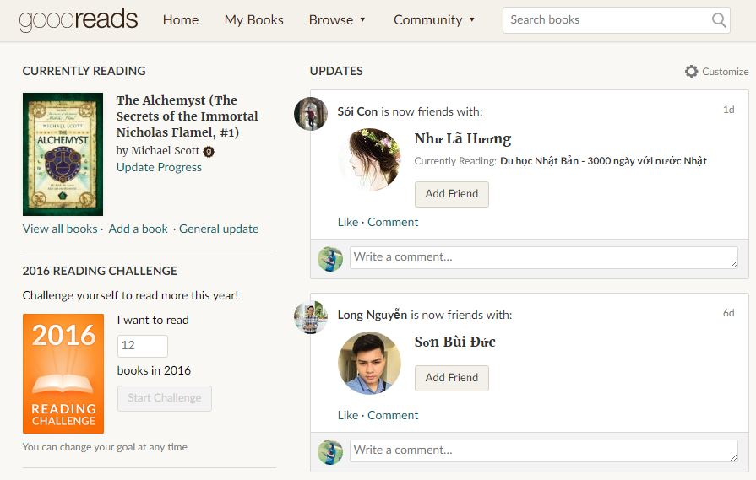

Figure 1‑1-1: Website Goodreads

Goodreads is a platform that allows members to recommend books, create connection with other members or follow a club to keep track of what they’ve read and would like to read.

* **Advantages:**

Goodreads launched in January 2007. It is the world’s largest site for readers and book recommendations with 50 million members, 1.5 billion books and 50 million reviews. Therefore, if you use Goodreads to its full potential, you'll find a robust community of book lovers and a nearly endless list of recommendations. Goodreads also allows users to join conversations about their favorite books or authors. Moreover, it lets you organize your personal collection of books and keep track of what you look for gaps within you collection.

* **Disadvantages:**

It has no real filter between kid and adult content. While 13 is the recommended age for signing up, there's nothing stopping a teen from joining groups which is about adult content. Teens should be cautious about what they share and use privacy settings to minimize contact with strangers.

* **Wattpad**



Figure 1-1‑2: Website Wattpad

Wattpad is a platform that authors and publishers use for online engagement and to create purposeful relationships with readers.

* **Advantages:**

Wattpad is user friendly, so it has a huge number of audiences. Therefore, when you publish something on Wattpad, you can build a fan base as well as a timestamp through which you can prove your original copyright. Wattpad allows authors to share their work with the world and easily interact with their fan.

* **Disadvantages:**

However, Wattpad usually recommends to users about things they do not really need. It’s annoying when the main page is all reading lists, recommendations that users do not really care about, especially with authors. Moreover, the writing feature is not well supported such as all the tools are hidden until you highlight something and then they pop up over the text.

## Proposal

### The idea

Nowadays, as the negative side of social media, teens are not often reading books, especially traditional books. In Vietnam, almost people prefer to spend time for web surfing than read a paper books. Our idea is creating a website that allows people to share and talk about books they would like to read or authors they are interested in. This project aims to make more fun in reading to encourage people especially teens to read more.

### The objective

This project is the Capstone Project in FPT University studying program. Firstly, this project is responsibility for all team members. Therefore, we must complete all requirements from teacher and FU. During the time doing project, we can learn how to develop a project, how to manage project, how to communicate better between team members, how to control time and how to perform teamwork effectively. Moreover, we will also have experience in .NET technology, website designing and software testing. Therefore, we think this project is very necessary for us to improve skills, knowledge which we studied in FU. Moreover, this project also makes our CV more attractive after graduating from FU. This is also an opportunity for us to prove capacity with recruiters.

Secondly, we all know that it is worth reading books. We believe this project will strengthen Vietnam’s reading culture. Specially, our website displays completely in Vietnamese, so users can use functions easily, even though they do not know English.

### Brief description about system

This project is the Capstone Project in FPT University studying program. Firstly, this project is responsibility for all team members. Therefore, we must complete all requirements from teacher and FU. During the time doing project, we can learn how to develop a project, how to manage project, how to communicate better between team members, how to control time and how to perform teamwork effectively. Moreover, we will also have experience in .NET technology, website designing and software testing. Therefore, we think this project is very necessary for us to improve skills, knowledge which we studied in FU. Moreover, this project also makes our CV more attractive after graduating from FU. This is also an opportunity for us to prove capacity with recruiters.

Secondly, we all know that it is worth reading books. We believe this project will strengthen Vietnam’s reading culture. Specially, our website displays completely in Vietnamese, so users can use functions easily, even though they do not know English.

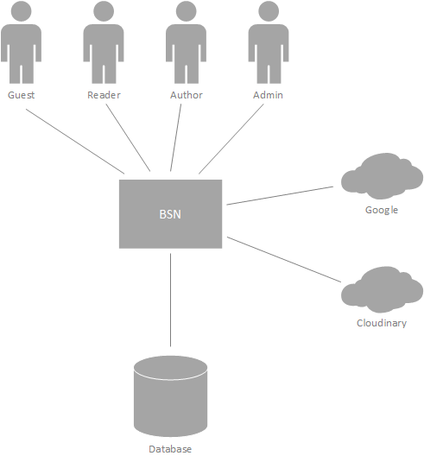

Figure 1‑3: Brief description diagram of BNS

### System features

About the features of BSN, we focus to provide for users main features as searching, recommend, discus about books, etc. Admin can manage members, database and manage the development of website through our statistic.

The detailed features are below.

#### Guest features

* Guests can register for an account to use features of our system.

#### Reader/Author features

* Manage account: Our website allows users to register for an account. Then they can login and use lots of features. Users can edit their profile such as name, date of birth, avatar and cover photo. In case users forget their password, they can send request and system will send them an auto mail to confirm new password.
* Manage recommendation: One of our website’s main features is posting recommendation about books or authors. Users will tag name of book(s) in their post and they can also edit or delete all these content latter. Our site aims to support users interact with others, so they can comment on a post and edit or delete that comment in need.
* Manage interactions: Users of BSN can interact with others by following them.

Moreover, there are several groups about books or authors and users can request to admin of a group to be its members. If users see a group is not appropriate with them or they do not want to join a group anymore, they can remove themselves from that group

Another feature is reporting. Users can report other accounts or groups if those accounts and groups have invalid content or copyright infringement.

* Manage groups: We allow users to create their own group. All groups have to be tagged a book or author as its topic. Admins of a group can add new members to their group by entering their name or accept join-group request.

To manage group members, admins can set other members admin or remove members out of their group

Moreover, admin of a group can edit group information as name, cover photo, etc. and they can also delete a group by removing all its members.

All members can create posts in a group.

* Search and Rate: User can search for books, authors or other accounts. They can also rate for books. Through users’ vote about books and their following authors, our system will calculate and suggest books or authors they may also like.

#### Admin features

* Manage user account: To manage user accounts, system admin can search for users and view their profile, posts, etc. After that, they can de-active, active or delete accounts within reporting about those accounts. Moreover, request about creating author accounts will be approved or declined by admins.
* Manage slides: Slides are pictures showed off to help guests preview about our website. Admins will add new slides if need. Depend on situations, admins can de-active, active or delete unnecessary slides.
* Manage publishers: Admins are allowed to add new, update information or delete a publisher.
* View statistic: Manage the development of website if necessary. Therefore, we support admins to view statistic about users, authors or group such as number of accounts, books or authors which is hot trend in that time, etc.

## Benefits from Project

### For our group

After developing and implementing this project, our group will get some benefits. Firstly, all members will have more experiences of software project management how to manage plan, time, member and risk. Moreover, we will get more knowledge and skill about .NET MVC5, Bootstrap and other skills about real-time programming. The most important benefit is members can improve their skill about communicating with team members and doing teamwork more effective.

### For Community

Just need to have a device that can connect to the internet and any web browser, user can easily join a community about books. They can share, discus with others about their favorite books or authors and update information about new books and trend of reading quickly. They can also find friends who have the same reading hobbit like them. All these things will make reading become more fun and attractive.

## Critical Assumption and Constraints

* **Critical assumption:**

There are some critical assumptions about training that must be true in real. It is almost members of our team just have basic knowledge about C# asp.Net. We do not have experience in C# asp.Net MVC5, html, CSS, etc. About human resources, we assume that all members in team have a good healthy to do their tasks.

* **Constraints:**

To have good working result, all members must follow some constraints. At first, about time and deadline: We must complete task on time. Our project runs for 14 weeks. Each member works 5 hours/day and 5 days/week. We do not have much time to complete developing and deliver application. Besides, we have to submit report documents before deadline to review. Secondly, about quality of product, it must be run well when users perform main functions in Google Chrome 4.0 or higher. About human resources, our team has 5 members, each member have to study 2 subjects (JPS and JIT) at school. The schedule will base on this and members have responsibility to join meeting and finish tasks on time.

## Potential Risks

After studying about this project, we find out some problem that we may be encountered. Firstly, project may be under-estimate scope and time or miss deadline because lack of experience in group working, managing and controlling work. Secondly, it may loss data, source code before uploading data to server because of careless. Moreover, about human resources, team member cannot complete their works because of health reasons, key member leave team or un-cooperating on team. Another risk is changing requirements, requirement changed when some functions cannot be completed or some technologies are not suitable.

# PROJECT MANAGEMENT

## Introduction

### Purpose

This is the Project Management Plan of Bookaholic Social Network Project – our Capstone Project in FPT University. It includes the project overview, project organization, tools, infrastructures and schedule of this project.

### Definitions and Acronyms

|  |  |  |
| --- | --- | --- |
| Acronym | Definition | Note |
| BA | Business Analyst |  |
| BU | Business Unit |  |
| CC | Infrastructure Configuration Controller |  |
| CM | Configuration Management |  |
| BSN | Bookaholic Social Network |  |
| DEV | Developer |  |
| PIC | Person in charge |  |
| PM | Project Manager |  |
| PTL | Project Technical Leader |  |
| QA | Quality Assurance Officer |  |
| SRS | Software Requirement Specification |  |
| TC | Test Case |  |
| PCB | Process Capability Baseline |  |
| HuyenPT | Pham Thi Huyen | Team member |
| VanTTC | Thai Thi Cam Van | Team member |
| DangVH | Vu Hai Dang | Team member |
| YenNTH | Nguyen Thi Hai Yen | Team member |
| HaiCM | Chu Minh Hai | Team member |
| FPTU | FPT University |  |

Definitions and acronyms

## Project Overview

### Project Description

|  |  |  |  |
| --- | --- | --- | --- |
| Project Code | BSN | Contract Type | None |
| Customer | FPT University | 2nd Customer | None |
| Project Level | Group | Project Rank | None |
| Application Type | Website | Project Manager | Pham Thi Huyen |
| Project Category | Development | Business Domain | E-commerce |

Project Description

### Scope and Purpose

#### Purpose

Nowadays, as the negative side of social media, teens are not often reading books, especially traditional books. In Vietnam, almost people prefer to spend time for web surfing than read a paper books. Our idea is creating a website that allows people to share and talk about books they would like to read or authors they are interested in. This project aims to make more fun in reading to encourage people especially teens to read more.

#### Scope

Our project scope included:

* Developing user requirement and software requirement specification.
* Developing architecture and detailed design documents.
* Coding and unit test.
* Developing test case and execute system test.

#### The functions of Project

These are the functions of BSN’s project:

##### Guest Module

* **Register**: To use lots of function of our website, guests can register for an account. However, there are difference between reader account and author account. If users want to have an author account, they will have to wait for admin to validate their personal information

##### Reader/Author Module

* **Account:**
* Login/Logout: Users login/logout an account to use or exit system BSN. All users have to register for an account to use our website.
* Edit profile: User can edit their profile such as name, date of birth, avatar photo, etc.
* Reset password: If users forget their password, they can send request and system will send them an auto mail to confirm new password.
* **Post:**
* Post a recommendation: User can recommend about books as a post. To recommend books, users are forced to tag those books on their post.
* Edit post: Users can edit both caption and tags of post.
* Like a post
* Delete a post
* Comment on a post: Users can comment on a post.
* Delete comments: Users can delete their comment in need.
* **Interaction:**
* Follow other accounts.
* Report other accounts/groups: Users can report other accounts/groups if those accounts/groups have invalid content or copyright infringement.
* Send join-group request: There are several groups about books or authors and users can request to admin of a group to be its members.
* Out a group: If users see a group is not appropriate with them or they do not want to join a group anymore, they can remove themselves from that group.
* **Group:**
* Create a group: To create a group, users have to tag a book or author as the topic of that group.
* Add new member to a group: Admin can add new members to their group by entering their name or accept join-group request.
* Manage group members:
* Set other members admin: Only admins can set other member admin.
* Remove members: Admin can remove members out of their group
* Edit group profile: Admin can edit group information as name, cover photo, etc.
* Delete a group: Admins can delete a group. To delete a group, they have to remove all of its members.
* Manage group post:
* Create a post in group: All members can create posts in a group and they do not need to tag a book/author.
* Edit a post in group: The owner of a post can edit their post.
* Delete a post: The owner of a post can delete if they want. Admins can also delete a post if they see it is inappropriate.
* **Search:** User can search for books, authors or other accounts
* **Rate a book:** User can rate books. We also suggest them books they may like.

##### Admin Module

* **Manage user account:**
* Search user: System admin can search for users and view their profile, posts, etc.
* Ban/Unban users: Admins can de-active user accounts.
* Decline requests about reporting an account/group: If a report is not valid, admin can decline it instead of approving.
* Accept/decline request about creating author account: Admins can approve or decline request about creating author account if it is valid or not.
* **Manage slides:**
* Add new slides: Slides are pictures showed off to help guests preview about our website. Admins will add new slides if need.
* Delete slides
* Active/De-active slides: If a slide is not in use, but admins want to keep it for using in future, they can de-active it and active when they need.
* **Manage publishers:**
* Add/Update/Delete publishers
* **View statistic:**
* Admins have right to view statistic about number of users/authors/group/books and authors in trend.

### Assumptions and Constraints

|  |  |  |
| --- | --- | --- |
| No | Description | Note |
| Assumptions | | |
| 1 | Customer reviewers will get seven days to approve a milestone document. If no comments are received within this time period, it will be considered as approved. | External Interfaces |
| Constraints | | |
| 1 | This project must be completed and delivered before 12/14/2016 | Schedule |
| 2 | In doing project processing, PM must submit report (include 6 reports) on certain date | Schedule |
| 3 | Software Requirement Specification for each phase will be completed at the end of that phase: + SRS for phase 1: deadline is 09/23/2016 + SRS for phase 2: deadline is 10/26/2016 + SRS for phase 3: deadline is 11/22/2016 | Schedule |
| 4 | Design Document (include Architecture Design, Screen Design, Database Design) of each phase must be completed at the end of each phase: + Screen Design for phase 1: deadline is 10/23/2016 + Screen Design for phase 2: deadline is 10/26/2016 + Screen Design for phase 3: deadline is 11/22/2016  + Database Design for whole project: deadline is 10/03/2016 + Architecture Design for whole project: deadline is 10/03/2016 | Schedule |
| 5 | Execute Integration TestPlan (include test plan and test case) | Schedule |
| 6 | Completed coding activity and have unit test result | Schedule |
| 8 | Deliver report about User manual, software package and installation guide | Schedule |
| 9 | Complete all of document and application before finishingtheprojecton | Schedule |
| 10 | Project contains 5 members | Resource |

### Project Objectives

#### Standard Objectives

|  |  |  |  |  |
| --- | --- | --- | --- | --- |
| Metrics | Unit | Committed | Re-committed | Note |
| **Start Date** |  | 09/05/2016 |  |  |
| **End Date** |  | 12/14/2016 |  |  |
| **Duration** | Day | 78 |  |  |
| **Team Size** | Person | 5 |  |  |
| **Billable Effort** | Person-day | 390 |  | 1 Person-day = 5 hours |
| **Calendar effort** | Person-day | 390 |  | 1 Person-day = 5 hours |
| **Effort Usage** | % | 100 |  | 1 Person-day = 5 hours |

Standard Objectives

|  |  |  |
| --- | --- | --- |
| Metrics | Unit | Basic for setting Goals |
| Average |
| Customer Satisfaction | Point | 9.5 |
| Leakage | Wdef/mm | 5 |
| Effort Efficiency | % | 95 |
| Timeliness | % | 100 |

Standard Objectives 2

#### Specific Objectives

|  |  |  |  |
| --- | --- | --- | --- |
| Metrics | Unit | Basic for setting Goals | |
| Plan | Actual |
| Training technology: ASP .net MVC5 framework, SignalR libary, Cloudinary service, etc. | Person-day | 12 | 12 |
| Execute group review | Person-day | 8 | 5 |
| Training requirements, process before coding | Person-day | 5 | 3 |

Specific Objectives

### Critical Dependencies

|  |  |  |  |
| --- | --- | --- | --- |
| No | Dependency | Expected delivery date | Note |
| 1 | This project must be completed and delivered to FPT University. | Dec/14/2016 |  |
| 2 | Project Plan and SRS must be completed and delivered to Supervisor by the end of each phase | + Phase 1: Sep/23/2016 + Phase 2: Oct/26/2016 + Phase 3: Nov/22/2016 |  |
| 3 | User manual, Software Package and Installation Guide must be completed and delivered to Supervisor and FPT University. | Dec/14/2016 |  |
| 4 | Beside Capstone Project, Team members have to joining in Japanese class and Japanese Fundamental Exam class. | Dec/17/2016 |  |

Critical Dependencies

### Project Risk

PM identifies risks in the Risk Management Plan. The document is updated to trigger each milestone, each event also. The document is updated weekly by the PM, Risk Management Plan will be notified to all of the stakeholders affected. Status of risk is reported to supervisor at Project Milestones Report.

Reference to BSN_Risk Management Plan_v1.0_EN.xlsx

|  |  |  |  |  |  |  |
| --- | --- | --- | --- | --- | --- | --- |
| **No** | **Risk** | **Root Cause** | **Triggers** | **Avoidance plan** | **Contingency plan** | **Fallback plan** |
| 1 | Conflict among team members | Team member doesn't understand each others | Has issue inside team | Plan some team buildings to improve teammate | Have a meeting to resolve conflict problem | Switch member to other team. |
| 2 | Requirement is changed after project is started | SRS not good (not realistic, not feasibility, not meet customer needs) | Customer (user) make change request. Or project team cannot develop the system as description in SRS. | Requirement should be paid a lot of attention. SRS should be reviewed carefully by PM and the supervisor. | With each requirement changes, the project team should have a meeting to analysis the change requests and take actions. | Re-estimate and update plan. |
| 3 | Team member do not meet the deadline | Undisciplined and habit of team member, loose management | Have a deadline | Setting rule and minus of do not meet the deadline: lost money and named at meeting minute. | Punish the member do not meet the deadline. Working over time. | Ask for help from out of team, supervisors. |
| 4 | Inability to verify/validate products against requirements. |  | Inability to verify/validate products against requirements. | Print out the result to check by normal eyes. Debug into code to see how the code is running | Print out the result to check by normal eyes. Debug into code to see how the code is running | Ask for help from supervisors |
| 5 | The server has defective parts. | Defective power supply… | Server is down… | Ensure the supplier provides with the adequate warranties. | Replace or fix the defective parts quickly. | Buy a new one. |
| 6 | Delivery project doesn’t meet requirement | Team member not understand requirement | Can't delivery project | Team lead have to review source code and follow requirement | Fix in next version | Extend deadline |

Risk Management plan

## Project Development Approach

### Project Process

Process of this project is performed follow to Iterative and Incremental model.

### Iterative and Incremental Model

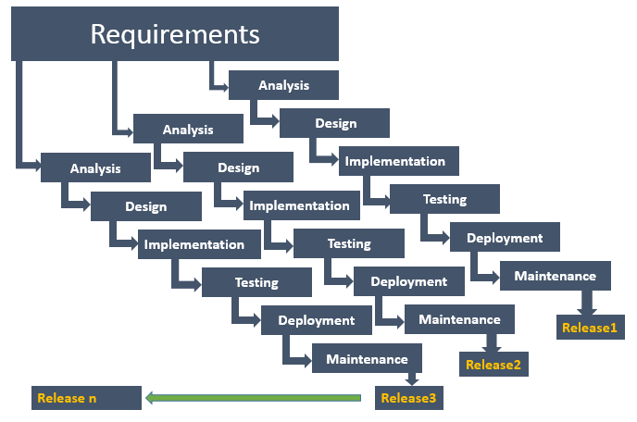

Figure 2‑1: Iterative and Incremental Model

#### Project Life Cycle

Basing on Iterative and Incremental model and real-world project, we decided to divide the project into 5 phases: Initiation, Implement 1, Implement 2, Implement 3 and Termination:

* **Initiation Phase:** This is the explanatory phase of the project. Project objective and description is described at this stage. The purpose of this phase is to collect and understand business requirements and detail the project plan. Our primary objectives are complete project identification and project plan. After these are completed, the project is checked against the following criteria:
* Identify business functions of the system
* Determining the scope, conditions and limitations of the project
* List the main functions of the system
* List one or more suitable architecture for the system
* Identify project risks
* Install tools and environment
* **Implement 1:** In this phase, the architecture of the 1st part of system is designed. The goal is to translate requirements and specification into a technical solution to produce Technical Design and coding.
* Ourobjectivesare completeRequirement Specification of 1st part, Architecture Design of 1st part and Database Design.
* Complete designing screen for first phase
* Code first part of admin module and account management module includes unit testing.
* Complete report #1, report #2, 1st part of report #3, 1st part of report #4 and 1st part of report #5.
* **Implement 2:** In this phase, the architecture of the 2nd part of system is designed. The goal is to translate requirements and specification into a technical solution to produce Technical Design and coding.
* Ourobjectivesare completeRequirement Specification of 2nd part and Architecture Design of 2nd part.
* Complete designing screen for second phase
* Code and execute unit test for second part includes: Recommendation Management Module, Group Management Module, Interaction Management Module and Common Module.
* Complete 2nd part of report #3, 2nd part of report #4 and 2nd part of report #5.
* **Implement 3:** In this phase, the architecture of the 3rd part of system is designed. The goal is to translate requirements and specification into a technical solution to produce Technical Design and coding.
* Ourobjectivesare completeRequirement Specification of 3rd part and Architecture Design of 3rd part.
* Complete designing screen for 3rd phase
* Code and execute unit test for second part includes Admin Module 2nd part.
* Complete 3rd part of report #3, 3rd part of Report #4 and 3rd part of report #5.
* **Termination Phase**: This is the final phase in the life cycle of our project.
* Create installing guideline and user guideline
* Complete and submit final report.

### Requirement Change Management

|  |  |
| --- | --- |
| Who logs the change request? | Any team members |
| Who reviews the change request? | PM or who is PM assigned |
| Who approves the change request? | PM by default. PTL if:   * Changes to project scope * Changes in delivery plan of project deliverables * Changes to assignment for key roles (PM, PTL) |

Requirement Change Management

### Quality Management

#### Defect Prevention Strategy

|  |  |  |
| --- | --- | --- |
| Item (Process/Product) | Strategy | Expected Benefits |
| Requirement missing | List up all of requirement into SRS document. | 10–20% reduction in defect injection rate and about 2% improvement in productivity |
| Careless mistake in Design Document Format/Template wrong | After designing, QA will review Document Format base on checklist review design | Improvement in quality as overall defect removal efficiency will be improved; some benefits in productivity as defects will be detected early |
| Use wrong template | Have a meeting to disseminate all template that is used in this project for all member | All member will use right template writing document |
| Coding application does not match with User Requirement. | Development Team must study Requirement/Design within 1 week since project is assigned.  PM and PTL has responsibility to review task results and explain User Requirement for Development Team | Coding Application match with User Requirement |

Defect Prevention Strategy

#### Review Strategy

|  |  |  |  |  |
| --- | --- | --- | --- | --- |
| Review Item | Reviewer | Review Type | Review Method | Completion Criteria |
| Project Plan  Project Schedule  CM Plan | Self-review PM QA Supervisor | Self-review Leader-review QA-Review | Use checklist and Self-review |  |
| Business analysis and requirements Specification Document, Use Case catalog | Other members  PM QA Supervisor | Peer-review Leader-review QA-Review | Use checklist |  |
| Design document, object model | Self-review PM QA Supervisor | Self-review Leader-review QA-Review | Use checklist |  |
| Stage plans | PM QA Supervisor | Leader-review QA-Review | Use checklist |  |
| Complex/first time generated program specs, test cases, interactive diagrams | All team members | Group review |  |  |
| Source code | Self-review Other members PM  Supervisor | Self-review  Peer-review Leader-review | Use checklist and Self-review |  |

Review Strategy

#### Unit Testing Strategy

|  |  |  |  |  |
| --- | --- | --- | --- | --- |
| Item to be Unit Tested | Unit Test Type | Unit Test Technique | Tool Used | Unit Test Completion Criteria |
| Source Code | White-Box Test | Using unit test case and test script | None | - Number of UTC/KLOC: 20 UTC/KLOC  - Number defects/KLOC: 3-4 defects/KLOC  - Statement coverage: 97%  - Branch coverage: 100%  - Path coverage: 100% |

Unit Testing Strategy

#### Integration Testing Strategy

|  |  |  |  |  |
| --- | --- | --- | --- | --- |
| Item to be Integration Tested | Integration Test Type | Integration Test Technique | Tool Used | Completion Criteria |
| Do test by flow of functions and items which concerns with each other | Black-Box Test | Using checklist | None | - Number of UTC/KLOC: 20  - Number of defects/KLOC: 2-3 |

Integration Testing Strategy

#### System Testing Strategy

|  |  |  |  |  |
| --- | --- | --- | --- | --- |
| Item to be System Tested | System Test Type | System Test Technique | Tool Used | Completion Criteria |
| Test whole system | Black-Box Test |  | None | -Number of UTC/KLOC: 60  -Number of defects/KLOC: 4-6 |

System Testing Strategy

#### Estimates of Defects to be detected

|  |  |  |  |
| --- | --- | --- | --- |
| Review/Testing Stage | Targeted No. of Defects to be detected | % of Defects to be detected | Basic for Estimation |
| Requirements review | 10 | 7% | Referenced to similar project estimations |
| Design review | 15 | 11% | Referenced to similar project estimations |
| Code review | 30 | 22% | Referenced to similar project estimations |
| Unit Test | 50 | 38% | Referenced to similar project estimations |
| Integration Test | 15 | 11% | Referenced to similar project estimations |
| System Test | 10 | 7% | Referenced to similar project estimations |
| User Acceptance Test | 5 | 4% | Referenced to similar project estimations |
| Total | 135 | 100% |  |

Estimates of Defects

#### Measurements Program

|  |  |  |  |
| --- | --- | --- | --- |
| Data to be collected | Purpose | PIC | When |
| Size: No. of KLOC | Achieve target | PM | At the end of stages |
| Effort: No. person-day | Monitor and controlling team member to keep plan. | Team members | Daily |
| Quality: No. defects detected | Managing product’s quality. | Reviewer  Tester | Right after the review/test |
| Schedule | Monitor and controlling software developing processing keep plan. | PM | Weekly and at the end of stages |

Measurements Program

## Estimation

### Size

Size of our project is limited by requirements from teacher and FPT University. Our project must complete all of those requirements.

### Effort

The Effort estimation is documented in the table below:

|  |  |  |  |  |  |  |
| --- | --- | --- | --- | --- | --- | --- |
|  | **Initiation** | **Implement 1** | **Implement 2** | **Implement 3** | **Termination** | **Total** |
| **Effort (person/day)** | 45 | 95 | 145 | 60 | 45 | **390** |
| **Total % budgeted effort usage (%)** | 100 | 100 | 100 | 100 | 100 |  |

Effort Estimation

### Schedule

#### Project Milestone & Deliverables

|  |  |  |  |  |
| --- | --- | --- | --- | --- |
| No | Stage | Committed Delivery date | Description of Deliverable | Delivery media |
| **Initiation** | |  |  | |
| 1 | Develop project idea | 09/05/2016 | Project goals and scope defined | Commit on Github |
| **Implement 1** | |  |  | |
| 1 | Q&A Sheet | 09/20/2016 | Q&A Sheet of phase #1 | Commit on Github |
| 2 | Project Plan | 09/20/2016 | Project Plan | Commit on Github |
| 3 | 1st part of User Requirement Specification | 09/23/2016 | SRS of phase #1 | Commit on Github |
| 4 | 1st part of Report #1 | 09/27/2016 | 1st part of Report #1 | Commit on Github |
| 5 | 1st part of Progress Report | 10/05/2016 | 1st part of Progress Report | Commit on Github |
| 6 | Coding checklist for 1st phase | 09/21/2016 | Coding checklist for 1st phase | Commit on Github |
| 7 | 1st part of Report #2 | 10/06/2016 | 1st part of Report #2 | Commit on Github |
| 8 | Unit Test Checklist for 1st phase | 10/03/2016 | Unit Test Checklist for 1st phase | Commit on Github |
| 9 | Source code for 1st part of Admin Module and Account Management Module | 10/10/2016 | Source code for 1st part of Admin Module and Account Management Module | Commit on Github |
| 10 | Screen Design for phase 1 | 10/03/2016 | Screen Design for phase 1 | Commit on Github |
| 11 | Test Plan for 1st phase | 10/03/2016 | Test Plan for 1st phase | Commit on Github |
| 12 | Test Case for 1st phase | 10/04/2016 | Test Case for 1st phase | Commit on Github |
| 13 | Test Report for executing 1st phase | 10/07/2016 | Test Report for executing 1st phase | Commit on Github |
| 14 | 1st part of Report #3 | 10/05/2016 | 1st part of Report #3 | Commit on Github |
| 15 | 1st part of Report #4 | 10/05/2016 | 1st part of Report #4 | Commit on Github |
| 16 | 1st part of Report #5 | 10/11/2016 | 1st part of Report #5 | Commit on Github |
| **Implement 2** | | | | |
| 1 | 2nd part of User Requirement | 10/18/2016 | 2nd part of User Requirement | Commit on Github |
| 2 | 2nd part of Report #1 | 10/18/2016 | 2nd part of Report #1 | Commit on Github |
| 3 | 2nd part of Progress Report | 10/18/2016 | 2nd part of Progress Report | Commit on Github |
| 4 | 2nd part of Report #2 | 10/18/2016 | 2nd part of Report #2 | Commit on Github |
| 5 | Unit Test Checklist for phase 2 | 10/21/2016 | Unit Test Checklist for phase 2 | Commit on Github |
| 6 | Screen Design for phase 2 | 10/19/2016 | Screen Design for phase 2 | Commit on Github |
| 7 | Source code for phase 2 | 11/15/2016 | Source code for phase 2 | Commit on Github |
| 8 | Test Plan for source code phase 2 | 10/21/2016 | Test Plan for source code phase 2 | Commit on Github |
| 9 | Test Case for source code of phase 2 | 10/27/2016 | Test Case for source code of phase 2 | Commit on Github |
| 10 | Test Report for phase 2 | 10/28/2016 | Test Report for phase 2 | Commit on Github |
| 11 | 3rd part of Report #3 | 10/27/2016 | 3rd part of Report #3 | Commit on Github |
| 12 | 3rd part of Report #4 | 10/27/2016 | 3rd part of Report #4 | Commit on Github |
| 13 | 2nd part of Quality Report | 10/28/2016 | 2nd part of Quality Report | Commit on Github |
| 14 | 3rd part of Report #5 | 11/21/2016 | 3rd part of Report #5 | Commit on Github |
| **Implement 3** | | | | |
| 1 | User Requirement completed | 11/25/2016 | User Requirement completed | Commit on Github |
| 2 | Coding Checklist for phase 3 | 11/28/2016 | Coding Checklist for phase 3 | Commit on Github |
| 3 | 3rd of Progress Report | 11/28/2016 | 3rd of Progress Report | Commit on Github |
| 4 | 3rd of Report #1 | 11/28/2016 | 3rd of Report #1 | Commit on Github |
| 5 | 3rd of Report #2 | 11/28/2016 | 3rd of Report #2 | Commit on Github |
| 6 | Unit Test Checklist for Implement 3 | 11/29/2016 | Unit Test Checklist for Implement 3 | Commit on Github |
| 7 | Source code for Implement 3 | 11/30/2016 | Source code for Implement 3 | Commit on Github |
| 8 | Test Plan for Implement 3 | 11/30/2016 | Test Plan for Implement 3 | Commit on Github |
| 9 | Test Case for Implement 3 | 12/02/2016 | Test Case for Implement 3 | Commit on Github |
| 10 | Test Report for Implement 3 | 12/06/2016 | Test Report for Implement 3 | Commit on Github |
| 11 | 3rd part of Report #3 | 11/23/2016 | 3rd part of Report #3 | Commit on Github |
| 12 | 3rd part of Report #4 | 11/23/2016 | 3rd part of Report #4 | Commit on Github |
| 13 | Quality Report for Implement #3 | 12/06/2016 | Quality Report for Implement #3 | Commit on Github |
| 14 | Progress Report for Implement #3 | 12/08/2016 | Progress Report for Implement #3 | Commit on Github |
| 15 | 3rd part of Report #5 | 12/08/2016 | 3rd part of Report #5 | Commit on Github |
| **Termination** | | | | |
| 1 | Lesson learned | 12/09/2016 | Lesson learned after project | Commit on Github |
| 2 | Final Report | 12/12/2016 | Final Report | Commit on Github |
| 3 | Installing Guideline | 12/12/2016 | Installing Guideline | Commit on Github |
| 4 | User Guideline | 12/13/2016 | User Guideline | Commit on Github |
| 5 | Project Result Assessment | 12/12/2016 | Project Result Assessment | Commit on Github |
| 6 | Slides for Final Presentation | 12/12/2016 | Slides for Final Presentation | Commit on Github |

Project Milestone and Deliverables

#### Detail Schedule

The detail project schedule is available in file BSN_ProjectSchedule_v1.1_EN.mpp.

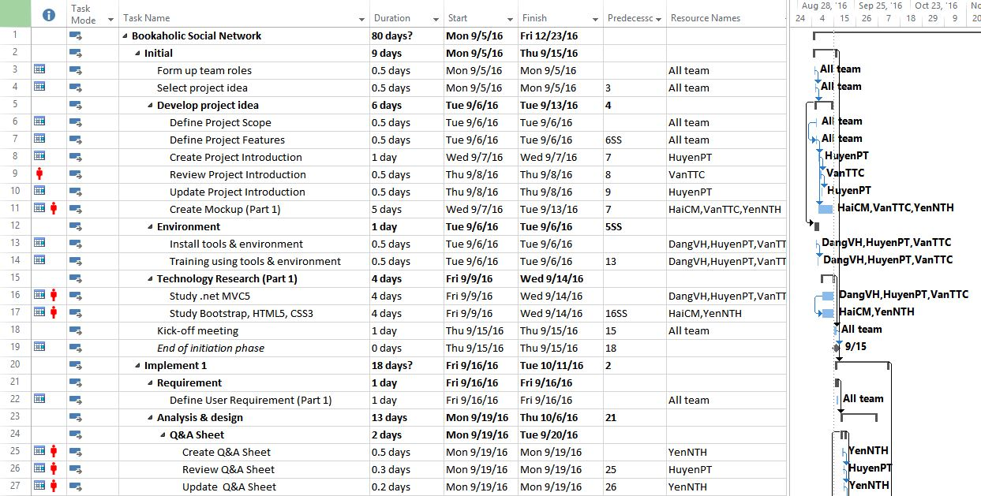

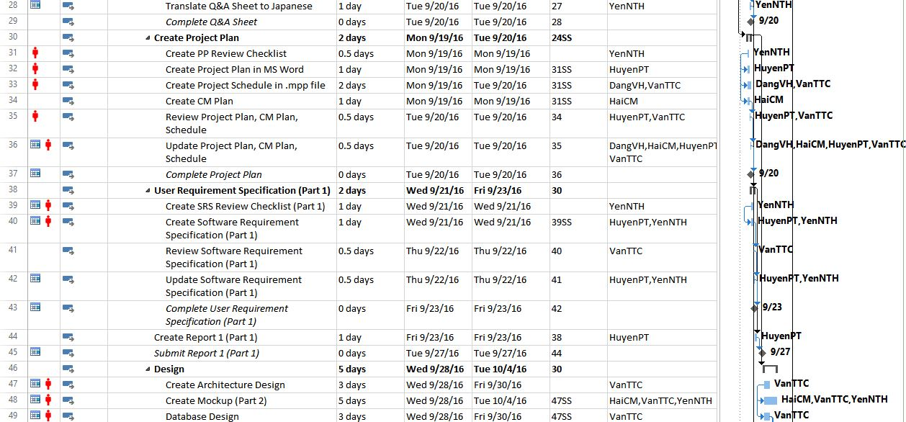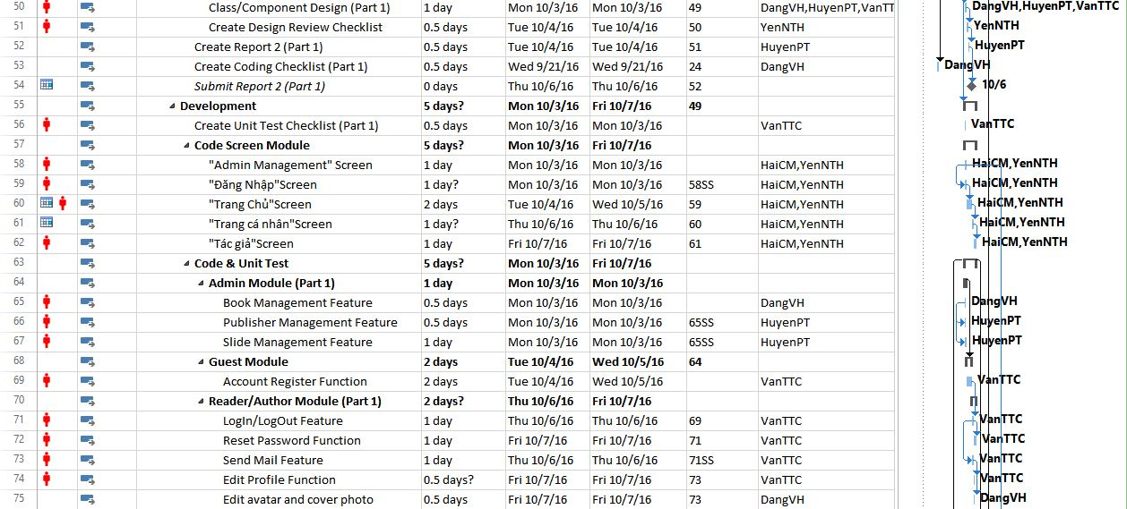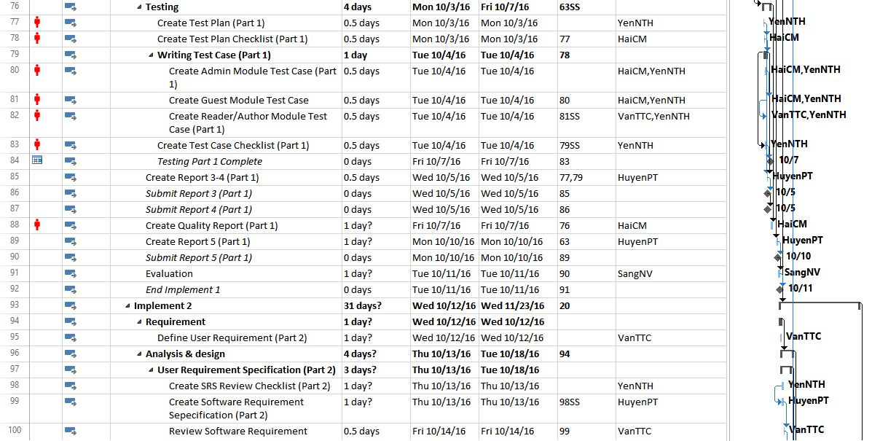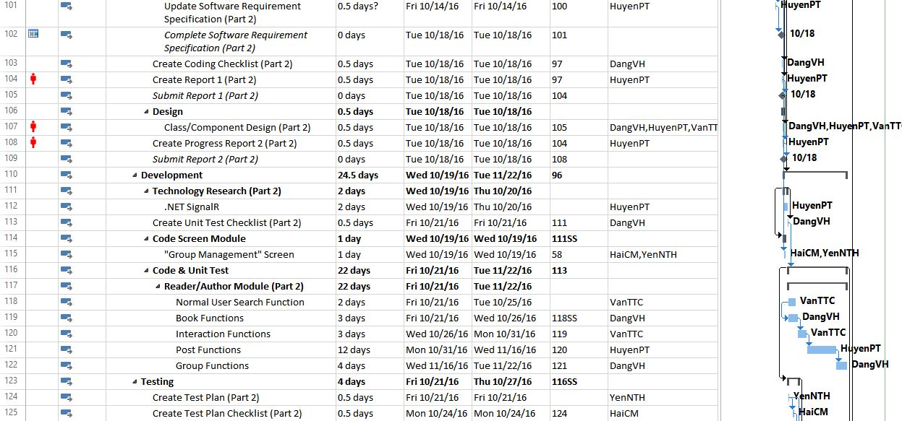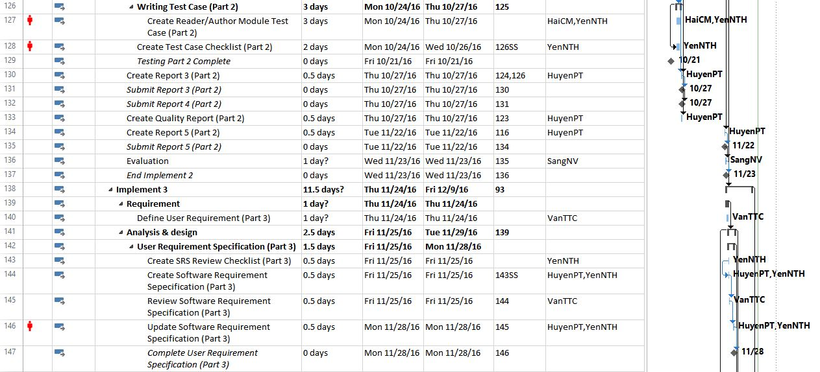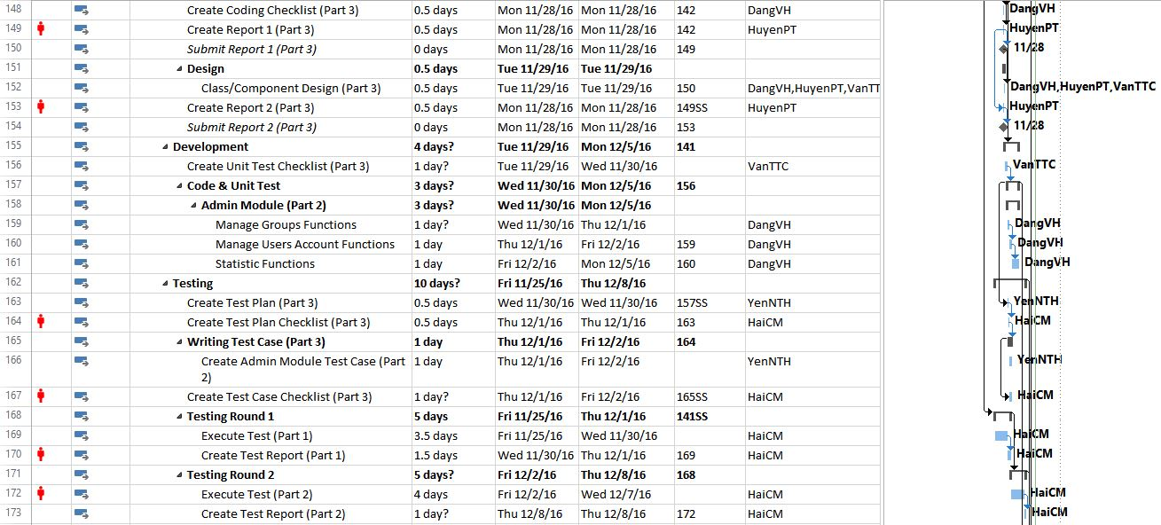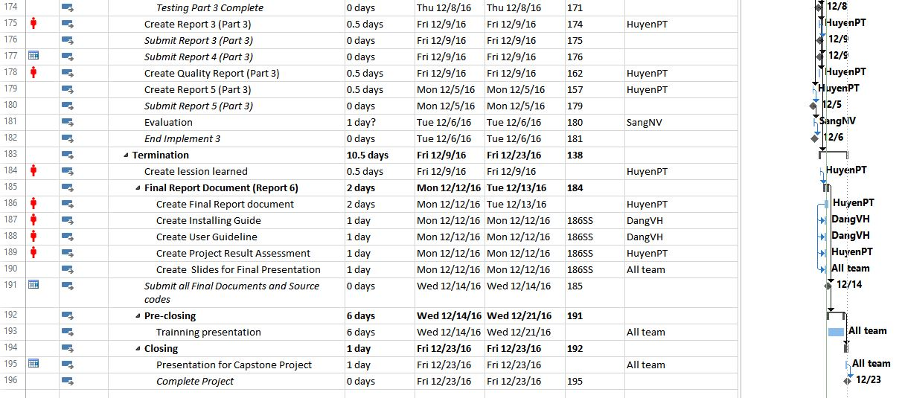

Project Schedule

### Resource

Specified as in the section 2.5.2 Project Team

### Infrastructure

|  |  |  |  |
| --- | --- | --- | --- |
| Item | Description | Expected Availability by | Note |
| **Development Environment** | | | |
| Operating System | Window 10 (32 bit, 64 bit) | All stages |  |
| Browser | Chrome (50 or above) | All stages |  |
| IDE | Visual Studio 2013 | Development and Testing stage |  |
| **Technology** | | | |
| Development language | C#, HTML, CSS, JavaScript |  |  |
| Development Framework | ASP .net MVC5, Bootstrap |  |  |
| Database | MongoDB | Development and Testing stage |  |
| **Hardware Requirement** | | | |
| Hardware Configuration | 2GB workspaces on server | All stages |  |
| **Equipment & Tools** | | | |
| Source Version Control | GitHub | Development and Testing stage |  |
| Task Tracking | MS Project Professional 2013 | Initiation stage |  |
| Document | Microsoft Office Word 2013, Microsoft Office Excel 2013 | All stage |  |
| Diagram | Microsoft Office Visio 2013,  Astah Professional | All stages |  |
| Mockup | Balsamiq Mockups 3.4.4 | Designing stage |  |
| Design | Brackets | Designing stage |  |

Figure 2‑2: Infrastructure

### Training Plan

|  |  |  |  |
| --- | --- | --- | --- |
| Training Area | Participants | Duration | Waiver Criteria |
| **Technical** | | | |
| ASP .net MVC5 | DangVH  HuyenPT  VanTTC | 1 week | Mandatory |
| JQuery, Knockout | DangVH  HuyenPT | 1 week | Mandatory |
| Bootstrap | YenNTH  HaiCM | 1 week | For design team only |
| **Process** | | | |
| Quality system | All team | 3 hours | If is already trained. |
| Configuration management | All team | 2 hours | If is already trained. |
| Group review process | All team | 2 hours | If is already trained |
| Defect prevention | All team | 2 hours | Mandatory |

Trainging Plan

### Finance

This project is non-business. It is a Capstone Project at FPT University. Therefore, we do not need to estimate about finance.

## Project Organization

### Organization Structure

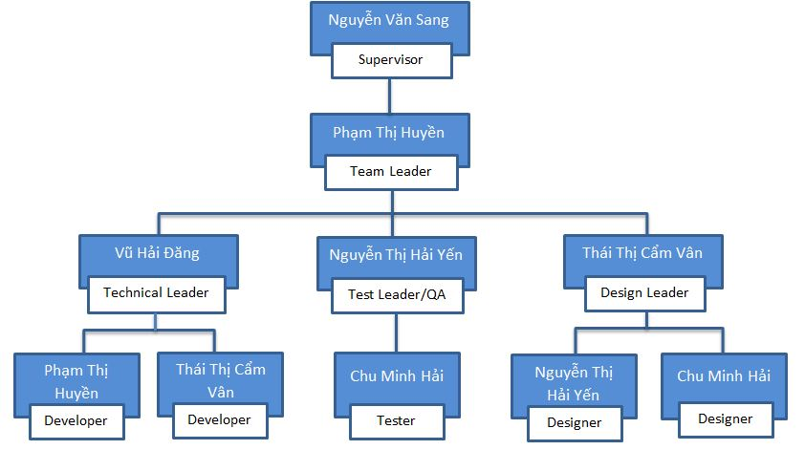

Figure 2‑3: Organization Structure

### Project Team

|  |  |  |  |  |  |
| --- | --- | --- | --- | --- | --- |
| Role | Responsibility | Full name | Effort (%) | Start date | End date |
| PM | Have overall responsibility of the project:  - Project planning and scheduling  - Task assignment and tracking processing  - Review documents  - Report to supervisor | Pham Thi Huyen | 50 | 09/05/2016 | 12/23/2016 |
| PTL | - PTL is responsible for the technical project execution  - Coding functions and modules of system  - Peer-review source code of others members | Vu Hai Dang | 100 | 09/05/2016 | 12/23/2016 |
| Programmer #1 | - Support studying technique  - Support coding functions and modules of system. | Pham Thi Huyen | 50 | 09/05/2016 | 12/23/2016 |
| Programmer #2 | - Support studying technique  - Support coding functions and modules of system. | Thai Thi Cam Van | 100 | 10/01/2016 | 12/23/2016 |
| Test Leader | - Create test plan, test case, test report, quality report  - Execute test. | Nguyen Thi Hai Yen | 100 | 10/30/2016 | 12/23/2016 |
| Tester | - Support creating test plan, test case, test report, quality report  - Execute test. | Chu Minh Hai | 100 | 10/30/2016 | 12/23/2016 |
| Design  Leader | - Create screen design  - Review design of others member | Thai Thi Cam Van | 100 | 09/05/2016 | 09/30/2016 |
| Designer #1 | - Support design screen  - Creating prototype | Nguyen Thi Hai Yen | 100 | 09/05/2016 | 10/30/2016 |
| Designer #1 | - Support design screen  - Creating prototype | Chu Minh Hai | 100 | 09/05/2016 | 10/30/2016 |

Project Team description

The detail of Human resource budget allocation over the whole project life is in the below table:

|  |  |  |  |  |  |
| --- | --- | --- | --- | --- | --- |
| Role | Responsibility | Full name | Effort (%) | Start date | End date |
| PM | Have overall responsibility of the project:  - Project planning and scheduling  - Task assignment and tracking processing  - Review documents  - Report to supervisor | Pham Thi Huyen | 50 | 09/05/2016 | 12/23/2016 |
| PTL | - PTL is responsible for the technical project execution  - Coding functions and modules of system  - Peer-review source code of others members | Vu Hai Dang | 100 | 09/05/2016 | 12/23/2016 |
| Programmer #1 | - Support studying technique  - Support coding functions and modules of system. | Pham Thi Huyen | 50 | 09/05/2016 | 12/23/2016 |
| Programmer #2 | - Support studying technique  - Support coding functions and modules of system. | Thai Thi Cam Van | 100 | 10/01/2016 | 12/23/2016 |
| Test Leader | - Create test plan, test case, test report, quality report  - Execute test. | Nguyen Thi Hai Yen | 100 | 10/30/2016 | 12/23/2016 |
| Tester | - Support creating test plan, test case, test report, quality report  - Execute test. | Chu Minh Hai | 100 | 10/30/2016 | 12/23/2016 |
| Design  Leader | - Create screen design  - Review design of others member | Thai Thi Cam Van | 100 | 09/05/2016 | 09/30/2016 |
| Designer #1 | - Support design screen  - Creating prototype | Nguyen Thi Hai Yen | 100 | 09/05/2016 | 10/30/2016 |
| Designer #1 | - Support design screen  - Creating prototype | Chu Minh Hai | 100 | 09/05/2016 | 10/30/2016 |

Human Resource Budget Allocation

## Communication & Reporting

|  |  |  |  |  |
| --- | --- | --- | --- | --- |
| Communication Type | Method/Tool | When | Information | Participants/ Responsible |
| **Project Task Tracking** | | | | |
| Task scheduling | MS Project Professional 2013 | - At the beginning of every stage, and weekly  - Refinement and rescheduling as necessary |  | PM |
| Task assignment | MS Project Professional 2013 | Weekly |  | PTL |
| Task status reporting | Daily Report | Daily |  | Project Team members |
| **Project Meeting** | | | | |
| Kick-off Meeting | Face to face | Initiation stage | - Project introduction  - Project plan review  - Risk identification  - Stakeholders identify | PM, Project Team Members |
| Project Progress Review Meetings | Face to face | Weekly and on event | - Discus about project status  - Discus and resolve any open issue, risks, and changes  - Discuss any suggested improvement | PM, Project Team Members |
| Milestone Meetings | Face to face | 2 days after the completion of each stages:  - Initial  - Implement 1  - Implement 2  - Implement 3  - Termination | - Project objective review  - Evaluate project performance (quality, schedule, effort)  - Causal analysis  - Update project plan for next stage | PM, Project Team Members, QA, Supervisor |
| **Supervisor Communication and Reporting:** | | | | |
| Transfer/Sharing of project documentation/information | GitHub | When available | All project documentation and information | PM, Project Team Members |
| Project Report | Agreed FPT Software and FU standard format | Weekly | - Project status report  - Issue requiring clarifications | PM |
| Project Meetings with supervisor | Face to face | 12h45 Wednesday, Weekly | As above | PM, Project Team Members |
| Requirement gathering/clarification | Face to face meeting or by email | During requirement analysis phase | As in Q&A list | PM |
| Review Project Plan & Project schedule | Face to face meeting | Significant changes to WO, PP and Project schedule (scope, objectives Organization, HR, major milestone, deliverables ) |  | PM |
| Project Progress Review | Face to face meeting or by email | Weekly | - Project status report  - Issue requiring clarifications | PM |
| Project Milestone Review | By email and via project milestone review meeting | The end of each phases | - Project objective review  - Evaluate project performance (quality, schedule, effort)  - Causal analysis  - Update project plan for next stage | PM |

Communication and Reporting Plan

# SOFTWARE REQUIREMENT

## Introduction

### Purpose

This document is created as the introduction for project Bookaholic Social Network – our Capstone Project at FPT University. In this document, we provide the describing of general requirement and non-functional requirements. These requirements will assure that the system will correctly and reliably perform its intended functionality. This specification will provide general, as well as specific requirements to be used in the design, testing and validation of the system. It is intended for both stakeholders and the project team of the system.

### Definitions and Acronyms

|  |  |  |
| --- | --- | --- |
| **Acronym** | **Definition** | **Note** |
| BSN | Bookaholic Social Network |  |
| SRS | Software Requirements Specifications |  |
| UC | Use Case |  |

Definition and Acronyms

## User Requirement Specification

### Business Process Overview

#### Approve/Suspend workflow



Approve/Suspend workflow

Brief description: Admin can use this function. Steps:

* Step 1: User click on projects list.
* Step 2: System return projects list page.
* Step 3: User click on button view
* Step 4: System return project detail page.
* Step 5: User click on button Approved/Suspended
* Step 6: System return success message or error message.
* Step 7: System return projects list page.

#### Activate/Deactivate workflow



Activate/Deactivate workflow

Brief description: Admin can use this function. Steps:

* Step 1: User click on users list.
* Step 2: System return users list page.
* Step 3: User click on button view a user
* Step 4: System return user profile page.
* Step 5: User click on button Activate/Deactivate
* Step 6: System return success message or error message.
* Step 7: System return users list page.

#### Add category workflow



Add category workflow

Brief description: Admin can use this function. Steps:

* Step 1: User click on Category.
* Step 2: System return category page.
* Step 3: User click on button new category
* Step 4: System return dialog “Add New Category”.
* Step 5: User fill information and click “Add”
* Step 6: System return success message or error message.
* Step 7: System return category page.

#### Add slider workflow



Add slider workflow

Brief description: Admin can use this function. Steps:

* Step 1: User click on Slider.
* Step 2: System return slider page.
* Step 3: User click on button new slider.
* Step 4: System return dialog “Add New Slider”.
* Step 5: User fill information and click “Add”
* Step 6: System return success message or error message.
* Step 7: System return slider page.

#### Sent message workflow



Sent message workflow

Brief description: Admin or user can use this function. Steps:

* Step 1: User click on Message.
* Step 2: System return message page.
* Step 3: User click on “new message” button.
* Step 4: System return dialog “New Message”.
* Step 5: User fill information and click “Sent”
* Step 6: System return success message or error message.
* Step 7: System return message page.

#### Register workflow



Register workflow

Brief description: Guest can use this function. Steps:

* Step 1: User click register.
* Step 2: System return register page.
* Step 3: User fill all required fields and click Register or press Enter.
* Step 4: System return complete message.
* Step 5: System send confirm mail to user’s entered email.

#### Search workflow



Search workflow

Brief description: Guest and Member can use this function. Steps:

* Step 1: User input keyword into search text box and click Search or press Enter
* Step 2: System return search results or message if nothing found.
* Step 3: User can click returned results to view.

#### Comment workflow



Comment workflow

Brief description: Member can use this function. Steps:

* Step 1: User click on a project.
* Step 2: System return Project information page.
* Step 3: User click on comment tab.
* Step 4: System show comment tab.
* Step 5: User fill comment box.
* Step 6: User click sent.

#### Back a project workflow



Back a project workflow

Brief description: Guest and Member can use this function. Steps:

* Step 1: User click on a project.
* Step 2: System return Project information page.
* Step 3: User click on button back.
* Step 4: System return Back page.
* Step 5: User choose back level then click continue.
* Step 6: System return Backer information page.
* Step 7: User fill all fields then click submit.

#### Create a project workflow



Create a project workflow

Brief description: Member can use this function. Steps:

* Step 1: User click on start button.
* Step 2: System return Create page.
* Step 3: User choose type and country then click start.
* Step 4: System return Basic page.
* Step 5: User fill all the fields then click submit.
* Step 6: System return Backer information page.

#### Remind a project workflow



Remind a project workflow

Brief description: Member can use this function. Steps:

* Step 1: User click on “Remind this project” button.
* Step 2: System return success message or error message.
* Step 3: System return Project Detail page.

#### Report a project workflow



Report a project workflow

Brief description: Member can use this function. Steps:

* Step 1: User click on report button.
* Step 2: System return “Report project” dialog.
* Step 3: User fill information and click “Sent”
* Step 4: System return success message or error message.
* Step 5: System return project detail page.

### Product Features

DDL is a website, user only connect to internet to use website. System provides these main functions:

#### Guest features

* **Register:** Guests can register for an account to use features of our system.

#### Client features

* **Login/Logout:** After register for an account, user can login as a registered user and use almost functions of our system.
* **Profile :**
  + Reset password**:** User can reset password when forgot password.
  + Update profile: Edit personal information includes name, email, address, date of birth, etc.
* **Search:** User can search book/user/group and system will display search results relate to keywords
* **Group :**
  + Create new group: User can create new group and they have to tag a book/author as the topic of that group.
  + Update group information**:** User can update information ofgroup such as name, type of group, etc.
  + Post in group**:** Users can post in group that they are members to follow and discuss with other users.
  + Report **:** User can report group which violate regulation to administration
  + Join group : User can send request to join group
* **Book :**
  + Rate book**:** User can rate book with 1 to 5 stars.
  + Comment**:** User can comment on book
  + Request add book **:** User can send request add book to administration
* **Post :**
  + Create new post : User can create post with book tag
  + Like/Unlike post :User can like or unlike post
  + Comment on post :User can comment on post
  + Edit/Delete post : User can edit post’s content or delete post
* **Interaction:**
  + Follow other user: User can follow other user
  + Receive notification: User can receive notification when someone like or comment on their post.

#### Admin features

* **Manage users :** 
  + Ban/Unban users: Admin can ban or unban user’s account
  + Accept/Decline request about creating an author account : Admin can accept or decline request create author account
  + Decline request about reporting an account
* **Manage Groups :**
  + Ban/Unban groups: Admin can active or de-active a group.
  + Decline request about reporting group
* **Manage Books :**
  + Add new Book/Category/Author: Admin can add new book, author or category.
  + Edit Book’s information: Admin can change or update book’s information
  + Accept add-book request: Admin can accept request add book from client
  + Decline add-book request: Admin can decline request add book from client
* **Manage Slides:**
  + Add new slides: Admin can add new slide
  + Delete slides: Admin can delete slide
  + Active/De-active slides: Admin can set slide’s status
* **Manage Publishers:**
  + Add new publishers: Admin can add new publisher
  + Edit publisher’s information: Admin can change or update publisher’s information
* **Statistic:**
  + View User/Author/Group/Book Statistic: Admin can view statistic about User,Author,Group,Book

### User characteristic

BSN website aim towards to anyone loves books and looking for a website to share their thought and make friends with other readers. Below are main actors that our system supports:

* **Guest:** Users who have not created an account, they can use functions such as: register for a normal account or register for an author account.
* **Readers & Authors:** Users who have account on system, they can use almost functions of website. For example: searching, posting, rating, connect to friends, etc.
* **Administrators:** They have an administrator control panel to manage all configurations of system

### Functional Requirements

#### Register Function

**Access right: Guest**

This function is used to by guest. Guest can register account and use it to login or logout to use BSN’s features.

#### Discover Book

**Access right: Reader and Author**

This function is used to view an overview of book. The system will display over view of book include image, book’s content, rating, comment, books relate.

#### Create Post

**Access right: Reader and Author**

This function is used to create new post. The system will display a create book with book tag and them user enter input to create a post.

#### Search Function

**Access right: Reader and Author**

This function is used to search user/book/group/. The system will display a search box for user to search.

#### Create Group

**Access right: Reader and Author**

This function is used create group about author or book. The system will display a create group for user. In this screen, users can create group, tag author or book and select group type.

#### Send Request Add Book

**Access right: Reader and Author**

This function is used to send request add book to admintrastion. The system will display a add book request screen. In this screen, users can enter input and send request.

#### Rating Book

**Access right: Reader and Author**

This function is used to rate a book. The system will display start as a book’s rate and user can click to rate.

#### Interaction

**Access right: Reader and Author**

This function is used to follow other account or group. The system will display icon for user to follow other account or group.

#### Create Report

**Access right: Reader and Author**

This function is used to create report other account or group. The system will display icon for user to click and report other account or group.

#### Management User’s Account

**Access right: Administrator**

This function is used to management user’s account. The system will display a Management Account Screen. In this screen, admin can view information about account, status of account and handing request create author account.

#### Management Groups

**Access right: Administrator**

This function is used to management group. The system will display management group screen. In this screen, admin can view information about group’s information and group such as the number of member, admin group, number of created group, etc.

#### Management Books

**Access right: Administration**

This function is used to management book. The system will display management book screen. In this screen, admin can add a new book/category/author and handling request add book.

#### Management Slide

**Access right: Administration**

This function is used to management slide. The system will display management slide screen. In this screen, admin can add/active/de-active slide.

#### Management Publisher

**Access right: Administration**

This function is used to management publisher. The system will display management publisher screen. In this screen, admin can add/edit/delete publisher.

### Non-functional Requirement

The system has to satisfy these principles:

* **Learnable**: The user interface must be easy to learn, even at the first time looking at the screen, user may immediately understand the function of each button or icon.
* **Efficiency**: The user interface must minimize the number of steps that the system takes to complete its task.
* **Memorable**: System contains some complex screens. Therefore, interface should be easier to use each time the user interacts with it.
* **Visibility**: Important information (example: text in nodes) should be clearly visible.
* **Consistency**: Like items should always be displayed and act the same way through the entire application.
* **Easy to maintain and upgrade**
* **Ensure data security capabilities, high performance**
* **Scalability system**

## Software Requirements Specification

### Overall Description

#### Product Features

|  |  |  |  |
| --- | --- | --- | --- |
| **Use Case No.** | **Group of functions** | **Functions** | **Glossary** |
| **GUEST MODULE** | | | |
| **UC001** | Register | Register for a normal account | Register for a normal account (reader) |
| **UC002** | Register for an author account | Register for an author account: User must upload an image of their identity card and wait for approve from admin of website. |
| **READER/AUTHOR MODULE** | | | |
| **UC003** | Account | Login | Login by registered account |
| **UC004** | Logout | Logout |
| **UC005** | Edit personal information | Edit personal information includes name, email, address, date of birth. |
| **UC006** | Edit avatar and cover photo | Edit avatar and cover photo |
| **UC007** | Reset password | Reset password by confirm an auto email. |
| **UC008** | Post | Create a post | Create a post to introduce about book(s). User has to tag book(s) as the topic of that post. |
| **UC009** | Edit a post | Edit caption and book tags of a created post. |
| **UC010** | Delete a post | Delete posts |
| **UC011** | Like a post | Like posts |
| **UC012** | Unlike a post | Unlike posts |
| **UC013** | Comment on a post | Comment on a post |
| **UC014** | Delete a comment | Delete comments |
| **UC015** | Interaction | Follow user account | Follow other account to get their new post on new-feed. |
| **UC016** | Report user account | Report other accounts. |
| **UC017** | Send join-group request | Send join-group request. After that, users have to wait admin of that group to add them as members. |
| **UC018** | Leave a group | Members can leave a group themselves. |
| **UC019** | Report a group | Report groups. |
| **UC020** | Get Notification | Users get notification when: + Other users like their post + Other users comment on their post + Other users follow their account |
| **UC021** | Group | Create a group | To create a group, users have to tag a book/author as the topic of that group. |
| **UC022** | Edit group information | Edit group profile |
| **UC023** | Edit group's avatar/cover photo |  |
| **UC024** | Add new members | Add new members by enter account name. |
| **UC025** | Accept join-group request | Users can send a request to group and admin have right to accept them as members or not. |
| **UC026** | Set group's admin | Set other members in group as admins. |
| **UC027** | Remove a member | Admins of a group van remove other members from their group. |
| **UC028** | Create a group post | Create group posts: Members do not need to tag books or authors. |
| **UC029** | Like a group post |  |
| **UC030** | Edit a group post | Edit group posts. |
| **UC031** | Delete a group post | Delete group posts. |
| **UC032** | Comment on a group post |  |
| **UC033** | Delete comment on a group post |  |
| **UC034** | Book | Rate a book | Rate a book: the highest score is 5 stars. |
| **UC035** | Comment on a book | Comment about book in its own details page |
| **UC036** | View a book's details | View details about a book: image, description, rating and comments of readers about that book. |
| **UC037** | Search book/author/other account/group | Search book/author/other account/group |
| **UC038** | View suggested books/authors | BSN system suggests books/authors base on the trend of reading: + Book: by access times + Author: by number of followers |
| **ADMIN MODULE** | | | |
| **UC039** | User Accounts Management | Search user | Search user |
| **UC040** | Ban user | If an account is reported, admin of page has right to ban that account of decline the reporting request. |
| **UC041** | Unban user | Unban user |
| **UC042** | Decline request about reporting an account | If an account is reported, admin of page has right to ban that account of decline the reporting request. |
| **UC043** | Accept request about creating author account |  |
| **UC044** | Decline request about creating author account | Accept/decline request about creating author account from guests. |
| **UC045** | Groups Management | Band a group | When a group is reported, admin of page can band it. |
| **UC046** | Unban a group | Unban a group |
| **UC047** | Decline request about reporting a group |  |
| **UC048** | Books Management | Add a new book | Add new books. |
| **UC049** | Add a new Category | Add new Categories. |
| **UC050** | Add an author | Add Authors |
| **UC051** | Edit book's information | Edit book's information |
| **UC052** | Accept add-book request |  |
| **UC053** | Decline add-book request | Approve/decline requests about adding a book |
| **UC054** | Sliders Management | Add a new slider | Add new sliders to introduce about website. |
| **UC055** | Delete a slider | Delete sliders. |
| **UC056** | Active/de-active a slider | Active/de-active slides. |
| **UC057** | Show a slider | Display sliders on the login page. |
| **UC058** | Publishers Management | Add a new publisher | Add new publishers |
| **UC059** | Edit publisher' information | Edit publishers' information |
| **UC060** | Delete a publisher | Delete publisher |
| **UC061** | Statistics | View user statistic | View statistic about users: + number of old accounts + number of new accounts |
| View author statistic | View statistic about authors: + number of old accounts + number of new accounts + authors with largest number of followers |
| View group statistic | View statistic about groups: + number of old groups + number of new groups |
| View book statistic | View statistic about books: + number of old books + number of new books + the book in trend: base on number of access time |

Table 3‑1: List of Product Features

#### User Characteristics

BSN website aim towards to anyone loves books and looking for a website to share their thought and make friends with other readers. Below are main actors that our system supports:

* **Guest:** Users who have not created an account, they can use functions such as: register for a normal account or register for an author account.
* **Readers & Authors:** Users who have account on system, they can use almost functions of website. For example: searching, posting, rating, connect to friends, etc.
* **Administrators:** They have an administrator control panel to manage all configurations of system

### Functional Specification

#### Business Rules

|  |  |
| --- | --- |
| No | Description |
| B1 | Email must content characters ‘@’ and ‘.’ |
| B2 | Authors must have CMND photo. |
| B3 | Allowed file extension: .jpg, .png |
| B4 | The tag book must be attached when user posting a new post. |
| B5 | Displayed date is dd/mm/yyyy format |
| B6 | Date time input format is datetime |

Table 3‑2: Bussiness Rules

#### Guest Module

##### Register

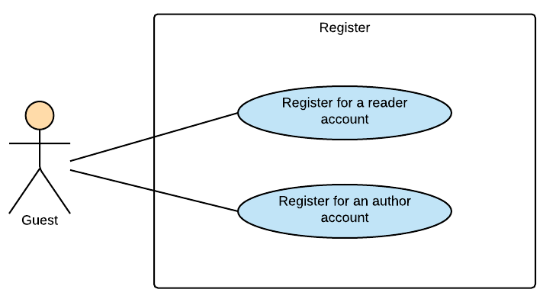

Figure 3‑1: Guest Module - Register

###### UC001-Register for a normal account

Use Case Specification - Normal flow

|  |  |  |  |  |
| --- | --- | --- | --- | --- |
| **Use Case ID** | | UC001 | **Version** | 1.0 |
| **Use Case Name** | | Register for a normal account | | |
| **Created by:** | | HaiCM | **Date Created:** | 09/16/2016 |
| **Primary Actor** | | Guest | **Secondary Actor** | N/A |
| **Description:** | | This function allow guests to register for a normal account (reader account) | | |
| **Preconditions:** | | 1. Guest are viewing Login-register page  2. Enter information in register form | | |
| **Trigger:** | | Click on “Đăng ký” button on the website | | |
| **Post conditions:** | | Confirm mail has sent to guest’s email. | | |
| **Normal Flow** | | | | |
| **Step** | **Actor** | **Action** | | |
| 1 | User | Enter BSN website | | |
| 2 | BSN | Display Login-register page includes:   * Email textbox * Password textbox * Login button: “Đăng nhập” * Forgot password hyperlink: “Bạn quên?” * Account name textbox on register form * Email textbox on register form * Password textbox on register form * Author registers hyperlink: “Tác giả đăng ký”   Sign up button: “Đăng ký” | | |
| 3 | User | Enter information in register form on website | | |
| 4 | User | Click “Đăng ký” button | | |
| 5 | BSN | Send confirm email | | |
| 6 | User | Follow guide in confirm email | | |
| 7 | BSN | Confirm account | | |
| 8 | BSN | Redirects user to Login-register page | | |
| **Priority** | | High | | |
| **Frequency of Use:** | | High | | |
| **Business Rules:** | | B1 | | |
| **Other Information:** | | N/A | | |

Alternative Flows and Exceptions

|  |  |  |  |  |
| --- | --- | --- | --- | --- |
| **Alternative Flows:** | | | | |
| **AT1** | At step 4 in the main flows, if user click other hyperlinks or buttons | | | |
| **Step** | **Actor** | | **Action** | |
| 4.1 | BSN | | Redirects user to chosen hyperlink or button | |
| **Exceptions:** | | | | |
| **EC1** | | At step 4, required fields are not entered | | |
| **Step** | | **Actor** | | **Action** |
| 4.1 | | BSN | | Display Login-register page with message: with MS01 |
| 4.1 | | BSN | | Mark error fields |
|  | |  | |  |
| **EC2** | | At step 4, fields are entered with wrong type of data | | |
| **Step** | | **Actor** | | **Action** |
| 4.1 | | BSN | | Display Login-register page with message: with MS01 |
| 4.2 | | BSN | | Mark error fields |

###### UC002-Register for an author account

Use Case Specification - Normal flow

|  |  |  |  |  |
| --- | --- | --- | --- | --- |
| **Use Case ID** | | UC002 | **Version** | 1.0 |
| **Use Case Name** | | Register for an author account | | |
| **Created by:** | | HaiCM | **Date Created:** | 09/16/2016 |
| **Primary Actor** | | Guest | **Secondary Actor** | N/A |
| **Description:** | | This function allows guests to register for an author account. | | |
| **Preconditions:** | | 1. Display Author register page  2. Enter information in author register form | | |
| **Trigger:** | | Click on register button on the website | | |
| **Post conditions:** | | Confirm mail has sent to guest’s email | | |
| **Normal Flow** | | | | |
| **Step** | **Actor** | **Action** | | |
| 1 | User | Enter BSN website | | |
| 2 | User | Click “Tác giả đăng ký” hyperlink | | |
| 3 | BSN | Display Author register page includes:   * Email textbox * Password textbox * Login button: “Đăng nhập” * Forgot password hyperlink: “Bạn quên?” * Account name textbox on register form * Email textbox on register form * Password textbox on register form * Choose file button   - Sign up button: “Đăng ký” | | |
| 4 | User | Enter information in register form on website and upload an identification image | | |
| 5 | User | Click “Đăng ký” button | | |
| 6 | BSN | Send confirm email | | |
| 7 | User | Follow guide in confirm email | | |
| 8 | BSN | Confirm account | | |
| 9 | BSN | Redirects user to Login-register page | | |
| **Priority** | | High | | |
| **Frequency of Use:** | | High | | |
| **Business Rules:** | | B1 B2 B3 | | |
| **Other Information:** | | N/A | | |

Alternative Flows and Exceptions

|  |  |  |  |  |
| --- | --- | --- | --- | --- |
| **Alternative Flows:** | | | | |
| **AT1** | At step 5 in the main flows, if user click other hyperlinks or buttons | | | |
| **Step** | **Actor** | | **Action** | |
| 5.1 | BSN | | Redirects user to chosen hyperlink or button | |
|  | | | | |
| **Exceptions: N/A** | | | | |
| **EC1** | | At step 5, required fields are not entered | | |
| **Step** | | **Actor** | | **Action** |
| 5.1 | | BSN | | Display Login-register page with message: with MS01 – MS09 |
| 5.2 | | BSN | | Mark error fields |
|  | |  | |  |
| **EC2** | | At step 5, fields are entered with wrong type of data | | |
| **Step** | | **Actor** | | **Action** |
| 5.1 | | BSN | | Display Login-register page with message: with MS01 – MS09 |

#### Reader/Author Module

##### Account

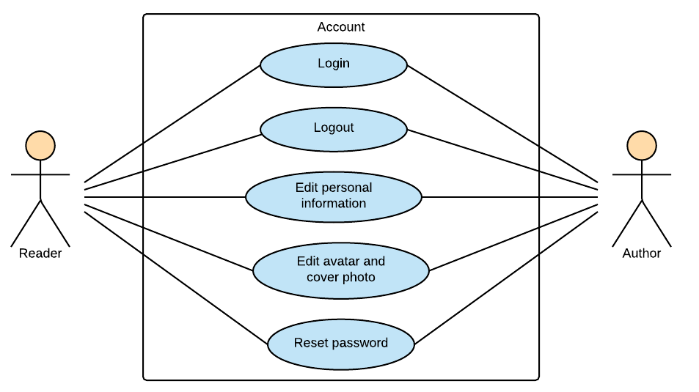

Figure 3‑2: Reader/Author Module - Account

###### UC003-Login

Use Case Specification - Normal flow

|  |  |  |  |  |
| --- | --- | --- | --- | --- |
| **Use Case ID** | | UC001 | **Version** | 1.0 |
| **Use Case Name** | | Login | | |
| **Created by:** | | HaiCM | **Date Created:** | 09/16/2016 |
| **Primary Actor** | | Registered User | **Secondary Actor** | N/A |
| **Description:** | | This function allows users to login system by registered account. | | |
| **Preconditions:** | | 1. Account must be existed.  2. Display login-register page. | | |
| **Trigger:** | | Click Login button (“Đăng nhập”) | | |
| **Post conditions:** | | 1. Validate account success  2. Display home page as reader or author’s interface. | | |
| **Normal Flow** | | | | |
| **Step** | **Actor** | **Action** | | |
| 1 | User | Enter BSN location on browser | | |
| 2 | BSN | Display login-register page includes:   * Email textbox * Password textbox * Login button: “Đăng nhập” * Forgot password hyperlink: “Bạn quên?” * Account name textbox on register form * Email textbox on register form * Password textbox on register form * Confirm password textbox on register form * Author register hyperlink: “Tác giả đăng ký”   Sign up button: “Đăng ký” | | |
| 3 | User | Enters email and password | | |
| 4 | User | Click “Đăng nhập” button | | |
| 5 | BSN | Logs user into system | | |
| 6 | BSN | Display home page as normal user or author’s interface. | | |
| **Priority** | | High | | |
| **Frequency of Use:** | | High | | |
| **Business Rules:** | | B1 | | |
| **Other Information:** | | N/A | | |

Alternative Flows and Exceptions

|  |  |  |  |  |  |  |
| --- | --- | --- | --- | --- | --- | --- |
| **Alternative Flows:** | | | | | | |
| **AT1** | At step 4 in the main flows, if user click other hyperlinks or buttons | | | | | |
| **Step** | **Actor** | | | **Action** | | |
| 4.1 | BSN | | | Redirects user to chosen hyperlink or button | | |
|  | | | | | | |
| **AT2** | | At step 4 in the main flows**,** if BSN failed to validate user name & password | | | | |
| **Step** | | **Actor** | | | **Action** | |
| 4.1 | | BSN | | | Display Login page with message MS01 MS02 | |
|  | | | | | | |
| **Exceptions:** | | | | | | |
| **EC1** | | | At step 3 in main flow, if user entered wrong email or password | | | |
| **Step** | | | **Actor** | | | **Action** |
| 3.1 | | | BSN | | | Display Login popup message with MS01 MS02 |

###### UC004-Logout

Use Case Specification - Normal flow

|  |  |  |  |  |
| --- | --- | --- | --- | --- |
| **Use Case ID** | | UC004 | **Version** | 1.0 |
| **Use Case Name** | | Logout | | |
| **Created by:** | | HaiCM | **Date Created:** | 09/16/2016 |
| **Primary Actor** | | Registered User | **Secondary Actor** | N/A |
| **Description:** | | This function allow user to log out system. | | |
| **Preconditions:** | | User logged in to system | | |
| **Trigger:** | | User click “Đăng xuất” on dropdown list from setting icon in navigation bar | | |
| **Post conditions:** | | 1. Log user out from system.  2. Display login-register page | | |
| **Normal Flow** | | | | |
| **Step** | **Actor** | **Action** | | |
| 1 | User | Click “Đăng xuất” button | | |
| 2 | BSN | Display login-register page | | |
| **Priority** | | High | | |
| **Frequency of Use:** | | High | | |
| **Business Rules:** | | N/A | | |
| **Other Information:** | | N/A | | |

Alternative Flows and Exceptions

|  |
| --- |
| **Alternative Flows: N/A** |
| **Exceptions: N/A** |

###### UC005-Edit personal Information

Use Case Specification - Normal flow

|  |  |  |  |  |
| --- | --- | --- | --- | --- |
| **Use Case ID** | | UC005 | **Version** | 1.0 |
| **Use Case Name** | | Edit personal Information | | |
| **Created by:** | | HaiCM | **Date Created:** | 09/16/2016 |
| **Primary Actor** | | Reader | **Secondary Actor** | Author |
| **Description:** | | This function allows users to edit personal information includes name, email, address, date of birth. | | |
| **Preconditions:** | | User logged in BSN website | | |
| **Trigger:** | | User click “Chỉnh sửa thông tin” hyperlink while in home page then click save button (“Lưu”) | | |
| **Post conditions:** | | Updated information display in edit profile page | | |
| **Normal Flow** | | | | |
| **Step** | **Actor** | **Action** | | |
| 1 | User | Click “Chỉnh sửa thông tin” hyperlink while in home page | | |
| 2 | BSN | Display Edit profile page includes:   * Navigation bar * User profile panel * Side bars   User’s information | | |
| 3 | BSN | Display user’s information and editable text box | | |
| 4 | User | Modifies fields | | |
| 5 | User | Click “Lưu” button | | |
| 6 | BSN | Display home page with updated information | | |
| **Priority** | | High | | |
| **Frequency of Use:** | | High | | |
| **Business Rules:** | | N/A | | |
| **Other Information:** | | N/A | | |

Alternative Flows and Exceptions

|  |  |  |  |  |
| --- | --- | --- | --- | --- |
| **Alternative Flows:** | | | | |
| **AT1** | At step 4 in the main flows, if user click other hyperlinks or buttons | | | |
| **Step** | **Actor** | | **Action** | |
| 4.1 | BSN | | Redirects user to chosen hyperlink or button | |
|  | | | | |
| **Exceptions:** | | | | |
| **EC1** | | At step 5, fields are entered with wrong type of data | | |
| **Step** | | **Actor** | | **Action** |
| 5.1 | | BSN | | Display Edit profile page with message: MS 07 |
| 5.2 | | BSN | | Mark error fields |
|  | |  | |  |
| **EC2** | | At step 5, fields are null | | |
| **Step** | | **Actor** | | **Action** |
| 5.1 | | BSN | | Disable “Lưu” button |

###### UC006-Edit avatar and cover photo

Use Case Specification - Normal flow

|  |  |  |  |  |
| --- | --- | --- | --- | --- |
| **Use Case ID** | | UC006 | **Version** | 1.0 |
| **Use Case Name** | | Edit avatar and cover photo | | |
| **Created by:** | | YenNTH | **Date Created:** | 09/16/2016 |
| **Primary Actor** | | Reader | **Secondary Actor** | Author |
| **Description:** | | This function allows users to edit their avatar and cover photo. | | |
| **Preconditions:** | | User logged in BSN website | | |
| **Trigger:** | | User click camera icon on the avatar or cover to edit avatar or cover photo | | |
| **Post conditions:** | | Avatar photo or cover photo is edited . | | |
| **Normal Flow** | | | | |
| **Step** | **Actor** | **Action** | | |
| 1 | Reader/Author | Click icon camera on the avatar or cover | | |
| 2 | BSN | Display form to choose avatar photo or cover photo | | |
| 3 | Reader/Author | Choose avatar photo or cover photo | | |
| 4 | BNS | Update avatar photo or cover photo | | |
| **Priority** | | High | | |
| **Frequency of Use:** | | High | | |
| **Business Rules:** | | B3 | | |
| **Other Information:** | | N/A | | |

Alternative Flows and Exceptions

|  |  |  |  |
| --- | --- | --- | --- |
| **Alternative Flows:** | | | |
| **AT1** | At step 3 in the main flows, if user click cancel | | |
| **Step** | **Actor** | **Action** | |
| 3.1 | BSN | | Form choose avatar photo or cover photo will be close |
| **AT2** | At step 3 in the main flows, if user choose file is not .jpg .png | | |
| **Step** | **Actor** | | **Action** |
| 3.1 | BSN | | Display message MS32 |
|  | | | |
| **Exceptions: N/A** | | | |

###### UC007-Reset password

Use Case Specification - Normal flow

|  |  |  |  |  |
| --- | --- | --- | --- | --- |
| **Use Case ID** | | UC007 | **Version** | 1.0 |
| **Use Case Name** | | Reset password | | |
| **Created by:** | | HaiCM | **Date Created:** | 09/16/2016 |
| **Primary Actor** | | Reader | **Secondary Actor** | Author |
| **Description:** | | This function allows users to reset their password through email. | | |
| **Preconditions:** | | 1. User’s account must be existed and correct.  2. User browsed BSN website | | |
| **Trigger:** | | Click “Bạn quên?” hyperlink in Login-register page | | |
| **Post conditions:** | | Reset password has sent to user’s email | | |
| **Normal Flow** | | | | |
| **Step** | **Actor** | **Action** | | |
| 1 | User | Click “Bạn quên?” hyperlink in Login-register page | | |
| 2 | BSN | Display reset password popup included:   * Email text box   “Gửi” and “Đóng” buttons | | |
| 3 | User | Enter registered email | | |
| 4 | User | Click “Gửi” button | | |
| 5 | BSN | Sends reset password email | | |
| 6 | BSN | Close popup | | |
| 7 | User | Follow guide in email | | |
| **Priority** | | High | | |
| **Frequency of Use:** | | High | | |
| **Business Rules:** | | N/A | | |
| **Other Information:** | | N/A | | |

Alternative Flows and Exceptions

|  |  |  |  |  |  |  |
| --- | --- | --- | --- | --- | --- | --- |
| **Alternative Flows:** | | | | | | |
| **AT1** | At step 3 in the main flow, user clicks on “Đóng” button | | | | | |
| **Step** | **Actor** | | | **Action** | | |
| 3.1 | BSN | | | Close pop-up | | |
|  | | | | | | |
| **AT2** | | At step 4 in the main flows, if user click other hyperlinks or buttons | | | | |
| **Step** | | **Actor** | | | **Action** | |
| 4.1 | | BSN | | | Redirects user to chosen hyperlink or button | |
|  | | | | | | |
| **Exceptions:** | | | | | | |
| **EC1** | | | At step 4, entered email is invalid or does not exist in databas | | | |
| **Step** | | | **Actor** | | | **Action** |
| 4.1 | | | BSN | | | Displays popup with message: with MS01 |

##### Post

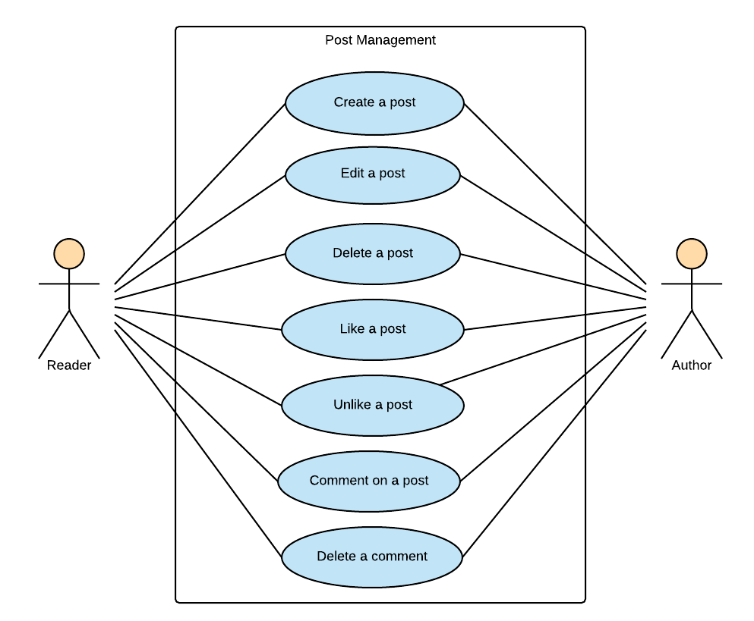

Figure 3‑3: Reader/Author Module-Post

###### UC008-Create a post

Use Case Specification - Normal flow

|  |  |  |  |  |
| --- | --- | --- | --- | --- |
| **Use Case ID** | | UC008 | **Version** | 1.0 |
| **Use Case Name** | | Create a post | | |
| **Created by:** | | HaiCM | **Date Created:** | 10/21/2016 |
| **Primary Actor** | | Reader | **Secondary Actor** | Author |
| **Description:** | | This function allows users to create a post to introduce about books. | | |
| **Preconditions:** | | User logged in BSN website | | |
| **Trigger:** | | Click “Đăng” button on recommendation area | | |
| **Post conditions:** | | New recommendation displays on home page or personal page | | |
| **Normal Flow** | | | | |
| **Step** | **Actor** | **Action** | | |
| 1 | User | Enter Home page or Personal page | | |
| 2 | User | Click text area and enter a recommendation | | |
| 3 | User | Click tag book | | |
| 4 | User | Input and enter book’s name or author’s name | | |
| 5 | BSN | Search book’s name or author’s name in database then show results | | |
| 6 | User | Choose a tag | | |
| 7 | User | Click “Đăng” button | | |
| 8 | BSN | Displays new recommendation on home page or personal page | | |
| **Priority** | | High | | |
| **Frequency of Use:** | | High | | |
| **Business Rules:** | | N/A | | |
| **Other Information:** | | N/A | | |

Alternative Flows and Exceptions

|  |  |  |  |  |
| --- | --- | --- | --- | --- |
| **Alternative Flows:** | | | | |
| **AT1** | At step 6 in the main flows, if user click other hyperlinks or buttons | | | |
| **Step** | **Actor** | | **Action** | |
| 6.1 | BSN | | Redirects user to chosen hyperlink or button | |
|  | | | | |
| **Exceptions:** | | | | |
| **EC1** | | At step 7, book’s tag does not chosen | | |
| **Step** | | **Actor** | | **Action** |
| 1 | | BSN | | Display viewing page with message: with MS19 |
| 2 | | BSN | | Mark error fields |
| **EC2** | | At step 5, BSN system cannot search any book or author | | |
| **Step** | | **Actor** | | **Action** |
| **1** | | BSN | | No data to display for the reader/author to choose |
| **2** | | BSN | | Mark error fields |

###### UC009-Edit a post

Use Case Specification - Normal flow

|  |  |  |  |  |
| --- | --- | --- | --- | --- |
| **Use Case ID** | | UC009 | **Version** | 1.0 |
| **Use Case Name** | | Edit a post | | |
| **Created by:** | | HaiCM | **Date Created:** | 10/21/2016 |
| **Primary Actor** | | User | **Secondary Actor** | N/A |
| **Description:** | | This function allows users to edit caption and book tags of a created post. | | |
| **Preconditions:** | | User is viewing their own recommendation | | |
| **Trigger:** | | Click “Sửa” hyperlink on angle-down icon at top-right of the post | | |
| **Post conditions:** | | Caption has changed | | |
| **Normal Flow** | | | | |
| **Step** | **Actor** | **Action** | | |
| 1 | User | Viewing personal’s recommendation | | |
| 2 | User | Click “Sửa” hyperlink on angle-down icon at top-right of the post | | |
| 3 | BSN | Display recommendation with text area and book’s tag editable | | |
| 4 | User | Modifies caption | | |
| 5 | User | Click “Đăng” button | | |
| 6 | BSN | Changes caption | | |
| **Exceptions:** | | | | |
| **Priority** | | High | | |
| **Frequency of Use:** | | High | | |
| **Business Rules:** | | N/A | | |
| **Other Information:** | | N/A | | |

Alternative Flows and Exceptions

|  |  |  |
| --- | --- | --- |
| **Alternative Flows:** | | |
| **AT1** | At step 4 in the main flows, if user click other hyperlinks or buttons | |
| **Step** | **Actor** | **Action** |
| 4.1 | BSN | Redirects user to chosen hyperlink or button |
| **AT1** | At step 5 in the main flows, if caption is null | |
| **Step** | **Actor** | **Action** |
| 5.1 | BSN | Disable “Đăng” button |
| **Exceptions: N/A** | | |

###### UC010-Delete a post

Use Case Specification - Normal flow

|  |  |  |  |  |
| --- | --- | --- | --- | --- |
| **Use Case ID** | | UC010 | **Version** | 1.0 |
| **Use Case Name** | | Delete a post | | |
| **Created by:** | | HaiCM | **Date Created:** | 10/21/2016 |
| **Primary Actor** | | User | **Secondary Actor** | N/A |
| **Description:** | | This function use to remove a recommendation | | |
| **Preconditions:** | | User is viewing their recommendation | | |
| **Trigger:** | | Click “Xóa” hyperlink on angle-down icon at top-right of the post | | |
| **Post conditions:** | | Recommendation has removed from home page or personal page | | |
| **Normal Flow** | | | | |
| **Step** | **Actor** | **Action** | | |
| 1 | User | Viewing personal’s recommendation | | |
| 2 | User | Click “Xóa” hyperlink on angle-down icon at top-right of the recommendation | | |
| 3 | BSN | Delete chosen post | | |
| 4 | BSN | Refresh viewing page in real-time | | |
| **Priority** | | High | | |
| **Frequency of Use:** | | High | | |
| **Business Rules:** | | N/A | | |
| **Other Information:** | | N/A | | |

Alternative Flows and Exceptions

|  |  |  |
| --- | --- | --- |
| **Alternative Flows:** | | |
| **AT1** | At step 2 in the main flows, if user click drop down list icon again | |
| **Step** | **Actor** | **Action** |
| 2.1 | BSN | Close drop down list |
| **Exceptions: N/A** | | |

###### UC011-Like a post

Use Case Specification - Normal flow

|  |  |  |  |  |
| --- | --- | --- | --- | --- |
| **Use Case ID** | | UC011 | **Version** | 1.0 |
| **Use Case Name** | | Like a post | | |
| **Created by:** | | HaiCM | **Date Created:** | 10/21/2016 |
| **Primary Actor** | | User | **Secondary Actor** |  |
| **Description:** | | This function allows user to like others’ post and their own post. | | |
| **Preconditions:** | | User logged in BSN website | | |
| **Trigger:** | | Click “Thích” button below a post | | |
| **Post conditions:** | | Display “Thích” button in liked status and number of “like” increase | | |
| **Normal Flow** | | | | |
| **Step** | **Actor** | **Action** | | |
| 1 | User | Viewing a post | | |
| 2 | User | Click “Like” button below caption | | |
| 3 | BSN | Display post has liked | | |
| **Priority** | | High | | |
| **Frequency of Use:** | | High | | |
| **Business Rules:** | | N/A | | |
| **Other Information:** | | N/A | | |

Alternative Flows and Exceptions

|  |
| --- |
| **Alternative Flows: N/A** |
| **Exceptions: N/A** |

###### UC012-Unlike a post

Use Case Specification - Normal flow

|  |  |  |  |  |
| --- | --- | --- | --- | --- |
| **Use Case ID** | | UC012 | **Version** | 1.0 |
| **Use Case Name** | | Unlike a post | | |
| **Created by:** | | YenNTH | **Date Created:** | 10/21/2016 |
| **Primary Actor** | | User | **Secondary Actor** | N/A |
| **Description:** | | This function allows user to unlike others’ post and their own post. | | |
| **Preconditions:** | | User logged in BSN website and post that user liked | | |
| **Trigger:** | | Click “Thích” button below a post | | |
| **Post conditions:** | | Display “Thích” button in liked status and number of “like” increase | | |
| **Normal Flow** | | | | |
| **Step** | **Actor** | **Action** | | |
| 1 | User | Viewing a post | | |
| 2 | User | Click “Like” button below caption | | |
| 3 | BSN | Display post has unliked | | |
| **Priority** | | High | | |
| **Frequency of Use:** | | High | | |
| **Business Rules:** | | N/A | | |
| **Other Information:** | | N/A | | |

Alternative Flows and Exceptions

|  |
| --- |
| **Alternative Flows: N/A** |
| **Exceptions: N/A** |

###### UC013-Comment on a post

Use Case Specification - Normal flow

|  |  |  |  |  |
| --- | --- | --- | --- | --- |
| **Use Case ID** | | UC013 | **Version** | 1.0 |
| **Use Case Name** | | Comment on a recommendation/ post | | |
| **Created by:** | | HuyenPT | **Date Created:** | 10/21/2016 |
| **Primary Actor** | | Reader | **Secondary Actor** | Author |
| **Description:** | | This function is used to comment on a recommendation/ post | | |
| **Preconditions:** | | User logged in BSN website | | |
| **Trigger:** | | Press enter button after enter a comment | | |
| **Post conditions:** | | Display comment below recommendation or post | | |
| **Normal Flow** | | | | |
| **Step** | **Actor** | **Action** | | |
| 1 | User | Click “Viết bình luận” text area below caption | | |
| 2 | User | Enter a comment | | |
| 3 | User | Click “Bình luận” button | | |
| 4 | BSN | Display recommendation or post with comment | | |
| **Priority** | | High | | |
| **Frequency of Use:** | | High | | |
| **Business Rules:** | | N/A | | |
| **Other Information:** | | N/A | | |

Alternative Flows and Exceptions

|  |
| --- |
| **Alternative Flows: N/A** |
| **Exceptions: N/A** |

###### UC014-Delete a comment

Use Case Specification - Normal flow

|  |  |  |  |  |
| --- | --- | --- | --- | --- |
| **Use Case ID** | | UC014 | **Version** | 1.0 |
| **Use Case Name** | | Delete a comment | | |
| **Created by:** | | HuyenPT | **Date Created:** | 10/21/2016 |
| **Primary Actor** | | Reader | **Secondary Actor** | Author |
| **Description:** | | This function use to edit a comment | | |
| **Preconditions:** | | User logged in BSN website | | |
| **Trigger:** | | Click “Xóa” hyperlink on icon at right of comment | | |
| **Post conditions:** | | Comment has deleted | | |
| **Normal Flow** | | | | |
| **Step** | **Actor** | **Action** | | |
| 1 | User | Click “Xóa” hyperlink on pencil icon at right of comment | | |
| 2 | BSN | Delete chosen post | | |
| 3 | BSN | Refresh viewing page in real-time | | |
| **Priority** | |  | | |
| **Frequency of Use:** | |  | | |
| **Business Rules:** | |  | | |
| **Other Information:** | |  | | |

Alternative Flows and Exceptions

|  |  |  |
| --- | --- | --- |
| **Alternative Flows:** | | |
| **AT1** | At step 1 in the main flows, if user click other hyperlinks or buttons | |
| **Step** | **Actor** | **Action** |
| 1.1 | BSN | Redirects user to chosen hyperlink or button |
| **Exceptions: N/A** | | |

##### Interaction

###### UC015-Follow user account

Use Case Specification - Normal flow

|  |  |  |  |  |
| --- | --- | --- | --- | --- |
| **Use Case ID** | | UC017 | **Version** | 1.0 |
| **Use Case Name** | | Follow user account | | |
| **Created by:** | | HuyenPT | **Date Created:** | 10/21/2016 |
| **Primary Actor** | | Reader | **Secondary Actor** | Author |
| **Description:** | | This function allows user can follows the other and get update their actions like: posting, etc. | | |
| **Preconditions:** | | User logged in BSN website | | |
| **Trigger:** | | Click “Theo dõi” button in another user’s personal page | | |
| **Post conditions:** | | Display “Theo dõi” button change to “Đã theo dõi” button | | |
| **Normal Flow** | | | | |
| **Step** | **Actor** | **Action** | | |
| 1 | User | Go to another user’s personal page | | |
| 2 | BSN | Display other’s personal page includes:   * Navigation bar * Personal panel * Side bars   Recommendation area | | |
| 3 | User | Click “Theo dõi” button in other’s personal panel | | |
| 4 | BSN | Display “Theo dõi” button change to “Đã theo dõi” button | | |
| **Priority** | | High | | |
| **Frequency of Use:** | | High | | |
| **Business Rules:** | | N/A | | |
| **Other Information:** | | N/A | | |

Alternative Flows and Exceptions

|  |  |  |
| --- | --- | --- |
| **Alternative Flows:** | | |
| **AT1** | At step 3 in the main flows, if user click other hyperlinks or buttons | |
| **Step** | **Actor** | **Action** |
| 3.1 | BSN | Redirects user to chosen hyperlink or button |
| **Exceptions: N/A** | | |

###### UC016-Report user account

Use Case Specification - Normal flow

|  |  |  |  |  |
| --- | --- | --- | --- | --- |
| **Use Case ID** | | UC016 | **Version** | 1.0 |
| **Use Case Name** | | Report user account | | |
| **Created by:** | | HuyenPT | **Date Created:** | 10/21/2016 |
| **Primary Actor** | | Reader | **Secondary Actor** | Author |
| **Description:** | | This function allows user report the other | | |
| **Preconditions:** | | User logged in BSN website | | |
| **Trigger:** | | Click “Báo cáo” button in another user’s personal page | | |
| **Post conditions:** | |  | | |
| **Normal Flow** | | | | |
| **Step** | **Actor** | **Action** | | |
| 1 | User | Go to another user’s personal page | | |
| 2 | BSN | Display other’s personal page includes:   * Navigation bar * Personal panel * Side bars   Recommendation area | | |
| 3 | User | Click “Báo cáo” button in other’s personal panel | | |
| 4 | BSN | Display popup with list of radio button includes:   * List of reasons   Text field to enter another reason | | |
| 5 | User | Choose a reason and click “Gửi” button | | |
| **Priority** | | High | | |
| **Frequency of Use:** | | High | | |
| **Business Rules:** | | N/A | | |
| **Other Information:** | | N/A | | |

Alternative Flows and Exceptions

|  |  |  |  |  |
| --- | --- | --- | --- | --- |
| **Alternative Flows:** | | | | |
| **AT1** | At step 2 in the main flows, if user click other hyperlinks or buttons | | | |
| **Step** | **Actor** | | **Action** | |
| 2.1 | BSN | | Redirects user to chosen hyperlink or button | |
| **AT2** | At step 4 in the main flows, if user click close icon | | | |
| **Step** | **Actor** | | **Action** | |
| 2.1 | BSN | | Redirects user to chosen hyperlink or button | |
| **Exceptions:** | | | | |
| **EC1** | | At step 5 in the main flows, if user want to report by enter another reason but text field is null | | |
| **Step** | | **Actor** | | **Action** |
| 5.1 | | BSN | | Disable “Gửi” button |

###### UC017-Send join-group request

Use Case Specification - Normal flow

|  |  |  |  |  |
| --- | --- | --- | --- | --- |
| **Use Case ID** | | UC017 | **Version** | 1.0 |
| **Use Case Name** | | Send join-group request | | |
| **Created by:** | | HuyenPT | **Date Created:** | 10/21/2016 |
| **Primary Actor** | | Reader | **Secondary Actor** | Author |
| **Description:** | | This function allows user send request to join a group | | |
| **Preconditions:** | | User logged in BSN website | | |
| **Trigger:** | | Click “Tham gia” button in group page | | |
| **Post conditions:** | | Display “Tham gia” button change to “Đã gửi yêu cầu” button | | |
| **Normal Flow** | | | | |
| **Step** | **Actor** | **Action** | | |
| 1 | User | Go to group page | | |
| 2 | BSN | Display group page includes:   * Navigation bar * Group’s panel * Side bars   Posts area | | |
| 3 | User | Click “Tham gia” button in group’s panel | | |
| 4 | BSN | Display “Tham gia” button change to “Đã gửi yêu cầu” button | | |
| **Priority** | | High | | |
| **Frequency of Use:** | | High | | |
| **Business Rules:** | | N/A | | |
| **Other Information:** | | N/A | | |

Alternative Flows and Exceptions

|  |  |  |
| --- | --- | --- |
| **Alternative Flows:** | | |
| **AT1** | At step 3 in the main flows, if user click other hyperlinks or buttons | |
| **Step** | **Actor** | **Action** |
| 3.1 | BSN | Redirects user to chosen hyperlink or button |
| **Exceptions: N/A** | | |

###### UC018-Leave a group

Use Case Specification - Normal flow

|  |  |  |  |  |
| --- | --- | --- | --- | --- |
| **Use Case ID** | | UC018 | **Version** | 1.0 |
| **Use Case Name** | | Leave a group | | |
| **Created by:** | | HuyenPT | **Date Created:** | 10/21/2016 |
| **Primary Actor** | | Reader | **Secondary Actor** | Author |
| **Description:** | | This function allows user out a group | | |
| **Preconditions:** | | 1. User logged in BSN website 2. User joined a group | | |
| **Trigger:** | | Click “Rời nhóm” button in group page | | |
| **Post conditions:** | | Display “Rời nhóm” button change to “Tham gia” button | | |
| **Normal Flow** | | | | |
| **Step** | **Actor** | **Action** | | |
| 1 | User | Go to group page | | |
| 2 | BSN | Display group page includes:   * Navigation bar * Group’s panel * Side bars   Posts area | | |
| 3 | User | Click “Rời nhóm” button in group’s panel | | |
| 4 | BSN | Display “Rời nhóm” button change to “Tham gia” button | | |
| **Priority** | | High | | |
| **Frequency of Use:** | | High | | |
| **Business Rules:** | | N/A | | |
| **Other Information:** | | N/A | | |

Alternative Flows and Exceptions

|  |
| --- |
| **Alternative Flows: N/A** |
| **Exceptions: N/A** |

###### UC019-Report a group

Use Case Specification - Normal flow

|  |  |  |  |  |
| --- | --- | --- | --- | --- |
| **Use Case ID** | | UC019 | **Version** | 1.0 |
| **Use Case Name** | | Report a group | | |
| **Created by:** | | HuyenPT | **Date Created:** | 10/21/2016 |
| **Primary Actor** | | Reader | **Secondary Actor** | Author |
| **Description:** | | This function allows user report a group | | |
| **Preconditions:** | | 1. User logged in BSN website 2. User joined a group | | |
| **Trigger:** | | Click “Báo cáo” button in group page | | |
| **Post conditions:** | |  | | |
| **Normal Flow** | | | | |
| **Step** | **Actor** | **Action** | | |
| 1 | User | Go to group page | | |
| 2 | BSN | Display other’s personal page includes:   * Navigation bar * Group’s panel * Side bars   Posts area | | |
| 3 | User | Click “Báo cáo” button in group’s panel | | |
| 4 | BSN | Display popup with list of radio button includes:   * List of reasons   Text field to enter another reason | | |
| 5 | User | Choose a reason and click “Gửi” button | | |
| **Priority** | | High | | |
| **Frequency of Use:** | | High | | |
| **Business Rules:** | | N/A | | |
| **Other Information:** | | N/A | | |

Alternative Flows and Exceptions

|  |  |  |  |  |
| --- | --- | --- | --- | --- |
| **Alternative Flows:** | | | | |
| **AT1** | At step 2 in the main flows, if user click other hyperlinks or buttons | | | |
| **Step** | **Actor** | | **Action** | |
| 2.1 | BSN | | Redirects user to chosen hyperlink or button | |
| **AT2** | At step 4 in the main flows, if user click close icon | | | |
| **Step** | **Actor** | | **Action** | |
| 4.1 | BSN | | Close popup | |
|  | | | | |
| **Exceptions:** | | | | |
| **EC1** | | At step 5 in the main flows, if user want to report by enter another reason but text field is null | | |
| **Step** | | **Actor** | | **Action** |
| 5.1 | | BSN | | Disable “Gửi” button |

###### UC020-Get notification

Use Case Specification - Normal flow

|  |  |  |  |  |
| --- | --- | --- | --- | --- |
| **Use Case ID** | | UC020 | **Version** | 1.0 |
| **Use Case Name** | | Get notification | | |
| **Created by:** | | HuyenPT | **Date Created:** | 10/21/2016 |
| **Primary Actor** | | Reader | **Secondary Actor** | Author |
| **Description:** | | This function allows user know about all activities related to that user | | |
| **Preconditions:** | | Login the BSN website | | |
| **Trigger:** | | Click bell icon in the navbar | | |
| **Post conditions:** | | Display notification | | |
| **Normal Flow** | | | | |
| **Step** | **Actor** | **Action** | | |
| 1 | User | Click bell icon in the navbar | | |
| 2 | BSN | Display notification | | |
| **Alternative Flows: N/A** | | | | |
| **Exceptions: N/A** | | | | |
| **Priority** | | High | | |
| **Frequency of Use:** | | High | | |
| **Business Rules:** | | N/A | | |
| **Other Information:** | | N/A | | |

Alternative Flows and Exceptions

|  |
| --- |
| **Alternative Flows: N/A** |
| **Exceptions: N/A** |

##### Group

###### UC021-Create a group

Use Case Specification - Normal flow

|  |  |  |  |  |
| --- | --- | --- | --- | --- |
| **Use Case ID** | | UC021 | **Version** | 1.0 |
| **Use Case Name** | | Create a group | | |
| **Created by:** | | HuyenPT | **Date Created:** | 10/21/2016 |
| **Primary Actor** | | Reader | **Secondary Actor** | Author |
| **Description:** | | This function allows user create a group | | |
| **Preconditions:** | | User logged in BSN website | | |
| **Trigger:** | | Click “Tạo nhóm” hyperlink in home page | | |
| **Post conditions:** | | New group has created | | |
| **Normal Flow** | | | | |
| **Step** | **Actor** | **Action** | | |
| 1 | User | Go to home page | | |
| 2 | BSN | Display home page includes:   * Navigation bar * Side bars   Posts area | | |
| 3 | User | Click “Tạo nhóm” button in home page | | |
| 4 | BSN | Display popup includes:   * Group name text box | | |
| 5 | User | Enter information and click “Tạo” button | | |
| **Priority** | | High | | |
| **Frequency of Use:** | | High | | |
| **Business Rules:** | | N/A | | |
| **Other Information:** | | N/A | | |

Alternative Flows and Exceptions

|  |  |  |  |  |
| --- | --- | --- | --- | --- |
| **Alternative Flows:** | | | | |
| **AT1** | At step 2 in the main flows, if user click other hyperlinks or buttons | | | |
| **Step** | **Actor** | | **Action** | |
| 2.1 | BSN | | Redirects user to chosen hyperlink or button | |
| **AT1** | At step 2 in the main flows, if user click other hyperlinks or buttons | | | |
| **Step** | **Actor** | | **Action** | |
| 4.1 | BSN | | Close popup | |
|  | | | | |
| **Exceptions:** | | | | |
| **EC1** | | At step 5 in the main flows, if any text box is null | | |
| **Step** | | **Actor** | | **Action** |
| 5.1 | | BSN | | Disable “Tạo” button |

###### UC022-Edit group information

Use Case Specification - Normal flow

|  |  |  |  |  |
| --- | --- | --- | --- | --- |
| **Use Case ID** | | UC022 | **Version** | 1.0 |
| **Use Case Name** | | Edit group information | | |
| **Created by:** | | HuyenPT | **Date Created:** | 10/21/2016 |
| **Primary Actor** | | Reader | **Secondary Actor** | Author |
| **Description:** | | This function allows user to edit group profile | | |
| **Preconditions:** | | User logged in BSN website | | |
| **Trigger:** | | Click “Cài đặt” button in group page then click “Lưu” button after change group’s information | | |
| **Post conditions:** | | Display updated group’s information | | |
| **Normal Flow** | | | | |
| **Step** | **Actor** | **Action** | | |
| 1 | User | Go to group page | | |
| 2 | BSN | Display group page includes:   * Navigation bar * Group’s panel * Side bars   Posts area | | |
| 3 | User | Click “Cài đặt” button in home page | | |
| 4 | BSN | Display edit group profile page includes:   * Navigation bar * Group’s panel * Side bar   Information area | | |
| 5 | User | Enter information and click “Lưu” button | | |
| 6 | BSN | Display updated group’s information | | |
| **Priority** | | High | | |
| **Frequency of Use:** | | High | | |
| **Business Rules:** | | N/A | | |
| **Other Information:** | | N/A | | |

Alternative Flows and Exceptions

|  |  |  |  |  |
| --- | --- | --- | --- | --- |
| **Alternative Flows:** | | | | |
| **AT1** | At step 2 in the main flows, if user click other hyperlinks or buttons | | | |
| **Step** | **Actor** | | **Action** | |
| 2.1 | BSN | | Redirects user to chosen hyperlink or button | |
|  | | | | |
| **Exceptions:** | | | | |
| **EC1** | | At step 5 in the main flows, if any text box is null | | |
| **Step** | | **Actor** | | **Action** |
| 5.1 | | BSN | | Show the corresponding error message |
| **EC2** | | At step 5 in the main flows, if any text box is entered wrong type of data | | |
| **Step** | | **Actor** | | **Action** |
| **5.1** | | BSN | | Show the corresponding error message |

###### UC023-Edit group’s avatar and cover photo

Use Case Specification - Normal flow

|  |  |  |  |  |
| --- | --- | --- | --- | --- |
| **Use Case ID** | | UC023 | **Version** | 1.0 |
| **Use Case Name** | | Edit group’s avatar and cover photo | | |
| **Created by:** | | HuyenPT | **Date Created:** | 10/21/2016 |
| **Primary Actor** | | Reader | **Secondary Actor** | Author |
| **Description:** | | This function allow admin of group edit cover and avatar photo | | |
| **Preconditions:** | | Go to group page | | |
| **Trigger:** | | Click on name of group | | |
| **Post conditions:** | | Avatar or cover photo of group is edited | | |
| **Normal Flow** | | | | |
| **Step** | **Actor** | **Action** | | |
| 1 | User | Go to group page | | |
| 2 | BSN | Display group page | | |
| 3 | User | 1. Click to camera icon to edit avatar and cover photo . 2. Choose photo | | |
| 4 | BSN | Update avatar and cover photo | | |
| **Priority** | | High | | |
| **Frequency of Use:** | | High | | |
| **Business Rules:** | | B3 | | |
| **Other Information:** | | N/A | | |

Alternative Flows and Exceptions

|  |  |  |  |  |
| --- | --- | --- | --- | --- |
| **Alternative Flows:** | | | | |
| **AT1** | At step 3 in the main flows, if user click other hyperlinks or buttons | | | |
| **Step** | **Actor** | | **Action** | |
| 3.1 | BSN | | Redirects user to chosen hyperlink or button | |
| **Exceptions:** | | | | |
| **EC1** | | At step 3 in the main flows, if photo is not .jpg, .png | | |
| **Step** | | **Actor** | | **Action** |
| 3.1 | | BSN | | Display message MS32 |

###### UC024-Add new member

Use Case Specification - Normal flow

|  |  |  |  |  |
| --- | --- | --- | --- | --- |
| **Use Case ID** | | UC024 | **Version** | 1.0 |
| **Use Case Name** | | Add new member | | |
| **Created by:** | | HuyenPT | **Date Created:** | 10/21/2016 |
| **Primary Actor** | | Reader | **Secondary Actor** | Author |
| **Description:** | | This function allows user as an admin of group to add new member by enter account name | | |
| **Preconditions:** | | 1. User logged in BSN website 2. User is an admin of group | | |
| **Trigger:** | |  | | |
| **Post conditions:** | | New member has added in group | | |
| **Normal Flow** | | | | |
| **Step** | **Actor** | **Action** | | |
| 1 | User | Go to group page | | |
| 2 | BSN | Display group page includes:   * Navigation bar * Group’s panel * Side bars   Posts area | | |
| 3 | BSN | Display list account name | | |
| 4 | User | Choose an account name | | |
| 5 | BSN | Add new member in group | | |
| **Priority** | | High | | |
| **Frequency of Use:** | | High | | |
| **Business Rules:** | | N/A | | |
| **Other Information:** | | N/A | | |

Alternative Flows and Exceptions

|  |  |  |
| --- | --- | --- |
| **Alternative Flows:** | | |
| **AT1** | At step 4 in the main flows, if BSN system cannot search any account name | |
| **Step** | **Actor** | **Action** |
| 4.1 | BSN | Display “Không tìm được người dùng” message |
| **Exceptions: N/A** | | |

###### UC025-Accept join-group request

Use Case Specification - Normal flow

|  |  |  |  |  |
| --- | --- | --- | --- | --- |
| **Use Case ID** | | UC025 | **Version** | 1.0 |
| **Use Case Name** | | Accept join-group request | | |
| **Created by:** | | HuyenPT | **Date Created:** | 10/21/2016 |
| **Primary Actor** | | Reader | **Secondary Actor** | Author |
| **Description:** | | This function allows user as an admin of group to add new member by accept their request | | |
| **Preconditions:** | | 1. User logged in BSN website 2. User is an admin of group | | |
| **Trigger:** | |  | | |
| **Post conditions:** | | New member has added in group | | |
| **Normal Flow** | | | | |
| **Step** | **Actor** | **Action** | | |
| 1 | User | Go to group page | | |
| 2 | BSN | Display group page includes:   * Navigation bar * Group’s panel * Side bars   Posts area | | |
| 3 | User | Click “Cài đặt” button, then click “Yêu cầu tham gia” tab | | |
| 4 | BSN | Display list join-request | | |
| 5 | User | Accept one or many request | | |
| 6 | BSN | Add new member in group | | |
| **Priority** | | High | | |
| **Frequency of Use:** | | High | | |
| **Business Rules:** | | N/A | | |
| **Other Information:** | | N/A | | |

Alternative Flows and Exceptions

|  |
| --- |
| **Alternative Flows: N/A** |
| **Exceptions: N/A** |

###### UC026-Set group’s admin

Use Case Specification - Normal flow

|  |  |  |  |  |
| --- | --- | --- | --- | --- |
| **Use Case ID** | | UC026 | **Version** | 1.0 |
| **Use Case Name** | | Set group’s admin | | |
| **Created by:** | | HuyenPT | **Date Created:** | 10/21/2016 |
| **Primary Actor** | | Reader | **Secondary Actor** | Author |
| **Description:** | | This function allows user as an admin of group to set other be an admin | | |
| **Preconditions:** | | 1. User logged in BSN website 2. User is an admin of group | | |
| **Trigger:** | | Click “Thêm với tư cách quản lí” hyperlink on dropdown list in config icon in “Thành viên” tab | | |
| **Post conditions:** | | “Quản trị viên” sub-tab has new admin | | |
| **Normal Flow** | | | | |
| **Step** | **Actor** | **Action** | | |
| 1 | User | Go to group page | | |
| 2 | BSN | Display group page includes:   * Navigation bar * Group’s panel * Side bars   Posts area | | |
| 3 | User | Click “Thêm với tư cách quản lí” hyperlink on dropdown list in config icon in “Thành viên” tab | | |
| 4 | BSN | “Quản trị viên” sub-tab has new admin | | |
| **Priority** | | High | | |
| **Frequency of Use:** | | High | | |
| **Business Rules:** | | N/A | | |
| **Other Information:** | | N/A | | |

Alternative Flows and Exceptions

|  |
| --- |
| **Alternative Flows: N/A** |
| **Exceptions: N/A** |

###### UC027-Remove a member

Use Case Specification - Normal flow

|  |  |  |  |  |
| --- | --- | --- | --- | --- |
| **Use Case ID** | | UC027 | **Version** | 1.0 |
| **Use Case Name** | | Remove a member | | |
| **Created by:** | | HuyenPT | **Date Created:** | 10/21/2016 |
| **Primary Actor** | | Reader | **Secondary Actor** | Author |
| **Description:** | | This function allows user as an admin of group to remove member out of group | | |
| **Preconditions:** | | 1. User logged in BSN website 2. User is an admin of group | | |
| **Trigger:** | | Click “Xóa khỏi nhóm” hyperlink on dropdown list in config icon in “Thành viên” tab | | |
| **Post conditions:** | | Number of members has decreased | | |
| **Normal Flow** | | | | |
| **Step** | **Actor** | **Action** | | |
| 1 | User | Go to group page | | |
| 2 | BSN | Display group page includes:   * Navigation bar * Group’s panel * Side bars   Posts area | | |
| 3 | User | Click “Xóa khỏi nhóm” hyperlink on dropdown list in config icon in “Thành viên” tab | | |
| 4 | BSN | Remove member and decrease number of members | | |
| **Priority** | | High | | |
| **Frequency of Use:** | | High | | |
| **Business Rules:** | | N/A | | |
| **Other Information:** | | N/A | | |

Alternative Flows and Exceptions

|  |
| --- |
| **Alternative Flows: N/A** |
| **Exceptions: N/A** |

###### UC028-Create group post

Use Case Specification - Normal flow

|  |  |  |  |  |
| --- | --- | --- | --- | --- |
| **Use Case ID** | | UC028 | **Version** | 1.0 |
| **Use Case Name** | | Create group post | | |
| **Created by:** | | HuyenPT | **Date Created:** | 10/21/2016 |
| **Primary Actor** | | Reader | **Secondary Actor** | Author |
| **Description:** | | This function allow user create a group | | |
| **Preconditions:** | | User logged in BSN website | | |
| **Trigger:** | | Click "Tạo nhóm" on setting item in the navbar | | |
| **Post conditions:** | | Create group successfully | | |
| **Normal Flow** | | | | |
| **Step** | **Actor** | **Action** | | |
| 1 | User | Click “Tạo nhóm” on setting item | | |
| 2 | BSN | Display pop to create group | | |
| 3 | User | Input all information of group | | |
| 4 | User | Click “Thêm” button | | |
| 5 | BSN | Create new group | | |
| **Priority** | | High | | |
| **Frequency of Use:** | | High | | |
| **Business Rules:** | | N/A | | |
| **Other Information:** | | N/A | | |

Alternative Flows and Exceptions

|  |  |  |  |  |
| --- | --- | --- | --- | --- |
| **Alternative Flows:** | | | | |
| **AT1** | At step 4 in the main flows, if user click other hyperlinks or buttons | | | |
| **Step** | **Actor** | | **Action** | |
| 1 | BSN | | Redirects user to chosen hyperlink or button | |
| **Exceptions:** | | | | |
| **EC1** | | At step 4 in the main flows, if user don’t input and click “Thêm” button | | |
| **Step** | | **Actor** | | **Action** |
| 1 | | User | | Don’t input anything and click “Thêm” button |
| 2 | | BSN | | Display the corresponding message |

###### UC029-Like a group post

Use Case Specification - Normal flow

|  |  |  |  |  |
| --- | --- | --- | --- | --- |
| **Use Case ID** | | UC029 | **Version** | 1.0 |
| **Use Case Name** | | Like a group post | | |
| **Created by:** | | HuyenPT | **Date Created:** | 10/21/2016 |
| **Primary Actor** | | Reader | **Secondary Actor** | Author |
| **Description:** | | This function allow user like a post of group | | |
| **Preconditions:** | | 1. User logged in BSN website 2. As one member of the group or admin of group | | |
| **Trigger:** | | Click “Like” button below post | | |
| **Post conditions:** | | Number of like is increased | | |
| **Normal Flow** | | | | |
| **Step** | **Actor** | **Action** | | |
| 1 | User | Go to BSN website | | |
| 2 | User | Create a group or join group | | |
| 3 | User | Click “Like” button | | |
| 4 | BSN | Calculates and displays the total number of likes | | |
| **Priority** | | High | | |
| **Frequency of Use:** | | High | | |
| **Business Rules:** | | N/A | | |
| **Other Information:** | | N/A | | |

Alternative Flows and Exceptions

|  |  |  |
| --- | --- | --- |
| **Alternative Flows:** | | |
| **AT1** | At step 4 in the main flows, if user click other hyperlinks or buttons | |
| **Step** | **Actor** | **Action** |
| 1 | BSN | Redirects user to chosen hyperlink or button |
| **Exceptions: N/A** | | |

###### UC030-Edit group post

Use Case Specification - Normal flow

|  |  |  |  |  |
| --- | --- | --- | --- | --- |
| **Use Case ID** | | UC030 | **Version** | 1.0 |
| **Use Case Name** | | Edit group post | | |
| **Created by:** | | HuyenPT | **Date Created:** | 10/21/2016 |
| **Primary Actor** | | Reader | **Secondary Actor** | Author |
| **Description:** | | This function allow creators post edit group post | | |
| **Preconditions:** | | 1. User logged in BSN website 2. As creators post | | |
| **Trigger:** | | Click “Sửa” on the drop down list | | |
| **Post conditions:** | | Display all information of group to edit | | |
| **Normal Flow** | | | | |
| **Step** | **Actor** | **Action** | | |
| 1 | User | Go to BSN website | | |
| 2 | User | Click “Sửa” on drop down list | | |
| 3 | BSN | Display all information of group to edit | | |
| 4 | User | Edit information | | |
| 5 | User | Click “Lưu” button | | |
| 6 | BSN | Update information of group | | |
| **Priority** | | High | | |
| **Frequency of Use:** | | High | | |
| **Business Rules:** | | N/A | | |
| **Other Information:** | | N/A | | |

Alternative Flows and Exceptions

|  |  |  |  |  |
| --- | --- | --- | --- | --- |
| **Alternative Flows:** | | | | |
| **AT1** | At step 5 in the main flows, if user click other hyperlinks or buttons | | | |
| **Step** | **Actor** | | **Action** | |
| 1 | BSN | | Redirects user to chosen hyperlink or button | |
| **Exceptions:** | | | | |
| **EC1** | | At step 5 in the main flows , if the user enters name of group empty | | |
| **Step** | | **Actor** | | **Action** |
| 1 | | User | | Enter name of group empty |
| 2 | | BSN | | Display message MS18 |
| **EC2** | | At step 5 in the main flows , if the user enters name of group already exists | | |
| **Step** | | **Actor** | | **Action** |
| **1** | | User | | Enter name of group already exists |
| **2** | | BSN | | Display message MS31 |

###### UC031-Delete group post

Use Case Specification - Normal flow

|  |  |  |  |  |
| --- | --- | --- | --- | --- |
| **Use Case ID** | | UC031 | **Version** | 1.0 |
| **Use Case Name** | | Delete group post | | |
| **Created by:** | | HuyenPT | **Date Created:** | 10/21/2016 |
| **Primary Actor** | | Reader | **Secondary Actor** | Author |
| **Description:** | | This function allow creators post or admin of group edit group post | | |
| **Preconditions:** | | 1. User logged in BSN website 2. As creators post or admin of group | | |
| **Trigger:** | | Click “Xóa” on the drop down list | | |
| **Post conditions:** | | Post was deleted | | |
| **Normal Flow** | | | | |
| **Step** | **Actor** | **Action** | | |
| 1 | User | Go to BSN website | | |
| 2 | User | Click “Xóa” on drop down list | | |
| 3 | BSN | Delete group post | | |
| **Priority** | | High | | |
| **Frequency of Use:** | | High | | |
| **Business Rules:** | | N/A | | |
| **Other Information:** | | N/A | | |

Alternative Flows and Exceptions

|  |  |  |
| --- | --- | --- |
| **Alternative Flows:** | | |
| **AT1** | At step 2 in the main flows, if user click other hyperlinks or buttons | |
| **Step** | **Actor** | **Action** |
| 1 | BSN | Redirects user to chosen hyperlink or button |
| **Exceptions: N/A** | | |

###### UC032-Comment on a group post

Use Case Specification - Normal flow

|  |  |  |  |  |
| --- | --- | --- | --- | --- |
| **Use Case ID** | | UC032 | **Version** | 1.0 |
| **Use Case Name** | | Comment on a group post | | |
| **Created by:** | | HuyenPT | **Date Created:** | 10/21/2016 |
| **Primary Actor** | | Reader | **Secondary Actor** | Author |
| **Description:** | | This function allow user comment on a group post | | |
| **Preconditions:** | | 1. User logged in BSN website 2. As member of group | | |
| **Trigger:** | | Click textbox comment | | |
| **Post conditions:** | | Show comment on below the post | | |
| **Normal Flow** | | | | |
| **Step** | **Actor** | **Action** | | |
| 1 | User | Go to BSN website | | |
| 2 | User | Click comment textbox and enter content | | |
| 3 | User | Click “Đăng” button | | |
| 4 | BSN | Display comment | | |
| **Priority** | | High | | |
| **Frequency of Use:** | | High | | |
| **Business Rules:** | | N/A | | |
| **Other Information:** | | N/A | | |

Alternative Flows and Exceptions

|  |  |  |
| --- | --- | --- |
| **Alternative Flows:** | | |
| **AT1** | At step 3 in the main flows, if user click other hyperlinks or buttons | |
| **Step** | **Actor** | **Action** |
| 1 | BSN | Redirects user to chosen hyperlink or button |
| **Exceptions: N/A** | | |

###### UC033-Delete a comment on a group post

Use Case Specification - Normal flow

|  |  |  |  |  |
| --- | --- | --- | --- | --- |
| **Use Case ID** | | UC033 | **Version** | 1.0 |
| **Use Case Name** | | Delete a comment on a group post | | |
| **Created by:** | | HuyenPT | **Date Created:** | 10/21/2016 |
| **Primary Actor** | | Reader | **Secondary Actor** | Author |
| **Description:** | | This function allow user delete comment of post | | |
| **Preconditions:** | | 1. User logged in BSN website 2. As commentator or creator’s post | | |
| **Trigger:** | | Click “Xóa” icon | | |
| **Post conditions:** | | The comment was deleted | | |
| **Normal Flow** | | | | |
| **Step** | **Actor** | **Action** | | |
| 1 | User | Go to BSN website | | |
| 2 | User | Click “Xóa” button | | |
| 3 | BSN | Comment was deleted | | |
| **Priority** | | High | | |
| **Frequency of Use:** | | High | | |
| **Business Rules:** | | N/A | | |
| **Other Information:** | | N/A | | |

Alternative Flows and Exceptions

|  |
| --- |
| **Alternative Flows: N/A** |
| **Exceptions: N/A** |

##### Book

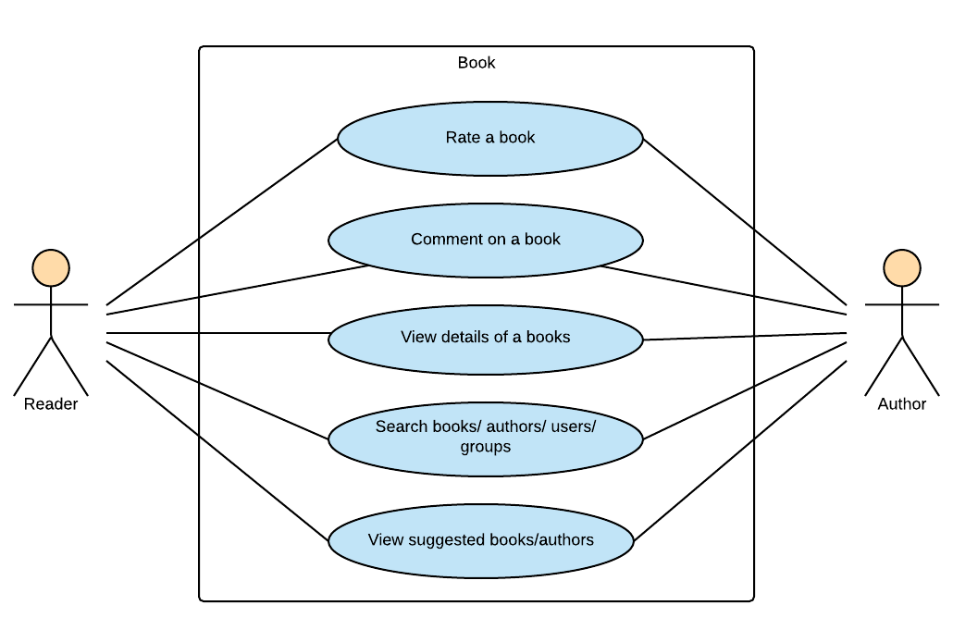

Figure 3‑6: Reader/Author Module-Book

###### UC034-Rate a book

Use Case Specification - Normal flow

|  |  |  |  |  |
| --- | --- | --- | --- | --- |
| **Use Case ID** | | UC034 | **Version** | 1.0 |
| **Use Case Name** | | Rate a book | | |
| **Created by:** | | HuyenPT | **Date Created:** | 10/21/2016 |
| **Primary Actor** | | Reader | **Secondary Actor** | Author |
| **Description:** | | This function allows user to rate a book | | |
| **Preconditions:** | | User logged in BSN website | | |
| **Trigger:** | | Click rating stars | | |
| **Post conditions:** | | Display rating point updated and rating success message | | |
| **Normal Flow** | | | | |
| **Step** | **Actor** | **Action** | | |
| 1 | User | Enter a book’s page | | |
| 2 | BSN | Display a book’s page includes:   * Book’s image * Book’s information * Rating stars * Comment area   Right side bar | | |
| 3 | User | Click rating stars between 1 – 5 star to rate this book | | |
| 4 | BSN | Display rating point updated and rating success message | | |
| **Priority** | | High | | |
| **Frequency of Use:** | | High | | |
| **Business Rules:** | | N/A | | |
| **Other Information:** | | N/A | | |

Alternative Flows and Exceptions

|  |
| --- |
| **Alternative Flows: N/A** |
| **Exceptions: N/A** |

###### UC035-Comment on a book

Use Case Specification - Normal flow

|  |  |  |  |  |
| --- | --- | --- | --- | --- |
| **Use Case ID** | | UC035 | **Version** | 1.0 |
| **Use Case Name** | | Comment on a book | | |
| **Created by:** | | HuyenPT | **Date Created:** | 10/21/2016 |
| **Primary Actor** | | Reader | **Secondary Actor** | Author |
| **Description:** | | This function allows user to comment on a book | | |
| **Preconditions:** | | User logged in BSN website | | |
| **Trigger:** | | Press Enter in comment textbox | | |
| **Post conditions:** | | Display new comment | | |
| **Normal Flow** | | | | |
| **Step** | **Actor** | **Action** | | |
| 1 | User | Enter a book’s page | | |
| 2 | BSN | Display a book’s page includes:   * Book’s image * Book’s information * Rating stars * Comment area   Right side bar | | |
| 3 | User | Click on comment textbox and enter a comment then press Enter | | |
| 4 | BSN | Display new comment | | |
| **Priority** | | High | | |
| **Frequency of Use:** | | High | | |
| **Business Rules:** | | N/A | | |
| **Other Information:** | | N/A | | |

Alternative Flows and Exceptions

|  |  |  |
| --- | --- | --- |
| **Alternative Flows:** | | |
| **AT1** | At step 2 in the main flows, if user click other hyperlinks or buttons | |
| **Step** | **Actor** | **Action** |
| 2.1 | BSN | Redirects user to chosen hyperlink or button |
| **Exceptions: N/A** | | |

###### UC036-View book’s detail

Use Case Specification - Normal flow

|  |  |  |  |  |
| --- | --- | --- | --- | --- |
| **Use Case ID** | | UC036 | **Version** | 1.0 |
| **Use Case Name** | | View book’s detail | | |
| **Created by:** | | HuyenPT | **Date Created:** | 10/21/2016 |
| **Primary Actor** | | Reader | **Secondary Actor** | Author |
| **Description:** | | This function allows user to view book’s details | | |
| **Preconditions:** | | User logged in BSN website | | |
| **Trigger:** | | Click on “Xem thêm” hyperlink in book’s page | | |
| **Post conditions:** | | Display detail popup | | |
| **Normal Flow** | | | | |
| **Step** | **Actor** | **Action** | | |
| 1 | User | Enter a book’s page | | |
| 2 | BSN | Display a book’s page includes:   * Book’s image * Book’s information * Rating stars * Comment area   Right side bar | | |
| 3 | User | Click on “Xem thêm” hyperlink in book’s page | | |
| 4 | BSN | Display detail popup | | |
| **Priority** | | High | | |
| **Frequency of Use:** | | High | | |
| **Business Rules:** | | N/A | | |
| **Other Information:** | | N/A | | |

Alternative Flows and Exceptions

|  |  |  |
| --- | --- | --- |
| **Alternative Flows:** | | |
| **AT1** | At step 2 in the main flows, if user click other hyperlinks or buttons | |
| **Step** | **Actor** | **Action** |
| 2.1 | BSN | Redirects user to chosen hyperlink or button |
| **Exceptions: N/A** | | |

###### UC037-Search book/author/other account/group

Use Case Specification - Normal flow

|  |  |  |  |  |
| --- | --- | --- | --- | --- |
| **Use Case ID** | | UC037 | **Version** | 1.0 |
| **Use Case Name** | | Search book/ author/ other accounts | | |
| **Created by:** | | HuyenPT | **Date Created:** | 10/21/2016 |
| **Primary Actor** | | Reader | **Secondary Actor** | Author |
| **Description:** | | This function allows user to search book/ author/ other accounts | | |
| **Preconditions:** | | User logged in BSN website | | |
| **Trigger:** | | Enter book/ author/ other accounts into search textbox | | |
| **Post conditions:** | | Display suggest book/ author/ other accounts | | |
| **Normal Flow** | | | | |
| **Step** | **Actor** | **Action** | | |
| 1 | User | Enter a book’s page | | |
| 2 | BSN | Display a book’s page includes:   * Book’s image * Book’s information * Rating stars * Comment area   Right side bar | | |
| 3 | User | Click on comment textbox and enter a comment then press Enter | | |
| 4 | BSN | Display new comment | | |
| **Priority** | | High | | |
| **Frequency of Use:** | | High | | |
| **Business Rules:** | | N/A | | |
| **Other Information:** | | N/A | | |

Alternative Flows and Exceptions

|  |  |  |
| --- | --- | --- |
| **Alternative Flows:** | | |
| **AT1** | At step 2 in the main flows, if user click other hyperlinks or buttons | |
| **Step** | **Actor** | **Action** |
| 2.1 | BSN | Redirects user to chosen hyperlink or button |
| **Exceptions: N/A** | | |

###### UC038-View suggested book/author

Use Case Specification - Normal flow

|  |  |  |  |  |
| --- | --- | --- | --- | --- |
| **Use Case ID** | | UC038 | **Version** | 1.0 |
| **Use Case Name** | | View suggested book/author | | |
| **Created by:** | | HuyenPT | **Date Created:** | 10/21/2016 |
| **Primary Actor** | | Reader | **Secondary Actor** | Author |
| **Description:** | | This function allows user to view suggested book/ author | | |
| **Preconditions:** | | User logged in BSN website | | |
| **Trigger:** | | N/A | | |
| **Post conditions:** | | N/A | | |
| **Normal Flow** | | | | |
| **Step** | **Actor** | **Action** | | |
| 1 | User | Enter a BSN website | | |
| 2 | BSN | Display a home page includes:   * Navigation bar * Side bars with list of groups, suggested books and authors * Recommendation area   Newfeed | | |
| **Priority** | | High | | |
| **Frequency of Use:** | | High | | |
| **Business Rules:** | | N/A | | |
| **Other Information:** | | N/A | | |

Alternative Flows and Exceptions

|  |  |  |
| --- | --- | --- |
| **Alternative Flows:** | | |
| **AT1** | At step 2 in the main flows, if user click other hyperlinks or buttons | |
| **Step** | **Actor** | **Action** |
| 2.1 | BSN | Redirects user to chosen hyperlink or button |
| **Exceptions: N/A** | | |

#### Admin Module

##### User Accounts Management

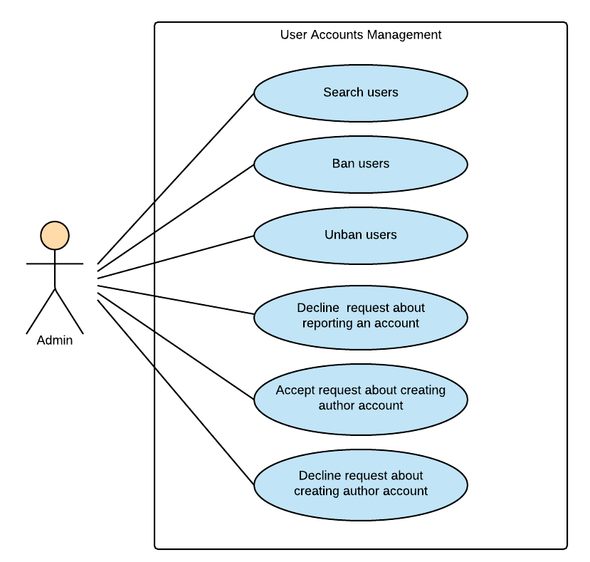

Figure 3‑7: Admin Module-User Accounts Management

###### UC039-Search user

Use Case Specification - Normal flow

|  |  |  |  |  |
| --- | --- | --- | --- | --- |
| **Use Case ID** | | UC039 | **Version** | 1.0 |
| **Use Case Name** | | Search user | | |
| **Created by:** | | HuyenPT | **Date Created:** | 10/21/2016 |
| **Primary Actor** | | Admin | **Secondary Actor** | N/A |
| **Description:** | | This function allow admin search user | | |
| **Preconditions:** | | Log in as admin | | |
| **Trigger:** | | Click search textbox | | |
| **Post conditions:** | |  | | |
| **Normal Flow** | | | | |
| **Step** | **Actor** | **Action** | | |
| 1 | Admin | Successful login as admin | | |
| 2 | Admin | Click search textbox | | |
| 3 | Admin | Enter name of user | | |
| 4 | BSN | Search and display the user | | |
| **Priority** | | High | | |
| **Frequency of Use:** | | High | | |
| **Business Rules:** | | N/A | | |
| **Other Information:** | | N/A | | |

Alternative Flows and Exceptions

|  |
| --- |
| **Alternative Flows: N/A** |
| **Exceptions: N/A** |

###### UC040-Ban user

Use Case Specification - Normal flow

|  |  |  |  |  |
| --- | --- | --- | --- | --- |
| **Use Case ID** | | UC040 | **Version** | 1.0 |
| **Use Case Name** | | Ban user | | |
| **Created by:** | | HuyenPT | **Date Created:** | 11/25/2016 |
| **Primary Actor** | | Admin | **Secondary Actor** | N/A |
| **Description:** | | This function allow ban user | | |
| **Preconditions:** | | Log in as admin | | |
| **Trigger:** | | Click ban button | | |
| **Post conditions:** | | User will be banned | | |
| **Normal Flow** | | | | |
| **Step** | **Actor** | **Action** | | |
| 1 | Admin | Successful login as admin | | |
| 2 | Admin | Click ban button | | |
| 3 | BSN | Ban users | | |
| **Priority** | | High | | |
| **Frequency of Use:** | | High | | |
| **Business Rules:** | | N/A | | |
| **Other Information:** | | N/A | | |

Alternative Flows and Exceptions

|  |
| --- |
| **Alternative Flows: N/A** |
| **Exceptions: N/A** |

###### UC041-Unban user

Use Case Specification - Normal flow

|  |  |  |  |  |
| --- | --- | --- | --- | --- |
| **Use Case ID** | | UC041 | **Version** | 1.0 |
| **Use Case Name** | | Unban user | | |
| **Created by:** | | HuyenPT | **Date Created:** | 11/25/2016 |
| **Primary Actor** | | Admin | **Secondary Actor** | N/A |
| **Description:** | | This function allow ban user | | |
| **Preconditions:** | | Log in as admin | | |
| **Trigger:** | | Click unban button | | |
| **Post conditions:** | | Unban users | | |
| **Normal Flow** | | | | |
| **Step** | **Actor** | **Action** | | |
| 1 | Admin | Successful login as admin | | |
| 2 | Admin | Click unban button | | |
| 3 | BSN | Unban users | | |
| **Priority** | | High | | |
| **Frequency of Use:** | | High | | |
| **Business Rules:** | | N/A | | |
| **Other Information:** | | N/A | | |

Alternative Flows and Exceptions

|  |
| --- |
| **Alternative Flows: N/A** |
| **Exceptions: N/A** |

###### UC043-Decline request reporting an account

Use Case Specification - Normal flow

|  |  |  |  |  |
| --- | --- | --- | --- | --- |
| **Use Case ID** | | UC0 | **Version** | 1.0 |
| **Use Case Name** | | Decline request reporting an account | | |
| **Created by:** | | HuyenPT | **Date Created:** | 11/25/2016 |
| **Primary Actor** | | Admin | **Secondary Actor** | N/A |
| **Description:** | | This function allow admin decline request reporting an account | | |
| **Preconditions:** | | Successful login as admin | | |
| **Trigger:** | | Click decline request button | | |
| **Post conditions:** | | Request will be declined | | |
| **Normal Flow** | | | | |
| **Step** | **Actor** | **Action** | | |
| 1 | Admin | Successful login as admin | | |
| 2 | Admin | Click decline request button | | |
| 3 | BSN | Decline request reporting an account | | |
| **Priority** | | High | | |
| **Frequency of Use:** | | High | | |
| **Business Rules:** | | N/A | | |
| **Other Information:** | | N/A | | |

Alternative Flows and Exceptions

|  |  |  |
| --- | --- | --- |
| **Alternative Flows:** | | |
| **AT1** | At step 2 in the main flows, if user click other hyperlinks or buttons | |
| **Step** | **Actor** | **Action** |
| 2.1 | BSN | Redirects user to chosen hyperlink or button |
| **Exceptions: N/A** | | |

###### UC043-Accept request creating author account

Use Case Specification - Normal flow

|  |  |  |  |  |
| --- | --- | --- | --- | --- |
| **Use Case ID** | | UC043 | **Version** | 1.0 |
| **Use Case Name** | | Accept request creating author account | | |
| **Created by:** | | HuyenPT | **Date Created:** | 11/25/2016 |
| **Primary Actor** | | Admin | **Secondary Actor** | N/A |
| **Description:** | | This function allow admin accept request creating author account | | |
| **Preconditions:** | | Successful login as admin | | |
| **Trigger:** | | Click accept button | | |
| **Post conditions:** | | Request creating author account will be accepted | | |
| **Normal Flow** | | | | |
| **Step** | **Actor** | **Action** | | |
| 1 | Admin | Successful login as admin | | |
| 2 | Admin | Click accept button | | |
| 3 | BSN | Request creating author account will be accepted | | |
| **Priority** | | High | | |
| **Frequency of Use:** | | High | | |
| **Business Rules:** | | N/A | | |
| **Other Information:** | | N/A | | |

Alternative Flows and Exceptions

|  |  |  |
| --- | --- | --- |
| **Alternative Flows:** | | |
| **AT1** | At step 2 in the main flows, if user click other hyperlinks or buttons | |
| **Step** | **Actor** | **Action** |
| 2.1 | BSN | Redirects user to chosen hyperlink or button |
| **Exceptions: N/A** | | |

###### UC044-Decline request creating author account

Use Case Specification - Normal flow

|  |  |  |  |  |
| --- | --- | --- | --- | --- |
| **Use Case ID** | | UC044 | **Version** | 1.0 |
| **Use Case Name** | | Decline request creating author account | | |
| **Created by:** | | HuyenPT | **Date Created:** | 11/25/2016 |
| **Primary Actor** | | Admin | **Secondary Actor** | N/A |
| **Description:** | | This function allow admin decline request creating author account | | |
| **Preconditions:** | | Successful login as admin | | |
| **Trigger:** | | Click decline button | | |
| **Post conditions:** | | Request creating author account will be declined | | |
| **Normal Flow** | | | | |
| **Step** | **Actor** | **Action** | | |
| 1 | Admin | Successful login as admin | | |
| 2 | Admin | Click decline button | | |
| 3 | BSN | Request creating author account will be declined | | |
| **Priority** | | High | | |
| **Frequency of Use:** | | High | | |
| **Business Rules:** | | N/A | | |
| **Other Information:** | | N/A | | |

Alternative Flows and Exceptions

|  |  |  |
| --- | --- | --- |
| **Alternative Flows:** | | |
| **AT1** | At step 2 in the main flows, if user click other hyperlinks or buttons | |
| **Step** | **Actor** | **Action** |
| 2.1 | BSN | Redirects user to chosen hyperlink or button |
| **Exceptions: N/A** | | |

##### Groups Management

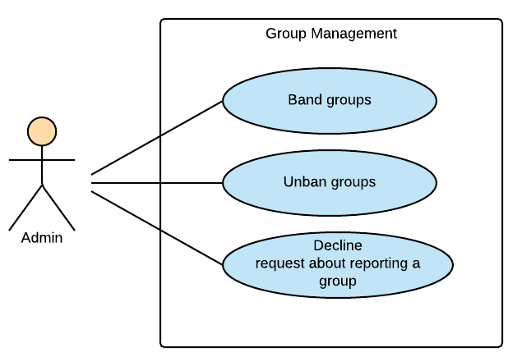

Figure 3‑8: Admin Module-Group Management

###### UC045-Band a group

Use Case Specification - Normal flow

|  |  |  |  |  |
| --- | --- | --- | --- | --- |
| **Use Case ID** | | UC045 | **Version** | 1.0 |
| **Use Case Name** | | Band a group | | |
| **Created by:** | | HuyenPT | **Date Created:** | 11/25/2016 |
| **Primary Actor** | | Admin | **Secondary Actor** | N/A |
| **Description:** | | This function allow admin ban a group | | |
| **Preconditions:** | | Successful login as admin | | |
| **Trigger:** | | Click ban button | | |
| **Post conditions:** | | Group was banned | | |
| **Normal Flow** | | | | |
| **Step** | **Actor** | **Action** | | |
| 1 | Admin | Successful login as admin | | |
| 2 | Admin | Click ban button | | |
| 3 | BSN | Ban group | | |
| **Priority** | | High | | |
| **Frequency of Use:** | | High | | |
| **Business Rules:** | | N/A | | |
| **Other Information:** | | N/A | | |

Alternative Flows and Exceptions

|  |  |  |
| --- | --- | --- |
| **Alternative Flows:** | | |
| **AT1** | At step 2 in the main flows, if user click other hyperlinks or buttons | |
| **Step** | **Actor** | **Action** |
| 2.1 | BSN | Redirects user to chosen hyperlink or button |
| **Exceptions: N/A** | | |

###### UC046-Unban a group

Use Case Specification - Normal flow

|  |  |  |  |  |
| --- | --- | --- | --- | --- |
| **Use Case ID** | | UC046 | **Version** | 1.0 |
| **Use Case Name** | | Unban a group | | |
| **Created by:** | | HuyenPT | **Date Created:** | 11/25/2016 |
| **Primary Actor** | | Admin | **Secondary Actor** | N/A |
| **Description:** | | This function allow admin unban a group | | |
| **Preconditions:** | | Successful login as admin | | |
| **Trigger:** | | Click unban button | | |
| **Post conditions:** | | Group was unbanned | | |
| **Normal Flow** | | | | |
| **Step** | **Actor** | **Action** | | |
| 1 | Admin | Successful login as admin | | |
| 2 | Admin | Click unban button | | |
| 3 | BSN | Unban group | | |
| **Priority** | | High | | |
| **Frequency of Use:** | | High | | |
| **Business Rules:** | | N/A | | |
| **Other Information:** | | N/A | | |

Alternative Flows and Exceptions

|  |  |  |
| --- | --- | --- |
| **Alternative Flows:** | | |
| **AT1** | At step 2 in the main flows, if user click other hyperlinks or buttons | |
| **Step** | **Actor** | **Action** |
| 2.1 | BSN | Redirects user to chosen hyperlink or button |
| **Exceptions: N/A** | | |

###### UC047-Decline request reporting a group

Use Case Specification - Normal flow

|  |  |  |  |  |
| --- | --- | --- | --- | --- |
| **Use Case ID** | | UC047 | **Version** | 1.0 |
| **Use Case Name** | | Decline request reporting a group | | |
| **Created by:** | | HuyenPT | **Date Created:** | 11/25/2016 |
| **Primary Actor** | | Admin | **Secondary Actor** | N/A |
| **Description:** | | This function allow admin decline request reporting a group | | |
| **Preconditions:** | | Successful login as admin | | |
| **Trigger:** | | Click decline request button | | |
| **Post conditions:** | | Request will be declined | | |
| **Normal Flow** | | | | |
| **Step** | **Actor** | **Action** | | |
| 1 | Admin | Successful login as admin | | |
| 2 | Admin | Click decline request button | | |
| 3 | BSN | Request will be declined | | |
| **Priority** | | High | | |
| **Frequency of Use:** | | High | | |
| **Business Rules:** | | N/A | | |
| **Other Information:** | | N/A | | |

Alternative Flows and Exceptions

|  |  |  |
| --- | --- | --- |
| **Alternative Flows:** | | |
| **AT1** | At step 2 in the main flows, if user click other hyperlinks or buttons | |
| **Step** | **Actor** | **Action** |
| 2.1 | BSN | Redirects user to chosen hyperlink or button |
| **Exceptions: N/A** | | |

##### Books Management

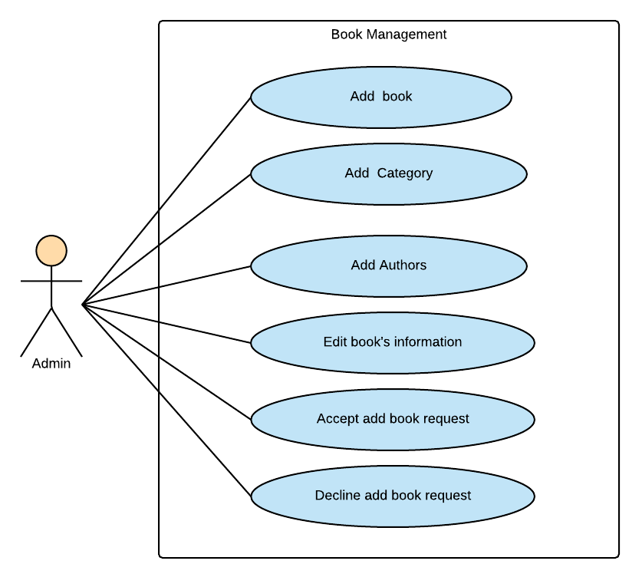

Figure 3‑9: Admin Module-Book Management

###### UC048-Add a new book

Use Case Specification - Normal flow

|  |  |  |  |  |
| --- | --- | --- | --- | --- |
| **Use Case ID** | | UC048 | **Version** | 1.0 |
| **Use Case Name** | | Add a new book | | |
| **Created by:** | | HuyenPT | **Date Created:** | 09/16/2016 |
| **Primary Actor** | | Admin | **Secondary Actor** | N/A |
| **Description:** | | This function allow admin add new book | | |
| **Preconditions:** | | Successful login as admin | | |
| **Trigger:** | | Click “Thêm sách” button | | |
| **Post conditions:** | | Popup to add new book is display then new book is added | | |
| **Normal Flow** | | | | |
| **Step** | **Actor** | **Action** | | |
| 1 | Admin | Successful login as admin | | |
| 2 | BSN | Popup add new book is displayed | | |
| 3 | Admin | Input all information of book | | |
| 4 | Admin | Click “Thêm” button | | |
| 5 | BSN | Books is added | | |
| **Priority** | | High | | |
| **Frequency of Use:** | | High | | |
| **Business Rules:** | | N/A | | |
| **Other Information:** | | N/A | | |

Alternative Flows and Exceptions

|  |  |  |  |  |
| --- | --- | --- | --- | --- |
| **Alternative Flows:** | | | | |
| **AT1** | At step 4 in the main flows, if user click other hyperlinks or buttons | | | |
| **Step** | **Actor** | | **Action** | |
| 4.1 | BSN | | Redirects user to chosen hyperlink or button | |
| **Exceptions:** | | | | |
| **EC1** | | At step 4 in the main flows, if admin input name of book empty | | |
| **Step** | | **Actor** | | **Action** |
| 4.1 | | BSN | | Display message MS10 |
| **EC2** | | At step 4 in the main flows, if admin input name of author empty | | |
| **Step** | | **Actor** | | **Action** |
| 4.1 | | BSN | | Display message MS11 |
| **EC3** | | At step 4 in the main flows, if admin input category empty | | |
| **Step** | | **Actor** | | **Action** |
| 4.1 | | BSN | | Display message MS12 |
| **EC3** | | At step 4 in the main flows, if admin input publisher empty | | |
| **Step** | | **Actor** | | **Action** |
| 4.1 | | BSN | | Display message MS14 |
| **EC3** | | At step 4 in the main flows, if admin don’t choose image of book | | |
| **Step** | | **Actor** | | **Action** |
| 4.1 | | BSN | | Display message MS16 |
| **EC3** | | At step 4 in the main flows, if admin don’t choose date | | |
| **Step** | | **Actor** | | **Action** |
| 4.1 | | BSN | | Display message MS17 |

###### UC050-Add a new category

Use Case Specification - Normal flow

|  |  |  |  |  |
| --- | --- | --- | --- | --- |
| **Use Case ID** | | UC0 | **Version** | 1.0 |
| **Use Case Name** | | Add a new category | | |
| **Created by:** | | HuyenPT | **Date Created:** | 09/16/2016 |
| **Primary Actor** | | Admin | **Secondary Actor** | N/A |
| **Description:** | | This function allow admin add a new category | | |
| **Preconditions:** | | Successful login as admin | | |
| **Trigger:** | | Click “Thêm thể loại” button | | |
| **Post conditions:** | | Popup to add new category is displayed and new category is added | | |
| **Normal Flow** | | | | |
| **Step** | **Actor** | **Action** | | |
| 1 | Admin | Successful login as admin | | |
| 2 | BSN | Popup add new category is displayed | | |
| 3 | Admin | Input all information of category | | |
| 4 | Admin | Click “Thêm” button | | |
| 5 | BSN | Category is added | | |
| **Priority** | | High | | |
| **Frequency of Use:** | | High | | |
| **Business Rules:** | | N/A | | |
| **Other Information:** | | N/A | | |

Alternative Flows and Exceptions

|  |  |  |  |  |
| --- | --- | --- | --- | --- |
| **Alternative Flows:** | | | | |
| **AT1** | At step 4 in the main flows, if user click other hyperlinks or buttons | | | |
| **Step** | **Actor** | | **Action** | |
| 4.1 | BSN | | Redirects user to chosen hyperlink or button | |
| **Exceptions:** | | | | |
| **EC1** | | At step 4 in the main flows, if admin input name of category empty | | |
| **Step** | | **Actor** | | **Action** |
| 4.1 | | BSN | | Display message MS26 |

###### UC050-Add an author

Use Case Specification - Normal flow

|  |  |  |  |  |
| --- | --- | --- | --- | --- |
| **Use Case ID** | | UC050 | **Version** | 1.0 |
| **Use Case Name** | | Add an author | | |
| **Created by:** | | HuyenPT | **Date Created:** | 09/16/2016 |
| **Primary Actor** | | Admin | **Secondary Actor** | N/A |
| **Description:** | | This function allow admin add a new author | | |
| **Preconditions:** | | Successful login as admin | | |
| **Trigger:** | |  | | |
| **Post conditions:** | | New author is added | | |
| **Normal Flow** | | | | |
| **Step** | **Actor** | **Action** | | |
| 1 | Admin | Successful login as admin | | |
| 2 | Admin | Click accept author account | | |
| 3 | BSN | Author account will be accepted | | |
| **Priority** | | High | | |
| **Frequency of Use:** | | High | | |
| **Business Rules:** | | N/A | | |
| **Other Information:** | | N/A | | |

Alternative Flows and Exceptions

|  |  |  |
| --- | --- | --- |
| **Alternative Flows:** | | |
| **AT1** | At step 2 in the main flows, if user click other hyperlinks or buttons | |
| **Step** | **Actor** | **Action** |
| 2.1 | BSN | Redirects user to chosen hyperlink or button |
| **Exceptions: N/A** | | |

###### UC051-Edit book's information

Use Case Specification - Normal flow

|  |  |  |  |  |
| --- | --- | --- | --- | --- |
| **Use Case ID** | | UC051 | **Version** | 1.0 |
| **Use Case Name** | | Edit book's information | | |
| **Created by:** | | HuyenPT | **Date Created:** | 09/16/2016 |
| **Primary Actor** | | Admin | **Secondary Actor** | N/A |
| **Description:** | | This function allow admin edit book’s information | | |
| **Preconditions:** | | Successful login as admin | | |
| **Trigger:** | | Click to edit book button | | |
| **Post conditions:** | | Information of book will be edited | | |
| **Normal Flow** | | | | |
| **Step** | **Actor** | **Action** | | |
| 1 | Admin | Successful login as admin | | |
| 2 | Admin | Edit information of book | | |
| 3 | BSN | Update new information of book | | |
| **Priority** | | High | | |
| **Frequency of Use:** | | High | | |
| **Business Rules:** | | N/A | | |
| **Other Information:** | | N/A | | |

Alternative Flows and Exceptions

|  |  |  |
| --- | --- | --- |
| **Alternative Flows:** | | |
| **AT1** | At step 2 in the main flows, if user click other hyperlinks or buttons | |
| **Step** | **Actor** | **Action** |
| 2.1 | BSN | Redirects user to chosen hyperlink or button |
| **Exceptions: N/A** | | |

###### UC052-Accept add-book request

Use Case Specification - Normal flow

|  |  |  |  |  |
| --- | --- | --- | --- | --- |
| **Use Case ID** | | UC052 | **Version** | 1.0 |
| **Use Case Name** | | Accept add-book request | | |
| **Created by:** | | HuyenPT | **Date Created:** | 09/16/2016 |
| **Primary Actor** | | Admin | **Secondary Actor** | N/A |
| **Description:** | | This function allow admin accept add book request | | |
| **Preconditions:** | | Successful login as admin | | |
| **Trigger:** | | Click accept button | | |
| **Post conditions:** | | Request add book will be accepted | | |
| **Normal Flow** | | | | |
| **Step** | **Actor** | **Action** | | |
| 1 | Admin | Successful login as admin | | |
| 2 | Admin | Click accept button | | |
| 3 | BSN | Request creating author account will be accepted | | |
| **Priority** | | High | | |
| **Frequency of Use:** | | High | | |
| **Business Rules:** | | N/A | | |
| **Other Information:** | | N/A | | |

Alternative Flows and Exceptions

|  |  |  |
| --- | --- | --- |
| **Alternative Flows:** | | |
| **AT1** | At step 2 in the main flows, if user click other hyperlinks or buttons | |
| **Step** | **Actor** | **Action** |
| 2.1 | BSN | Redirects user to chosen hyperlink or button |
| **Exceptions: N/A** | | |

###### UC053-Decline add-book request

Use Case Specification - Normal flow

|  |  |  |  |  |
| --- | --- | --- | --- | --- |
| **Use Case ID** | | UC053 | **Version** | 1.0 |
| **Use Case Name** | | Decline add-book request | | |
| **Created by:** | | HuyenPT | **Date Created:** | 09/16/2016 |
| **Primary Actor** | | Admin | **Secondary Actor** | N/A |
| **Description:** | | This function allow admin decline request add book | | |
| **Preconditions:** | | Successful login as admin | | |
| **Trigger:** | | Click decline request button | | |
| **Post conditions:** | | Request will be declined | | |
| **Normal Flow** | | | | |
| **Step** | **Actor** | **Action** | | |
| 1 | Admin | Successful login as admin | | |
| 2 | Admin | Click decline request button | | |
| 3 | BSN | Request will be declined | | |
| **Priority** | | High | | |
| **Frequency of Use:** | | High | | |
| **Business Rules:** | | N/A | | |
| **Other Information:** | | N/A | | |

Alternative Flows and Exceptions

|  |  |  |
| --- | --- | --- |
| **Alternative Flows:** | | |
| **AT1** | At step 2 in the main flows, if user click other hyperlinks or buttons | |
| **Step** | **Actor** | **Action** |
| 2.1 | BSN | Redirects user to chosen hyperlink or button |
| **Exceptions: N/A** | | |

##### Sliders Management

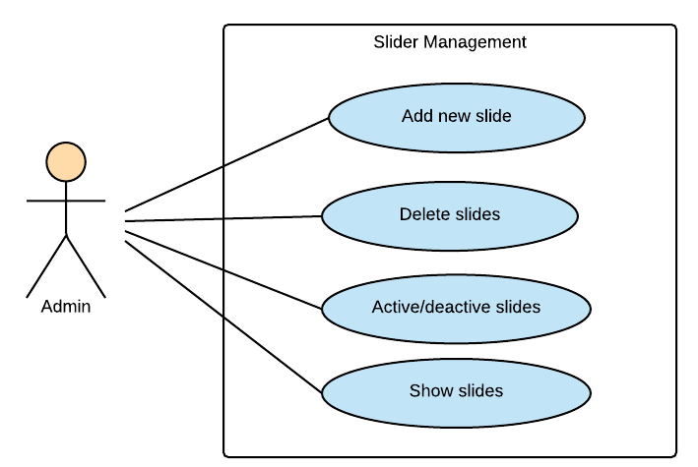

Figure 3‑10: Admin Module-Slider Management

###### UC054-Add a new slider

Use Case Specification - Normal flow

|  |  |  |  |  |
| --- | --- | --- | --- | --- |
| **Use Case ID** | | UC054 | **Version** | 1.0 |
| **Use Case Name** | | Add a new slider | | |
| **Created by:** | | HuyenPT | **Date Created:** | 09/16/2016 |
| **Primary Actor** | | Admin | **Secondary Actor** | N/A |
| **Description:** | | This function allow admin add a new slider | | |
| **Preconditions:** | | Successful login as admin | | |
| **Trigger:** | |  | | |
| **Post conditions:** | | New slider is added | | |
| **Normal Flow** | | | | |
| **Step** | **Actor** | **Action** | | |
| 1 | Admin | Successful login as admin | | |
| 2 | Admin | Click add slider | | |
| 3 | Admin | Input all field to add slider | | |
| 4 | Admin | Click “Thêm” button | | |
| 5 | BSN | Slider will be accepted | | |
| **Priority** | | High | | |
| **Frequency of Use:** | | High | | |
| **Business Rules:** | | B3 | | |
| **Other Information:** | | N/A | | |

2Alternative Flows and Exceptions

|  |  |  |  |  |
| --- | --- | --- | --- | --- |
| **Alternative Flows:** | | | | |
| **AT1** | At step 4 in the main flows, if user click other hyperlinks or buttons | | | |
| **Step** | **Actor** | | **Action** | |
| 4.1 | BSN | | Redirects user to chosen hyperlink or button | |
| **Exceptions:** | | | | |
| **EC1** | | At step 4 in the main flows, if admin add photo is not .jpg, .png | | |
| **Step** | | **Actor** | | **Action** |
| 4.1 | | BSN | | Display message MS32 |

###### UC055-Delete a slider

Use Case Specification - Normal flow

|  |  |  |  |  |
| --- | --- | --- | --- | --- |
| **Use Case ID** | | UC055 | **Version** | 1.0 |
| **Use Case Name** | | Delete a slider | | |
| **Created by:** | | HuyenPT | **Date Created:** | 09/16/2016 |
| **Primary Actor** | | Admin | **Secondary Actor** | N/A |
| **Description:** | | This function allow admin delete a slider | | |
| **Preconditions:** | | Successful login as admin | | |
| **Trigger:** | | Click delete button | | |
| **Post conditions:** | | Slider will be deleted | | |
| **Normal Flow** | | | | |
| **Step** | **Actor** | **Action** | | |
| 1 | Admin | Successful login as admin | | |
| 2 | Admin | Click add slider | | |
| 3 | BSN | Slider was deleted | | |
| **Priority** | | High | | |
| **Frequency of Use:** | | High | | |
| **Business Rules:** | | N/A | | |
| **Other Information:** | | N/A | | |

Alternative Flows and Exceptions

|  |  |  |
| --- | --- | --- |
| **Alternative Flows:** | | |
| **AT1** | At step 2 in the main flows, if user click other hyperlinks or buttons | |
| **Step** | **Actor** | **Action** |
| 2.1 | BSN | Redirects user to chosen hyperlink or button |
| **Exceptions: N/A** | | |

###### UC056-Active/de-active a slider

Use Case Specification - Normal flow

|  |  |  |  |  |
| --- | --- | --- | --- | --- |
| **Use Case ID** | | UC056 | **Version** | 1.0 |
| **Use Case Name** | | Active/de-active a slider | | |
| **Created by:** | | HuyenPT | **Date Created:** | 09/16/2016 |
| **Primary Actor** | | Admin | **Secondary Actor** | N/A |
| **Description:** | | This function allow admin active/de-active a slider | | |
| **Preconditions:** | | Successful login as admin | | |
| **Trigger:** | | Click active/de-active button | | |
| **Post conditions:** | | Slider will be active/de-active | | |
| **Normal Flow** | | | | |
| **Step** | **Actor** | **Action** | | |
| 1 | Admin | Successful login as admin | | |
| 2 | Admin | Click active/de-active button | | |
| 3 | BSN | Slider will be active/de-active | | |
| **Priority** | | High | | |
| **Frequency of Use:** | | High | | |
| **Business Rules:** | | N/A | | |
| **Other Information:** | | N/A | | |

Alternative Flows and Exceptions

|  |  |  |
| --- | --- | --- |
| **Alternative Flows:** | | |
| **AT1** | At step 2 in the main flows, if user click other hyperlinks or buttons | |
| **Step** | **Actor** | **Action** |
| 2.1 | BSN | Redirects user to chosen hyperlink or button |
| **Exceptions: N/A** | | |

###### UC057-Show a slider

Use Case Specification - Normal flow

|  |  |  |  |  |
| --- | --- | --- | --- | --- |
| **Use Case ID** | | UC057 | **Version** | 1.0 |
| **Use Case Name** | | Show a slider | | |
| **Created by:** | | HuyenPT | **Date Created:** | 09/16/2016 |
| **Primary Actor** | | Admin | **Secondary Actor** | N/A |
| **Description:** | | This function allow admin view all slider | | |
| **Preconditions:** | | Successful login as admin | | |
| **Trigger:** | |  | | |
| **Post conditions:** | | Can view all slider of BSN website | | |
| **Normal Flow** | | | | |
| **Step** | **Actor** | **Action** | | |
| 1 | Admin | Successful login as admin | | |
| 2 | BSN | Show all slider of BSN website | | |
| **Priority** | | High | | |
| **Frequency of Use:** | | High | | |
| **Business Rules:** | | N/A | | |
| **Other Information:** | | N/A | | |

Alternative Flows and Exceptions

|  |
| --- |
| **Alternative Flows: N/A** |
| **Exceptions: N/A** |

##### Publishers Management

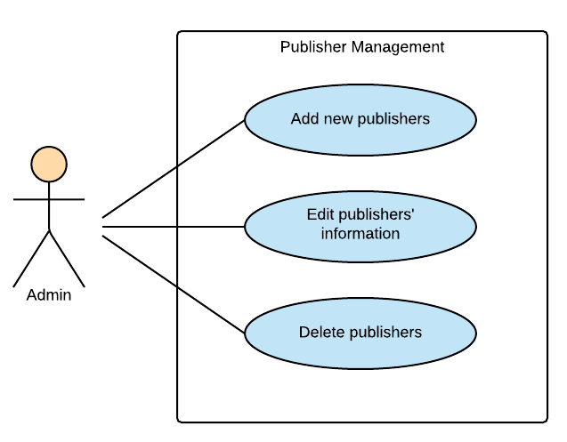

Figure 3‑11: Admin Module Publisher Management

###### UC058-Add a new publisher

Use Case Specification - Normal flow

|  |  |  |  |  |
| --- | --- | --- | --- | --- |
| **Use Case ID** | | UC058 | **Version** | 1.0 |
| **Use Case Name** | | Add a new publisher | | |
| **Created by:** | | HuyenPT | **Date Created:** | 09/16/2016 |
| **Primary Actor** | | Admin | **Secondary Actor** | N/A |
| **Description:** | | This function allow admin add a new publisher | | |
| **Preconditions:** | | Successful login as admin | | |
| **Trigger:** | | Click add publisher button | | |
| **Post conditions:** | | Publisher is added | | |
| **Normal Flow** | | | | |
| **Step** | **Actor** | **Action** | | |
| 1 | Admin | Successful login as admin | | |
| 2 | Admin | Click add publisher | | |
| 3 | Admin | Input all field to add publisher | | |
| 4 | Admin | Click “Thêm” button | | |
| 5 | BSN | Publisher is added | | |
| **Priority** | | High | | |
| **Frequency of Use:** | | High | | |
| **Business Rules:** | | N/A | | |
| **Other Information:** | | N/A | | |

Alternative Flows and Exceptions

|  |  |  |  |  |
| --- | --- | --- | --- | --- |
| **Alternative Flows:** | | | | |
| **AT1** | At step 4 in the main flows, if user click other hyperlinks or buttons | | | |
| **Step** | **Actor** | | **Action** | |
| 4.1 | BSN | | Redirects user to chosen hyperlink or button | |
| **Exceptions:** | | | | |
| **EC1** | | At step 4 in the main flows, if admin add photo is not .jpg, .png | | |
| **Step** | | **Actor** | | **Action** |
| 4.1 | | BSN | | Display message MS32 |

###### UC059-Edit publisher's information

Use Case Specification - Normal flow

|  |  |  |  |  |
| --- | --- | --- | --- | --- |
| **Use Case ID** | | UC059 | **Version** | 1.0 |
| **Use Case Name** | | Edit publisher's information | | |
| **Created by:** | | HuyenPT | **Date Created:** | 09/16/2016 |
| **Primary Actor** | | Admin | **Secondary Actor** | N/A |
| **Description:** | | This function allow admin edit publisher's information | | |
| **Preconditions:** | | Successful login as admin | | |
| **Trigger:** | | Click to edit publisher button | | |
| **Post conditions:** | | Information of publisher will be edited | | |
| **Normal Flow** | | | | |
| **Step** | **Actor** | **Action** | | |
| 1 | Admin | Successful login as admin | | |
| 2 | Admin | Edit information of publisher | | |
| 3 | BSN | Update new information of publisher | | |
| **Priority** | | High | | |
| **Frequency of Use:** | | High | | |
| **Business Rules:** | | N/A | | |
| **Other Information:** | | N/A | | |

Alternative Flows and Exceptions

|  |  |  |
| --- | --- | --- |
| **Alternative Flows:** | | |
| **AT1** | At step 2 in the main flows, if user click other hyperlinks or buttons | |
| **Step** | **Actor** | **Action** |
| 2.1 | BSN | Redirects user to chosen hyperlink or button |
| **Exceptions: N/A** | | |

###### UC060-Delete a publisher

Use Case Specification - Normal flow

|  |  |  |  |  |
| --- | --- | --- | --- | --- |
| **Use Case ID** | | UC060 | **Version** | 1.0 |
| **Use Case Name** | | Delete a publisher | | |
| **Created by:** | | HuyenPT | **Date Created:** | 09/16/2016 |
| **Primary Actor** | | Admin | **Secondary Actor** | N/A |
| **Description:** | | This function allow admin delete a publisher | | |
| **Preconditions:** | | Successful login as admin | | |
| **Trigger:** | | Click delete button | | |
| **Post conditions:** | | Publisher is deleted | | |
| **Normal Flow** | | | | |
| **Step** | **Actor** | **Action** | | |
| 1 | Admin | Successful login as admin | | |
| 2 | Admin | Click delete button | | |
| 3 | BSN | Publisher is deleted | | |
| **Priority** | | High | | |
| **Frequency of Use:** | | High | | |
| **Business Rules:** | | N/A | | |
| **Other Information:** | | N/A | | |

Alternative Flows and Exceptions

|  |  |  |
| --- | --- | --- |
| **Alternative Flows:** | | |
| **AT1** | At step 2 in the main flows, if user click other hyperlinks or buttons | |
| **Step** | **Actor** | **Action** |
| 2.1 | BSN | Redirects user to chosen hyperlink or button |
| **Exceptions: N/A** | | |

##### Statistics

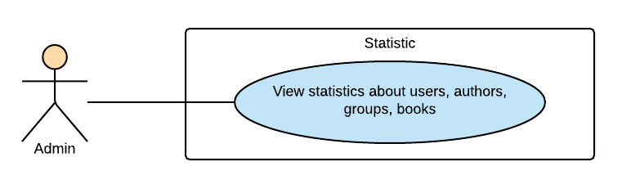

Figure 3‑12: Admin Module-Statistics

###### UC061-View statistic

Use Case Specification - Normal flow

|  |  |  |  |  |
| --- | --- | --- | --- | --- |
| **Use Case ID** | | UC061 | **Version** | 1.0 |
| **Use Case Name** | | View statistic | | |
| **Created by:** | | HuyenPT | **Date Created:** | 11/25/2016 |
| **Primary Actor** | | Admin | **Secondary Actor** | N/A |
| **Description:** | | This function allow admin view statistic | | |
| **Preconditions:** | | Successful login as admin | | |
| **Trigger:** | |  | | |
| **Post conditions:** | | Can view statistic | | |
| **Normal Flow** | | | | |
| **Step** | **Actor** | **Action** | | |
| 1 | Admin | Successful login as admin | | |
| 2 | BSN | Show all statistic | | |
| **Priority** | | High | | |
| **Frequency of Use:** | | High | | |
| **Business Rules:** | | N/A | | |
| **Other Information:** | | N/A | | |

Alternative Flows and Exceptions

|  |
| --- |
| **Alternative Flows: N/A** |
| **Exceptions: N/A** |

### Non-Functional Specification

#### Reliability

1. Mean time between failures: The mean time between each failure is expected to be about 480 hours of using.
2. The maximum bugs per function are 2 bugs/a function when user uses software within 2 months. The average number of bugs in the software during system testing is about to be around 1 bugs/KLOC.
3. The database must be backed up daily and can be recovered if necessary

#### Performance Requirements

##### Availability

The application must be available 95% of time. Users can access to it everywhere from their Web browser with internet connection.

##### Response time

In term of response time, waiting time of processing will be 2 to 5 seconds; time to process any functions will not exceed 7 seconds.

##### Maintainability

* **Coding standards and naming conventions**
  + Output of the project must include coding standards and naming conventions documentations. Implementation code must be easy to maintain.
  + If some components are reused, the documentations of those components must also be included.
* **Design**
  + The design of the system must be loosely coupled that chances on some module will not affect others.
* **Logging**
  + All the errors should be logged, supporting for bug fixing and maintenance.
  + All strange or sensitive situations should also be logged.
* **Mean time to repair:** Immediately when Administrator finds out problem or website is attacked/ hacked by someone. Average 1 day.

##### Usability

Usability Requirements support the following from the perspective of its primary users:

● **Efficiency of use:** user can complete each function in less than 12 actions

● **Intuitiveness:** User can understand approximately 90% help/ error messages

##### Security Requirements

In order to avoid unwanted access by strangers, the security implemented in various ways:

* **User authorize**: Each function must be distributed system access and manipulate the individual parts. To edit information, user must declare their username and password before the operation. Functions will be show after users login dependencies user’s role and permission of each user.
* **Manage Data Layer**: Only Administrator can modify database system.

##### Hardware/Software Requirements

**Hardware requirement:**

**- Server:** Web service 2013, IIS8

**- Client:** PC/Laptop (window 7, window 8, window 10)

● **Software requirements:** Web browser (Chrome 50.0 or higher) with internet connection

# SOFTWARE DESIGN

## Introduction

### Purpose

This chapter provides a guideline for the development team of what the system’s architect, how to implement functions.

This section of document is the software design of the project in order to develop the software, it includes four main parts:

* Architecture Design.
* Detail Design.
* Database design.
* Screen design.

### Definitions, Acronyms, Abbreviations

|  |  |  |
| --- | --- | --- |
| **Acronym** | **Definition** | **Note** |
| DDL | Dandelion |  |
| DB | Database |  |
| MVC | Model view control |  |
| IDE | Integrated development environment |  |
| Q&A | Question and answer |  |
| GUI | Graphic user interface |  |
| FU | FPT University |  |

1. Definitions and Acronyms

## Architecture design

### Choice of Architecture Design

#### MVC Model

The purpose of BSN is developing a social network, where people can share and discus about book. The system of BSN is structured based on MVC combined with layered architecture.

##### MVC Model Overview

The **model-view-controller or MVC** is software architecture commonly used for creating web applications or software. In other words, it's a structure for web applications to follow in order to ensure efficiency and consistency. Many of the most popular frameworks use the MVC architecture, including ASP.NET, CodeIgniter, Zend, Django, and Ruby on Rails. At the same time, there are many web developers who don't use a coding framework yet still set up their applications to follow the MVC structure.

The Model-View-Controller (MVC) design pattern assigns objects in an application one of  
three roles: model, view, or controller. The pattern defines not only the roles objects play in  
the application, it defines the way objects communicate with each other. Each of the three  
types of objects is separated from the others by abstract boundaries and communicates with  
objects of the other types across those boundaries. The collection of objects of a certain MVC  
type in an application is sometimes referred to as a layer—for example, model layer.

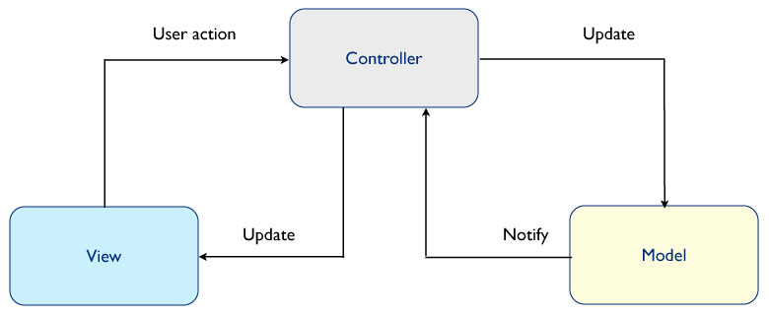

Figure 1: MVC Model

In addition to dividing the application into three kinds of components, the MVC design defines the interactions between them:

* **Controller:** The controller can be considered the "middle man" of the application. It works with the user, taking in data, and then working with the model to get the appropriate data or calculation, and then working with the view to show the response to the user.
* **Model:** A model is simply a representation of something we need to deal within our application. It is a "model" for something we must represent in code, such as a book, user, bank account, or whatever. The model is responsible for holding the functions and variables that are involved with whatever it's representing. You can think of a model's logic as the core concept to object oriented programming — models are just our "classes". However, don't let this confuse you as controllers are technically structured as classes as well.
* **View:** Finally, after the controller requests information from the model it sends it to a view. A view is just like the application's templating system — there might be a view for a certain type of page layout *(profile page)*, a mobile view, or a view for a particular theme/skin. A view will contain all of the markup, CSS, and etc. that you traditionally use with creating a static web page.

##### Advantages and disadvantages of MVC Model

* Advantages:
* MVC separates system into components, which can be developed, maintained and upgraded individually without pausing system.
* Develop tools is useful and easy to use.
* Large of documentary sources.
* Disadvantages:
* For small projects that apply MVC model caused cumbersome, time consuming in development process.
* Time consuming to transits data between components.
* Not suitable for agent-oriented applications such as interactive mobile and robotics applications.
* Multiple pairs of controllers and views based on the same data model make data model change expensive.
* The division between the View and the Controller is not clear in some cases.

##### The reasons for choosing MVC Model

* MVC makes parts of system can be developed individually and simultaneously to reduce developing time.
* Better support for test-driven development.
* Easy to develop in case of larger source.
* BSN system is not complete system, now. We built the system that towards extensibility and maintainability in the future.

#### .Net Framework

##### .Net Framework Overview

. NET Framework is a software framework developed by Microsoft that runs primarily on Microsoft Windows. It includes a large class library known as Framework Class Library (FCL) and provides language interoperability (each language can use code written in other languages) across several programming languages.

The .NET Framework is a technology that supports building and running the next generation of applications and XML Web services. The .NET Framework is designed to fulfill the following objectives:

* To provide a consistent object-oriented programming environment whether object code is stored and executed locally, executed locally but Internet-distributed, or executed remotely.
* To provide a code-execution environment that minimizes software deployment and versioning conflicts.
* To provide a code-execution environment that promotes safe execution of code, including code created by an unknown or semi-trusted third party.
* To provide a code-execution environment that eliminates the performance problems of scripted or interpreted environments.
* To make the developer experience consistent across widely varying types of applications, such as Windows-based applications and Web-based applications.
* To build all communication on industry standards to ensure that code based on the .NET Framework can integrate with any other code.

##### Advantages and disadvantages of .Net Framework

* Advantages
* Less time to produce product
* Less Complexity.
* Easily to access complex O.S functions
* Easily to build Data Oriented Project, support huge DB functions.
* Managed
* Support Both Windows and Web Application.
* Easy to create Dynamic sites.
* Disadvantages
* Not suitable for High End Application
* Low performance compare to C, C++.
* Unavailability of build in methods.
* .NET framework is free to download but Code Editor is costly.
* Only few O.S supports .NET.

##### The reasons for choosing .Net Framework

* Consistent with BSN system.
* There are many plugins and resources which support creating a website using MVC model.
* Many members can use and have experiences using C# (a language of .Net Framework)

### Architecture Representation

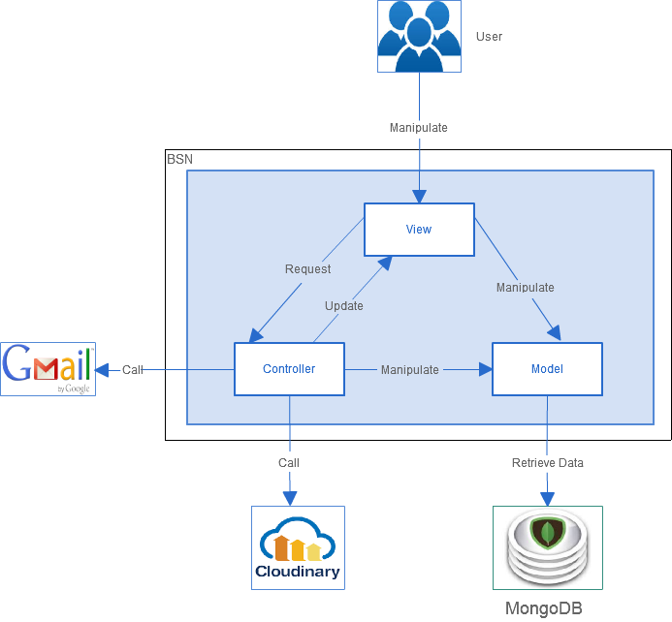

Figure 2: System Overview

* **Model** includes “**Models”** and “**View Models”**. View Models is an object that defines how the data will be sent over the network to remove circular references from Models, hide particular properties that clients are not supposed to view, omit some properties in order to reduce payload size, flatten object graphs that contain nested objects, to make them more convenient for clients, avoid “over-posting” vulnerabilities and decouple your service layer from your database layer. “Models” is where the application’s data objects are stored. A model object is in charge of encapsulating application state and one object could be related to other objects establishing a one-to-one or one-to-many relationship.
* **View** is what is presented to the users and how users interact with the system. The view is expected to render the model in a meaningful way to the user. In BSN, the view is made with .cshtml file including CSS, HTML, JavaScript and jQuery, it sends user gestures to controller and allows controller to select view.
* **Controller** is the decision maker and the glue between the model and view; it handles user actions and gestures, and responds to user events.

### Architectural Goals and Constraints

* **Availability:**
* The application must be available 95% of time. Users can access to it everywhere from there .Web browser with internet connection.
* **Maintainability:**
  + Coding standards and naming conventions:
    - Output of the project must include coding standards and naming conventions documentations. Implementation code must be easy to maintain.
    - All code must be clearly commented, including class, method documentations.
    - If some components are reused, the documentations of those components must also be included.
* Design:
  + - The design of the system must be loosely coupled that chances on some module will not affect others.
* Logging:
  + - All the errors should be logged, supporting for bug fixing and maintenance.
    - All strange or sensitive situations should also be logged.
* **Usability:**
  + Intuitiveness: all help/error messages are simple to understand; user can know exactly how to do each feature after one time using it.
* **Capacity and scalability:**
  + Throughput, storage and growth requirements.

### Logical View

#### Overview

Logical View includes Package diagram and Class diagram. Package diagram describes the organization of packages and elements. Class Diagram provides an overview of the target system by describing the objects and classes inside the system and the relationships between them. It provides a wide variety of usages; from modeling the domain-specific data structure to detailed design of the target system

* + Controller contain the interface between:
    - Associated models
    - Associated views
    - The input devices (e.g., keyboard, pointing device, time).
    - Send commands to the model to update the model's state.
    - Create queries to DB
    - Process data.
  + Model is:
    - the domain-specific software simulation
    - Or implementation of the application's central structure.
  + View: deal with everything graphical:
    - Requests data from their model
    - Display the data.

#### Architecturally Significant Design Packages

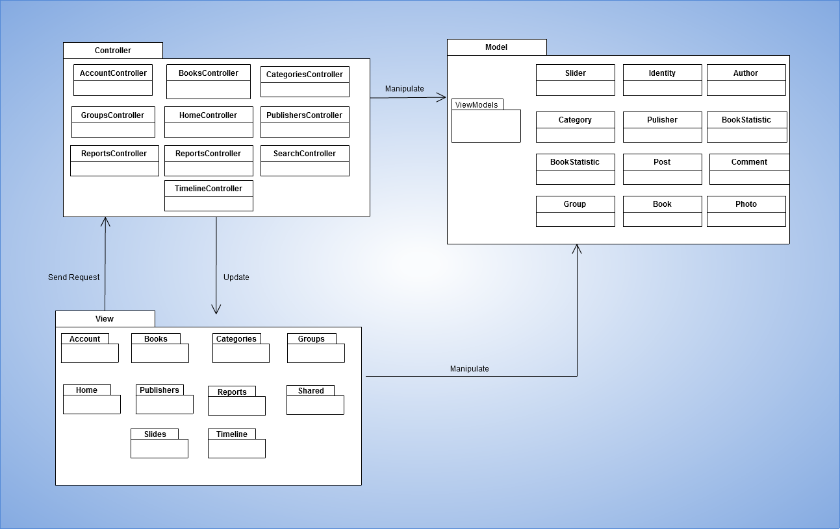

Figure 15: Package Diagram

* **Model:**

|  |  |  |
| --- | --- | --- |
| No | Model class | Role |
|  | Identity | Description entity of User in database |
|  | Book | Description entity of Book in database |
|  | Slider | Description entity of Conversation in database |
|  | Group | Description entity of Group in database |
|  | Publisher | Description entity of Publisher in database |
|  | Post | Description entity of Post in database |
|  | Comment | Description entity of Comment in database |
|  | Author | Description entity of Author in database |

Table 14 : Model list

* **Controller:**

|  |  |  |
| --- | --- | --- |
| No | Controller class | Role |
|  | AccountController | * Receive request login, logout, register from client then process data and respond login view, logout view, register view and login, logout, register status. |
|  | HomeController | * Receive request to home page from client. * Handle request from client and process data to get all data of home page. * Respond data back to Home View. |
|  | BooksController | * Receive request about book from client. Process data and respond to client. |
|  | PublishersController | * Receive request about publisher from client. Process data and respond to client. |
|  | CategoriesController | * Receive request about category from client. Process data and respond to client |
|  | SlidersController | * Receive request about slider from client. Process data and respond to client. |
|  | TimeLineController | * Receive request about user’s page from client. Process data to get all data of user’s page and respond to client |
|  | GroupsController | * Receive request about group from client. Process data and respond to client. |
|  | SearchController | * Receive request about search from client. Process data and respond to client. |

Table 15: Controller list

* **View:**

Include many .cshtml file

### Process view

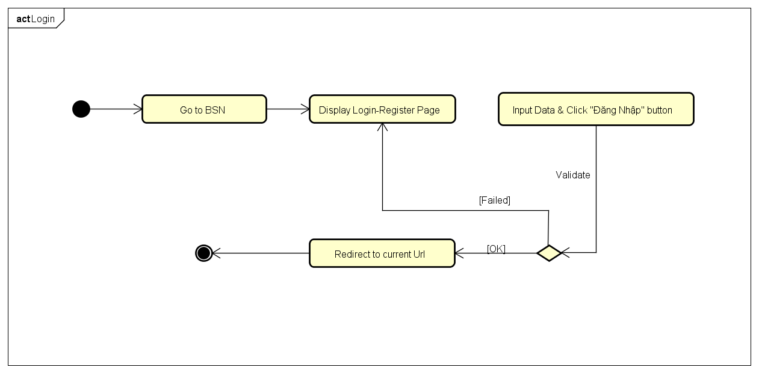

Figure 17: Login activity diagram

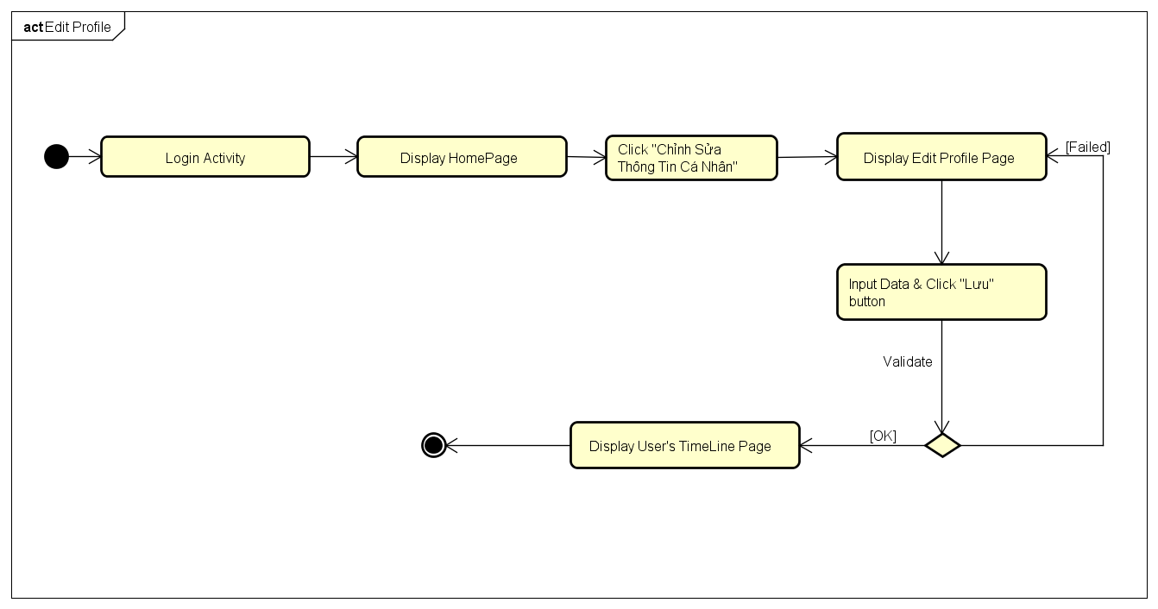

Figure 18 : Edit Profile activity diagram

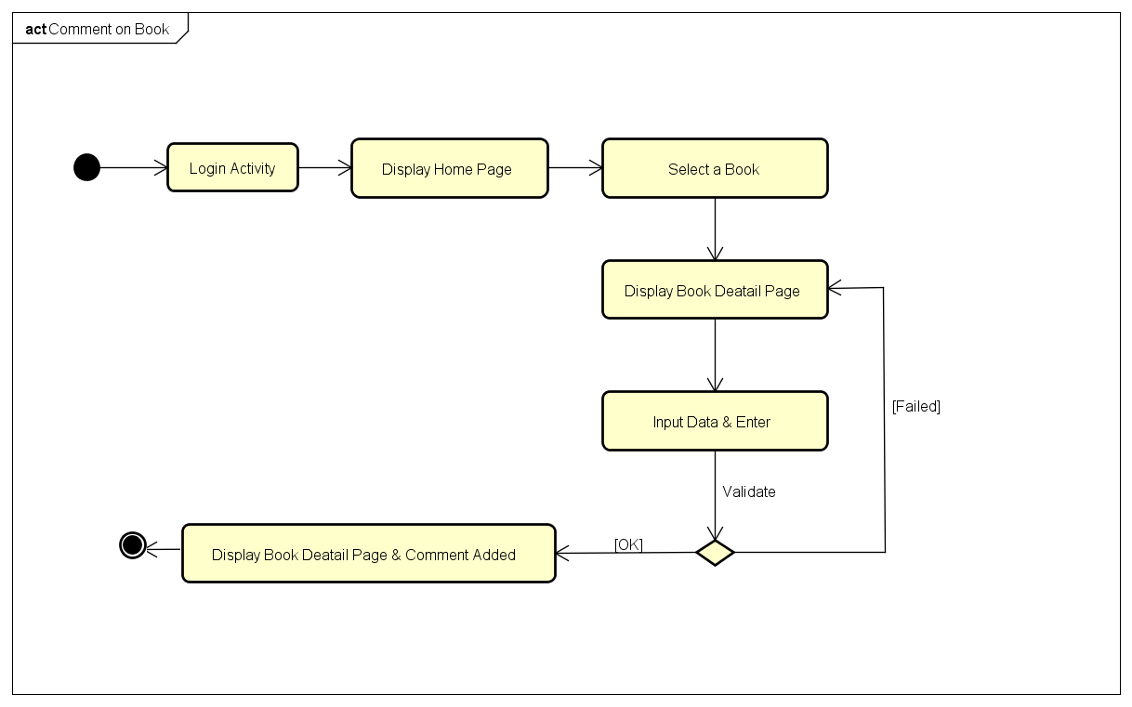

Figure 19: Comment on book activity diagram

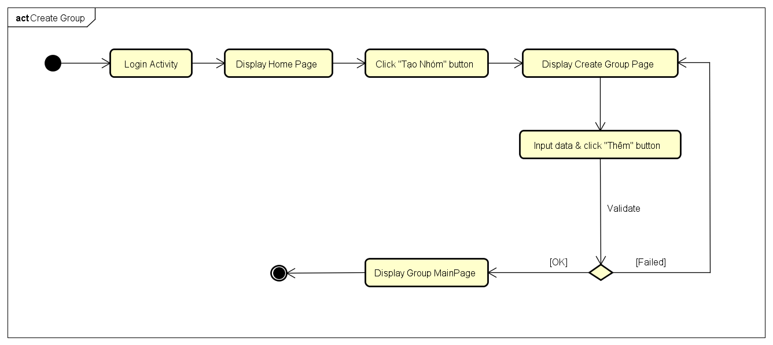

Figure 20: Create Group activity diagram

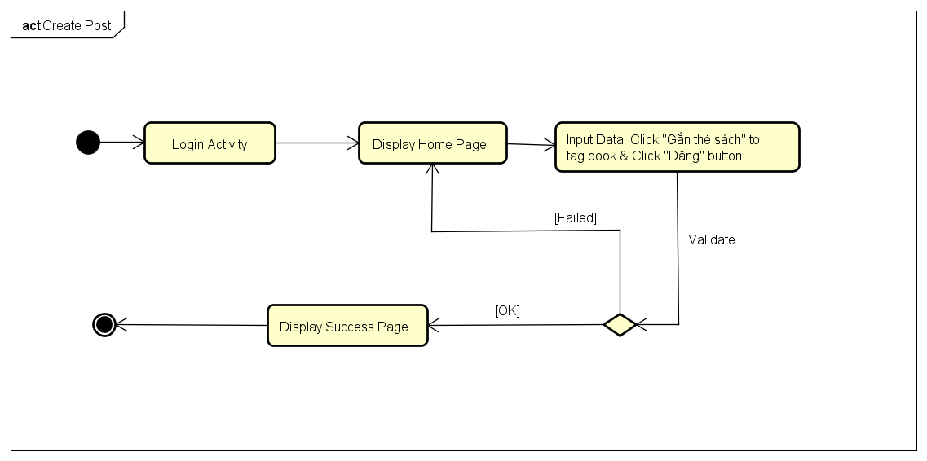

Figure 21 : Create Post activity diagram

### Deployment View

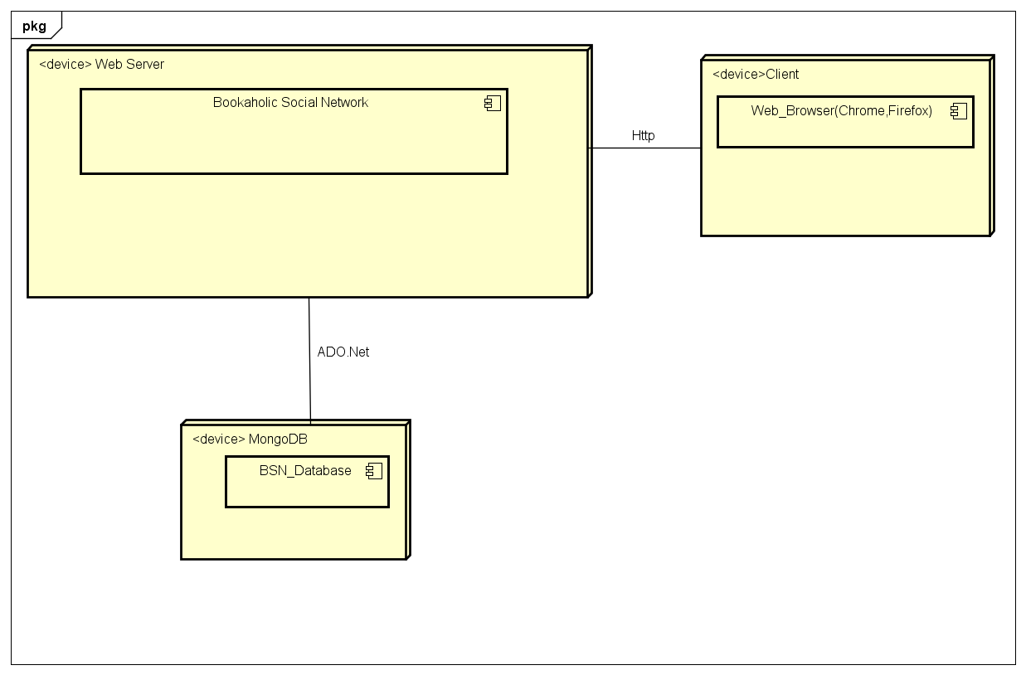

Figure 22: Deployment Diagram

|  |  |  |
| --- | --- | --- |
| **No** | **Name** | **Description** |
| 1 | MongoDB | MongoDB use to store system’s data.  Using MongoDB version 3.0.12. |
| 2 | Client | Client is web browser to use system. Chrome 50 or higher. |
| 5 | Web Server | Web server is hosted by … Web Service. |

Table 16 : Deployment Diagram Description

## Detail Design

### Package

#### Package Diagram

Package Diagram

#### Package Description

##### Model

###### BSN_User

|  |  |  |  |  |  |
| --- | --- | --- | --- | --- | --- |
| **No** | **Field Name** | **Type** | **Default** | **Note** | **Description** |
|  | _id | ObjectId |  | Public | Mongodb objectid  Unique for each document |
|  | UserName | String |  | Public | User’s name |
|  | Email | String |  | Public | User’s Email |
|  | EmailConfirmed | Boolean |  | Public | Status of registration confirmation via email |
|  | PasswordHash | String |  | Public | Password encrypt by SHA 256 |
|  | Role | String |  | Public | User’s role |
|  | Gender | String |  | Public | User’s gender |
|  | Avatar | String |  | Public | Public id of user’s avatar in cloudinary |
|  | Cover | String |  | Public | Public id of user’s cover in cloudinary |
|  | DOB | DateTime |  | Public | User’s date of birth |
|  | Address | String |  | Public | User’s address |
|  | SSNImgId | String |  | Public | User’s SSN image public id in cloudinary |

###### Post

|  |  |  |  |  |  |
| --- | --- | --- | --- | --- | --- |
| **No** | **Field Name** | **Type** | **Default** | **Note** | **Description** |
| 1 | _id | ObjectId |  | Public |  |
| 2 | Content | String |  | Public |  |
| 3 | PostedBy | String |  | Public |  |
| 4 | PostedDate | DateTime |  | Public |  |
| 5 | BookTag | Array[String] |  | Public | List of book taged in user’s posst |

###### Book

|  |  |  |  |  |  |
| --- | --- | --- | --- | --- | --- |
| **No** | **Field Name** | **Type** | **Default** | **Note** | **Description** |
| 1 | _id | ObjectId |  | Public | Mongodb objectid  Unique for each document |
| 2 | BookName | String |  | Public | Book’s name |
| 3 | ImgPublicId | String |  | Public | Book’s image publicid in cloudinary |
| 4 | ReleaseDay | DateTime |  | Public | Date of book release |
| 5 | Url | String |  | Public | Link detail of book |
| 6 | Description | String |  | Public | Content of book |
| 7 | RateTime | Int |  | Public | Sum rating point of each rate |
| 8 | RatingPoint | Int |  | Public | Sum rating time |
| 9 | AvarageRating | Double |  | Public | RatingPoint/RateTime |

###### Category

|  |  |  |  |  |  |
| --- | --- | --- | --- | --- | --- |
| **No** | **Field Name** | **Type** | **Default** | **Note** | **Description** |
| 1 | _id | ObjectId |  | public | Mongodb objectid  Unique for each document |
| 2 | Name | String |  | public | Category’s name |

###### Author

|  |  |  |  |  |  |
| --- | --- | --- | --- | --- | --- |
| **No** | **Field Name** | **Type** | **Default** | **Note** | **Description** |
| 1 | _id | ObjectId |  | Public | Mongodb objectid  Unique for each document |
| 2 | UserId | ObjectId |  | Public | User’s id |
| 3 | AuthorName | String |  | Public | Name of Author |
| 4 | RatingPoint | Double |  | Public | Author’s rating point |

###### Publisher

|  |  |  |  |  |  |
| --- | --- | --- | --- | --- | --- |
| **No** | **Field Name** | **Type** | **Default** | **Note** | **Description** |
| 1 | _id | ObjectId |  | Public | Mongodb objectid  Unique for each document |
| 2 | Name | String |  | Public | Publisher’s name |
| 3 | PhoneNumber | String |  | Public | Publisher’s phone number |
| 4 | ImagePublicId | String |  | Public | Publisher’s image publicid in cloudinary |
| 5 | Address | String |  | Public | Publisher’s address |

###### Reports

|  |  |  |  |  |  |
| --- | --- | --- | --- | --- | --- |
| **No** | **Field Name** | **Type** | **Default** | **Note** | **Description** |
| 1 | _id | ObjectId |  | Public | Mongodb objectid  Unique for each document |
| 2 | UserId | ObjectId |  | Public | User’s id |
| 3 | GroupId | ObjectId |  | Public | Group’s id |
| 4 | Reporteduserid | ObjectId |  | Public | Id of user reported |
| 5 | Reportedgroupid | ObjectId |  | Public | Id of group reported |
| 6 | Content | String |  | Public | Content of report |
| 7 | Status | Boolean |  | Public | Status of report if admin accepted or decline report |

###### Group

|  |  |  |  |  |  |
| --- | --- | --- | --- | --- | --- |
| **No** | **Field Name** | **Type** | **Default** | **Note** | **Description** |
| 1 | _id | ObjectId |  | Public | Mongodb objectid  Unique for each document |
| 2 | GroupName | String |  | Public | Book’s name |
| 3 | Locked | Boolean |  | Public | Status of group (lock or not) |
| 4 | GroupType | String |  | Public | Group’s type |
| 5 | CreateDate | DateTime |  | Public | Date time group created |
| 6 | Tag | String |  | Public | Group’s tag(author’s name or book’s name) |
| 7 | CreatorId | String |  | Public | Id of user that created group |
| 8 | Description | String |  | Public | Content of group |
| 9 | CoverImg | String |  | Public | Group cover’s image public id in cloudinary |
| 10 | AvaImg | String |  | Public | Group avatar’s image public id in cloudinary |

###### Slider

|  |  |  |  |  |  |
| --- | --- | --- | --- | --- | --- |
| **No** | **Field Name** | **Type** | **Default** | **Note** | **Description** |
| 1 | _id | ObjectId |  | Public | Mongodb objectid  Unique for each document |
| 2 | ImagePublicId | String |  | Public | Slide’s image public id in cloudinary |
| 3 | Description | String |  | Public | Content of slide |
| 4 | Status | Boolean | True | Public | Slide’s status (show or not show) |

###### Book Statistic

|  |  |  |  |  |  |
| --- | --- | --- | --- | --- | --- |
| **No** | **Field Name** | **Type** | **Default** | **Note** | **Description** |
| 1 | _id | ObjectId |  | Public | Mongodb objectid  Unique for each document |
| 2 | BookId | String |  | Public | Book’s id |
| 3 | EachDate | DateTime |  | Public | Each date of book statistic |
| 4 | Count | int |  | Public | Number of access time in book page each date |

##### View

Contain.cshtml files to display user interface.

##### Controller

###### AccountController

|  |  |  |  |  |
| --- | --- | --- | --- | --- |
| No | Method | Parameter | Return | Description |
|  | AccountController | + userManager : ApplicationUserManager |  | Get user management |
|  | Login | + returnUrl : string | ActionResult | Show login form for user |
|  | Login | + model : AccountViewModel  + returnUrl : string | async | Handle login request from user |
|  | Register |  | ActionResult | Show normal user register form for user |
|  | AuthorRegister |  | ActionResult | Show author register request form for user |
|  | Register | model : AccountViewModel | async | Handle register for normal account |
|  | AuthorRegister | model : AccountViewModel | async | Handle register request for author account |
|  | ConfirmEmail | + userId : string  + code : string | async | Send email confirm for activate account to user |
|  | ForgotPassword |  | ActionResult | Show forgot password form for user |
|  | ForgotPassword | model : AccountViewModel | async | Handle input data from user then send email to reset password to user |
|  | ForgotPasswordConfirmation |  | ActionResult | Show confirm message when user confirm |
|  | ResetPassword | code : string | [AllowAnonymous] | Show reset password form for user |
|  | ResetPassword | model : ResetPasswordViewModel | async | Handle reset password |
|  | ResetPasswordConfirmation |  | ActionResult | Show confirm message when user confirm |
|  | LogOff |  | ActionResult | Handle log out |
|  | Users | + searchString : string  + currentFilter : string, page : int | ActionResult Authors | Get all users to show for admin manage |
|  | Authors | + searchString : string  + currentFilter : string, page : int | ActionResult | Get all authors to show for admin manage |
|  | AuthorConfirm | id : string | async | Admin confirm request when guest register as author account |

###### Book Controller

|  |  |  |  |  |
| --- | --- | --- | --- | --- |
| No | Method | Parameter | Return | Description |
| 1 | Index | + searchString : string  + currentFilter : string  + page : int | ActionResult | Get all books for admin manage |
| 2 | Details | id : string | ActionResult | Get book information that have book id equal with requested book |
| 3 | Create |  | ActionResult | Show book create form for admin to create new book |
| 4 | Create | book : Book | ActionResult | Accept input data and handle data then send back respond |
| 5 | Edit | id : string | ActionResult | Show book edit form with all information for admin to edit |
| 6 | Edit | book : Book | ActionResult | Accept input data and handle data then send back respond |
| 7 | DeleteConfirm | id : string | ActionResult | Handle delete request a book from admin |
| 8 | RatingBook | + id : string  + rating : int | ActionResult | Auto plus 1 to RatingPoint and RateTime each time user rate a book |
| 9 | CommentBook | + commentedUser : string  + bookId : string  + commentContent : string | ActionResult | Save user comment in book page |
| 10 | BookRequest | searchString : string | ActionResult | Handle data when user request a book |
| 11 | RequestAddBook | + bookName : string  + author : string  + categories : string | ActionResult | Handle user book request |

###### Category Controller

|  |  |  |  |  |
| --- | --- | --- | --- | --- |
| No | Method | Parameter | Return | Description |
| 1 | Index |  | ActionResult | Get all categories |
| 2 | Create | categoryName : string | ActionResult | Create new category |

###### Group Controller

|  |  |  |  |  |
| --- | --- | --- | --- | --- |
| No | Method | Parameter | Return | Description |
| 1 | GetUserForAdd | + selectedValues : string [][]  + groupId : string | MultiSelectList | Get all user that following group admin for add new member function |
| 2 | GroupReportContent |  | List<string> | Get all group report content |
| 3 | Index | + searchString : string  + currentFilter : string  + page : int | ActionResult | Get all groups for admin manage |
| 4 | Lock | + id : string  + option : int  + reportId : string | ActionResult | Lock or Unlock group |
| 5 | MainPage | id : string | ActionResult | Get information for group main page |
| 6 | Members | id : string | ActionResult | Get all member in group for member page |
| 7 | GroupRequestHandle | + groupId : string  + userId : string  + option : int | ActionResult | Handle all request to group (Join request, leave group, accept join request, set to admin, delete member…) |
| 8 | Setting | id : string | ActionResult | Get information of group for setting page |
| 9 | Setting | groupSetting : GroupSettingViewModel | ActionResult | Handle input data to update group information |
| 10 | Create | + groupName : string  + groupTag : string  + groupDesc : string  + groupType : string | ActionResult | Handle input data to create new group |
| 11 | ChangeImage | + id : string  + file : HttpPostedFileBase  + option : int | ActionResult | Handle change group avatar and group cover image and upload to cloudinary |
| 12 | AddNewMember | + addUser : string  + groupId : string | ActionResult | Add new member into group |

###### Home Controller

|  |  |  |  |  |
| --- | --- | --- | --- | --- |
| No | Method | Parameter | Return | Description |
| 1 | Index |  | ActionResult | Get all information, post of user and suggest books, authors for user |
| 2 | GetListBookTag | input : string | ActionResult | Get all books for book tag |
| 3 | LockedPage |  | ActionResult | Show locked page if user or group has been locked |

###### Timeline Controller

|  |  |  |  |  |
| --- | --- | --- | --- | --- |
| No | Method | Parameter | Return | Description |
| 1 | Details | id : string | ActionResult | Show user time line with all information |
| 2 | EditProfile | id : string | ActionResult | Show edit form for user change information |
| 3 | EditProfile | user : UserProfile | async | Edit user information |
| 4 | ChangeImage | + id : string  + file : HttpPostedFileBase, option : int | ActionResult | Handle change user avatar and user cover image |
| 5 | FollowHandle | + followerId : string  + followedUserId : string  + option : int | ActionResult | Handle follow or unfollow user |
| 6 | Lock | + id : string  + option : int  + reportId : string | ActionResult | Handle lock or unlock user |

###### Report Controller

|  |  |  |  |  |
| --- | --- | --- | --- | --- |
| No | Method | Parameter | Return | Description |
| 1 | Index | page : int | ActionResult | Get all user report for admin to manage |
| 2 | GetReport | + reportContent : string  + userId : string  + beReportedId : string  + option : int | ActionResult | Get report from user and save into database |

###### Publisher Controller

|  |  |  |  |  |
| --- | --- | --- | --- | --- |
| No | Method | Parameter | Return | Description |
| 1 | Get | page : int | ActionResult | Get list publishers |
| 2 | Upload | publisher : Publisher | ActionResult | Upload new publisher |
| 3 | Delete | id : string | ActionResult | Delete a publisher |
| 4 | Edit | publisher : Publisher | ActionResult | Edit a publisher’s information |

###### Slider Controller

|  |  |  |  |  |
| --- | --- | --- | --- | --- |
| No | Method | Parameter | Return | Description |
| 1 | Get | page : int | ActionResult | Get list sliders |
| 2 | Upload | desc : string | ActionResult | Upload new slider |
| 3 | Delete | id : string | ActionResult | Delete a slider |
| 4 | Show | id : string | ActionResult | Show sliders on register page |

### Function

## Data design

### Entity Relationship Diagram

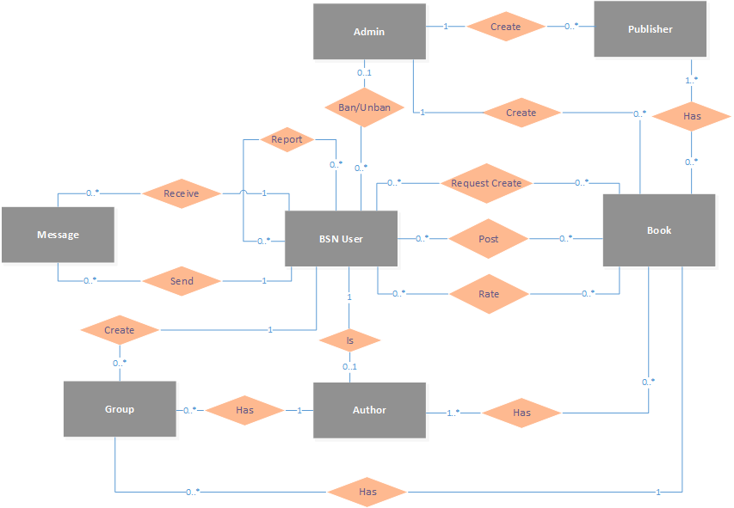

**Figure 2‑1:** Entity Relationship Diagram

#### Entity description

|  |  |  |
| --- | --- | --- |
| **No** | **Entity** | **Description** |
|  | BSN User | User is all people who using BSN feature |
|  | Author | Kind of special User that has book on their own in BSN |
|  | Admin | User that manager BSN system |
|  | Book | A book which user can view or interact with it |
|  | Publisher | A Publisher which produce book |
|  | Group | A Group which user created and joined |
|  | Message | A Message which user send or receive to talk together |

**Table 2-3:** Entity description

#### Relationship

|  |  |  |  |  |
| --- | --- | --- | --- | --- |
| **No** | **Relation** | **From** | **To** | **Description** |
|  | Create | Admin | Publisher | An admin create publishers and a publisher is created by an admin |
|  | Create | Admin | Book | An admin creates a books and a book is created by an admin |
|  | Has | Book | Publisher | Each book has its publishers |
|  | Ban/Unban | Admin | BSN User | Admin bans/unbans BSN users form system |
|  | RequestCreate | BSN User | Book | A BSN user request to create new books |
|  | Post | BSN User | Book | BSN users posts about books |
|  | Rate | BSN User | Book | BSN user rate for a books |
|  | Receive | BSN User | Message | BSN user receive messages from other BSN users |
|  | Send | BSN User | Message | BSN user send messages to other BSN Users |
|  | Create | BSN User | Group | BSN user create groups |
|  | Has | Group | Author | Each group is about an author or a book |
|  | Has | Group | Book | Each group is about an author or a book |
|  | Has | Author | Book | Author has books |

Table 2‑1: Relationship description

### Table Diagram

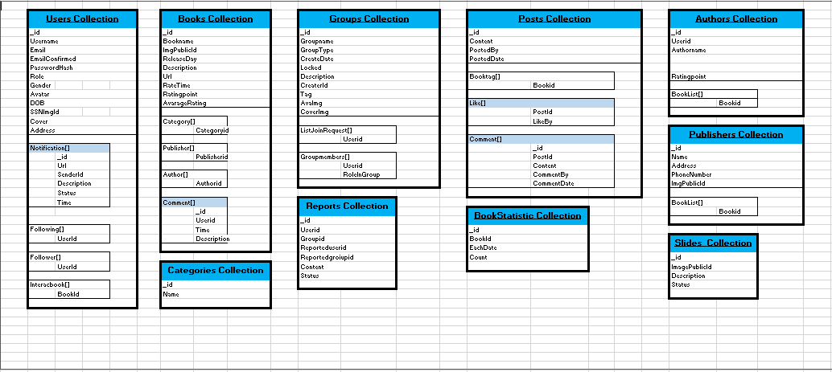

**Figure 2‑2:** Table Diagram

#### Users Collection

|  |  |  |  |
| --- | --- | --- | --- |
| Filed Name | | Type | Description |
| _id | | ObjectId | Mongodb objectid  Unique for each document |
| UserName | | String | User’s name |
| Email | | String | User’s Email |
| EmailConfirmed | | Boolean | Status of registration confirmation via email |
| PasswordHash | | String | Password encrypt by SHA 256 |
| Role | | String | User’s role |
| Gender | | String | User’s gender |
| Avatar | | String | Publicid of user’s avatar in cloudinary |
| Cover | | String | Publicid of user’s cover in cloudinary |
| DOB | | DateTime | User’s date of birth |
| Address | | String | User’s address |
| SSNImgId | | String | User’s SSN image publicid in cloudinary |
| Interacbook |  | Array[String] | List of book’s id that user interac with it |
| BookId | ObjectId | Book’s id |
| Follower |  | Array[String] | List other user’s id that follow user’s account |
| UserId | ObjectId | User’s id |
| Following |  | Array[String] | List other user’s id that user followed |
| UserId | ObjectId | User’s id |
| Notification |  | BsonArray | List user’s notification |
|  | _id | ObjectId | User’s id |
| Url | String | Notification’s link |
| SenderId | ObjectId | Sender’s id |

Table 2‑2: Users Collection

#### Posts Collection

|  |  |  |  |
| --- | --- | --- | --- |
| Field Name | | Type | Description |
| _id | | ObjectId | Mongodb objectid  Unique for each document |
| Content | | String | User’s post content |
| PostedBy | | String | User’s id |
| PostedDate | | DateTime | Time of user’s post |
| BookTag |  | Array[String] | List of book taged in user’s posst |
| BookId | ObjectId | Book’s id |
| Like |  | BsonArray | List like of user’s post |
|  | PostId | String | User’s Post’s id |
| LikeBy | String | User’s id |
| Comment |  | BsonArray | List comment of user’s post |
|  | _id | ObjectId | Mongodb objectid  Unique for each document |
| PostId | String | User’s Post’s id |
| Content | String | Content of User’s comment |
| CommentedBy | String | User’s id |
| CommentedDate | DateTime | Comment’s date |

Table 2‑3: Posts Collection

#### Books Collection

|  |  |  |  |
| --- | --- | --- | --- |
| Field Name | | Type | Description |
| _id | | ObjectId | Mongodb objectid  Unique for each document |
| BookName | | String | Book’s name |
| ImgPublicId | | String | Book’s image publicid in cloudinary |
| ReleaseDay | | DateTime | Date of book release |
| Url | | String | Link detail of book |
| Description | | String | Content of book |
| RateTime | | Int | Sum rating point of each rate |
| RatingPoint | | Int | Sum rating time |
| AvarageRating | | Double | RatingPoint/RateTime |
| Category |  | Array[String] | List category’s id of book |
| CategoryId | ObjectId | Category’s id |
| Publisher |  | Array[String] | List publisher’s id of book |
| PublisherId | ObjectId | Publisher’s id |
| Author |  | Array[String] | List author’s id of book |
| AuthorId | ObjectId | Author’s id |
| Comment |  | BsonArray | List comment of book |
|  | _id | ObjectId | Mongodb objectid |
| UserId | ObjectId | Mongodb objectid |
| Time | DateTime | Date time of comment |
| Description | String | Content of comment |

Table 2‑4: Books Collection

#### Authors Collection

|  |  |  |  |
| --- | --- | --- | --- |
| Field Name | | Type | Description |
| _id | | ObjectId | Mongodb objectid  Unique for each document |
| UserId | | ObjectId | User’s id |
| AuthorName | | String | Name of Author |
| RatingPoint | | Double | Author’s rating point |
| BookList |  | Array[String] | List Book of Author |
| BookId | ObjectId | Book’s id |

Table 2‑5: Authors Collection

#### Publishers Collection

|  |  |  |
| --- | --- | --- |
| Field Name | Type | Description |
| _id | ObjectId | Mongodb objectid  Unique for each document |
| Name | String | Publisher’s name |
| PhoneNumber | String | Publisher’s phone number |
| ImagePublicId | String | Publisher’s image publicid in cloudinary |
| Address | String | Publisher’s address |

Table 2‑6: Publishers Collection

#### Reports Collection

|  |  |  |
| --- | --- | --- |
| Field Name | Type | Description |
| _id | ObjectId | Mongodb objectid  Unique for each document |
| UserId | ObjectId | User’s id |
| GroupId | ObjectId | Group’s id |
| Reporteduserid | ObjectId | Id of user reported |
| Reportedgroupid | ObjectId | Id of group reported |
| Content | String | Content of report |
| Status | Boolean |  |

Table 2‑7: Reports Collection

#### Category Collection

|  |  |  |
| --- | --- | --- |
| Field Name | Type | Description |
| _id | ObjectId | Mongodb objectid  Unique for each document |
| Name | String | Category’s name |

Table 2‑8: Category Collection

#### Groups Collection

|  |  |  |  |
| --- | --- | --- | --- |
| Field Name | | Type | Description |
| _id | | ObjectId | Mongodb objectid  Unique for each document |
| GroupName | | String | Book’s name |
| Locked | | Boolean | Status of group(lock or not) |
| GroupType | | String | Group’s type |
| CreateDate | | DateTime | Date time group created |
| Tag | | String | Group’s tag(author’s name or book’s name) |
| CreaterId | | String | Id of user that created group |
| Description | | String | Content of group |
| CoverImg | | String | Group cover’s image public id in cloudinary |
| AvaImg | | String | Group avatar’s image public id in cloudinary |
| ListJoinRequest |  | Array[String] | List of users request to join group |
| UserId | ObjectId | User’s id |
| GroupMembers |  | Array[String] | List of group members |
| UserId | ObjectId | User’s id |
| RoleInGroup | String | Group member role name |

Table 2‑9: Groups Collection

#### Slides Collection

|  |  |  |
| --- | --- | --- |
| Field Name | Type | Description |
| _id | ObjectId | Mongodb objectid  Unique for each document |
| ImagePublicId | String | Slide’s image publicid in cloudinary |
| Description | String | Content of slide |
| Status | Boolean | Slide’s status (on or off) |

Table 2‑10: Slides Collection

#### BookStatistic Collection

|  |  |  |
| --- | --- | --- |
| Field Name | Type | Description |
| _id | ObjectId | Mongodb objectid  Unique for each document |
| BookId | String | Book’s id |
| EachDate | DateTime |  |
| Count | int |  |

Table 2‑11: B

## Screen Design

### Guest

#### Register

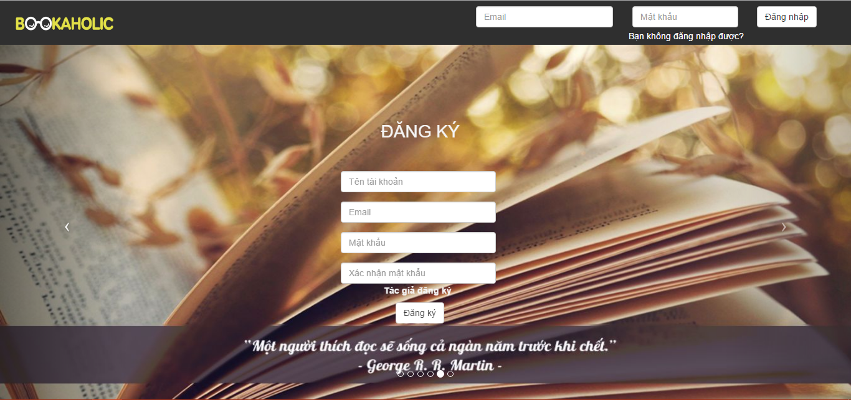

Figure 2.1: Register screen

|  |  |  |  |  |  |  |  |
| --- | --- | --- | --- | --- | --- | --- | --- |
| No | Field name | Field name in Vietnamese | Type | Require | Mandatory | Max-Length | Description |
|  | Register | Đăng ký | Label |  | Y |  | Display register form |
|  | Username | Tên tài khoản | Text box | Type | Y | 8-20 | Username of user |
|  | Email | Email | Textbox | Type | Y |  | Email of user |
|  | Password | Mật khẩu | Text box | Type | Y | 8-50 | Password of user |
|  | Sign up | Đăng ký | Button | Click | Y |  | User register a new account |

Table 2.1: Register screen

#### Reader/Author

##### Login



Figure 2.2:Login screen

|  |  |  |  |  |  |  |  |
| --- | --- | --- | --- | --- | --- | --- | --- |
| No | Field name | Field name in Vietnamese | Type | Require | Mandatory | Max-Length | Description |
|  | Email | Email | Text box | Type | Y |  | Email of registered user |
|  | Password | Mật khẩu | Text box | Type | Y | 8-20 | Password of registered user |
|  | Login | Đăng nhập | Button | Click | Y |  | Login |
|  | Forgot Password | Bạn không đăng nhập được? | Hyperlink | Click | Y |  | Resend password to user |

Table 2.2: Login screen

##### Forget password

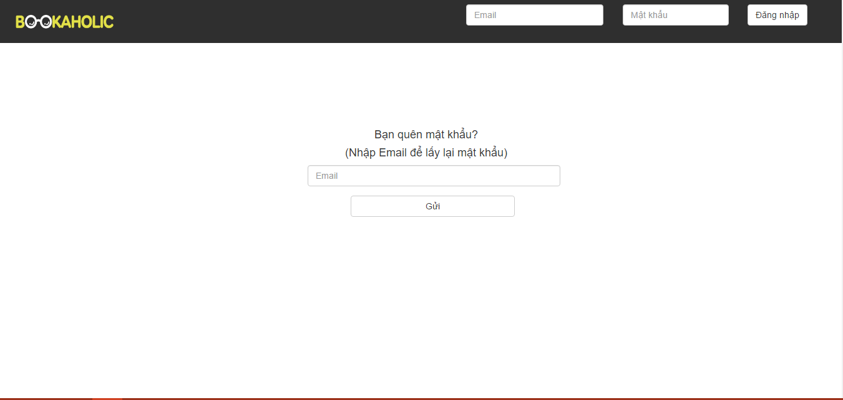

Figure 2.3: Forgot password

|  |  |  |  |  |  |  |  |
| --- | --- | --- | --- | --- | --- | --- | --- |
| No | Field name | Field name in Vietnamese | Type | Require | Mandatory | Max-Length | Description |
| 1 | Email | Khung Email | Text area |  | Y |  | Enter email to reset password. |
| 2 | Send | Gửi | Button | Click | Y |  | Send reset password request to system |

Table 2.3: Forgot password

##### Homepage

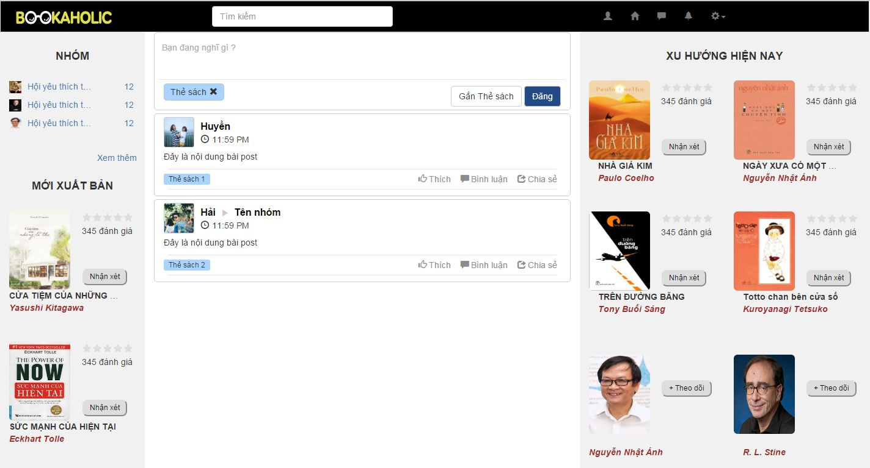

Figure 2.4: Homepage

|  |  |  |  |  |  |  |  |
| --- | --- | --- | --- | --- | --- | --- | --- |
| No | Field name | Field name in Vietnamese | Type | Require | Mandatory | Max-Length | Description |
| 1 | Logo | Bookaholic | Image | Click | Y |  | Display homepage |
| 2 | Search box | Ô tìm kiếm | Textbox |  | Y |  | Search author, book. |
| 3 | Icon User | Trang cá nhân | Icon | Click | Y |  | Display user page |
| 4 | Icon Home | Trang chủ | Icon | Click | Y |  | Reload homepage |
| 5 | Icon comment | Tin nhắn | Icon | Click | Y |  | Displays list of messages |
| 6 | Icon bell | Thông báo | Icon | Click | Y |  | Displays list of notifications |
| 7 | Icon setting | Cài đặt | Icon | Click | Y |  | Display   * Create group * Setting * Logout |
| 8 | Create group | Tạo nhóm | Hyperlink | Click | Y |  | Display create group popup |
| 9 | Setting | Cài đặt | Hyperlink | Click | Y |  | Display edit information page |
| 10 | Logout | Đăng xuất | Hyperlink | Click | Y |  | Redirect to login page |
| 11 | Group | Nhóm | Hyperlink | Click | Y |  | Display group page |
| 12 | Username | Tên người dùng | Hyperlink | Click | Y |  | Display personal page |
| 13 | Book | Sách | Image | Click | Y |  | Show image’s book and name, author.  When click the image’s book then display book page. |
| 14 | Rating | Đánh giá | Icon |  | Y |  | Display average rating point |
| 15 | Button recommendation | Nhận xét | Button | Click | Y |  | Display the form to post comment about this book. |
| 16 | Form comment  (Click button recommendation) | Tên sách | Hyperlink | Click | Y |  | Display the new tag : Bookpage |
| Ảnh người dùng | Image |  | Y |  | Display the image of user |
| Khung nhập nội dung | Textarea | Type | Y |  | Allow enter feelings about the book |
| Thẻ sách | Text |  | Y |  | Display book tag |
| Nút post | Button | Click | Y |  | Posted 1 post comments on personal pages |
| 17 | Form recommendation | Khung nhập nội dung | Textarea | Type | Y |  | Allow enter feelings about the book |
| Gắn thẻ sách | Button | Click | Y |  | Display the input form to enter the booktag |
| Nút post | Button | Click | Y |  | Posted 1 post comments on personal pages |
| 18 | Review form | Ảnh đại diện người dùng | Image |  | Y |  | Display image of user |
| Tên người dùng | Text | Click | Y |  | Display the personal page |
| Thời gian đăng bài | Time |  | Y |  | Show time post comments |
| Nội dung | Text |  | Y |  | Show the comment of user about book |
| Thẻ sách | Text |  | Y |  | Display book tag |
| Thích | Button | Click | Y |  | Switch to liked status and increase the number of likes. |
| 19 | Author | Tác giả | Image | Click | Y |  | Show image’s author and name of author.  When click the image’s book then display author page |
| 20 | Button Follow | Nút theo dõi | Button | Click | Y |  | Switch to followed status |
| 21 | Publisher | Nhà xuất bản | Image |  | Y |  | Show image’s publisher and name of publisher, rating . |

Table 2.4: HomePage

##### Personal page

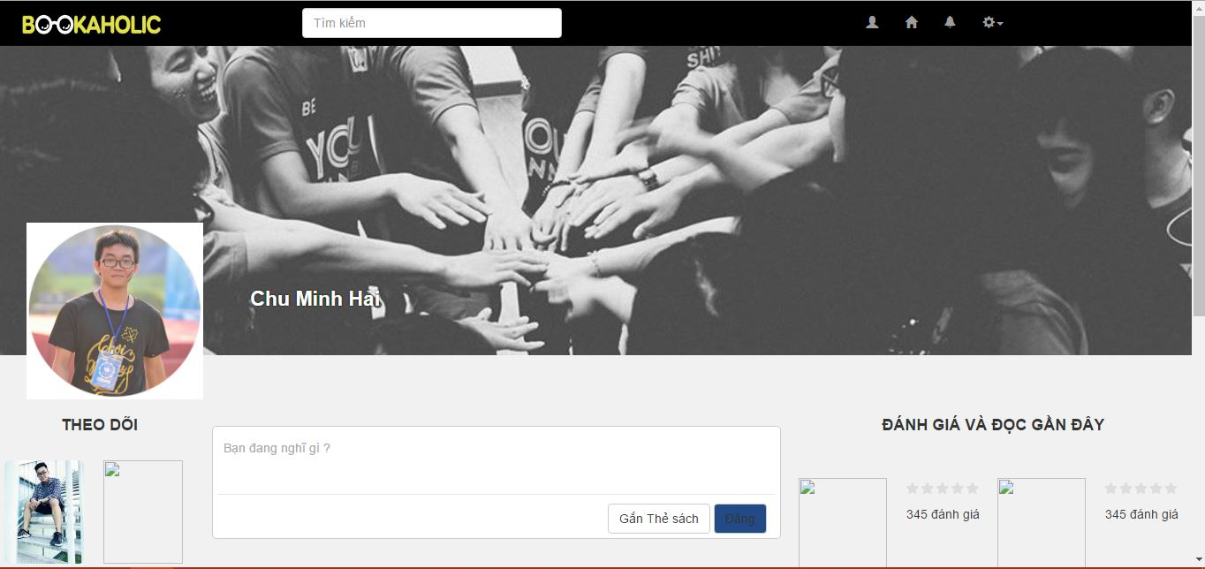

Figure 2.5: Personal Page

|  |  |  |  |  |  |  |  |
| --- | --- | --- | --- | --- | --- | --- | --- |
| No | Field name | Field name in Vietnamese | Type | Require | Mandatory | Max-Length | Description |
|  | Logo | Bookaholic | Image | Click | Y |  | Display homepage |
|  | Search box | Ô tìm kiếm | Textbox |  | Y |  | Search author, book. |
|  | Icon User | Trang cá nhân | Icon | Click | Y |  | Display user page |
|  | Icon Home | Trang chủ | Icon | Click | Y |  | Reload homepage |
|  | Icon comment | Tin nhắn | Icon | Click | Y |  | Displays list of messages |
|  | Icon bell | Thông báo | Icon | Click | Y |  | Displays list of notifications |
|  | Icon setting | Cài đặt | Icon | Click | Y |  | Display   * Create group * Setting * Logout |
|  | Create group | Tạo nhóm | Hyperlink | Click | Y |  | Display create group popup |
|  | Setting | Cài đặt | Hyperlink | Click | Y |  | Display edit information page |
|  | Logout | Đăng xuất | Hyperlink | Click | Y |  | Redirect to login page |
|  | Recommendation | Khung nhận xét | Text field |  | Y |  | Use to enter a recommendation |
|  | Tag a book | Gắn thẻ sách | Button | Click | Y |  | Click button to tag a book or tag an author |
|  | Post | Đăng | Button | Click | Y |  | Click to post a recommendation |
|  | Avatar | Ảnh đại diện | Image |  | Y |  | Avatar of user |
|  | Change avatar | Thay đổi ảnh đại diện | Hyperlink | Click | Y |  | Click to change avatar |
|  | Cover | Ảnh bìa | Image |  | Y |  | Cover of user |
|  | Change cover | Thay đổi ảnh bìa | Hyperlink | Click | Y |  | Click to change cover |
|  | Username | Tên người dùng | Hyperlink | Click | Y |  | Redirect to user page |
|  | Book’s image | Ảnh bìa sách | Image |  | Y |  |  |
|  | Book name | Tên sách | Hyperlink | Click | Y |  | Redirect to book page |

Table 2.5: Personal Page

##### Edit profile

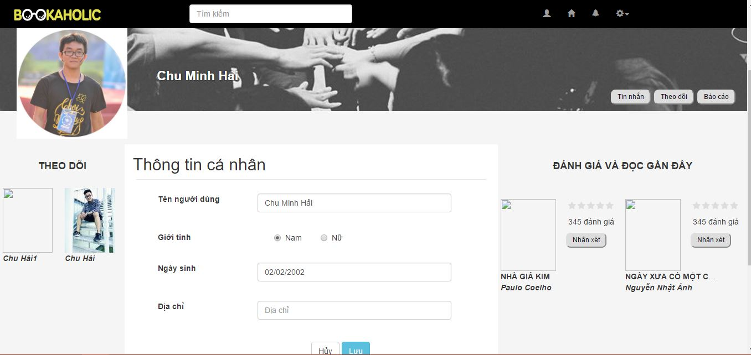

Figure 2.6: Edit profile

|  |  |  |  |  |  |  |  |
| --- | --- | --- | --- | --- | --- | --- | --- |
| No | Field name | Field name in Vietnamese | Type | Require | Mandatory | Max-Length | Description |
| 1 | Username | Tên người dùng | Text field |  | Y |  | Text field can be edited to change username |
| 2 | Gender | Giới tính | Radio buttons | Click | Y |  | Click to change gender of user |
| 3 | Date of birth | Ngày sinh | Text field |  | Y |  | Edit to change date of birth |
| 4 | Address | Địa chỉ | Text field |  | Y |  | Edit to change address |
| 5 | Cancel | Huỷ | Button | Click | Y |  | When click cancel button, all editing info will cancel |
| 6 | Save | Lưu | Button | Click | Y |  | Click to save all editing info |

Table 2.6: Edit profile

##### Report user

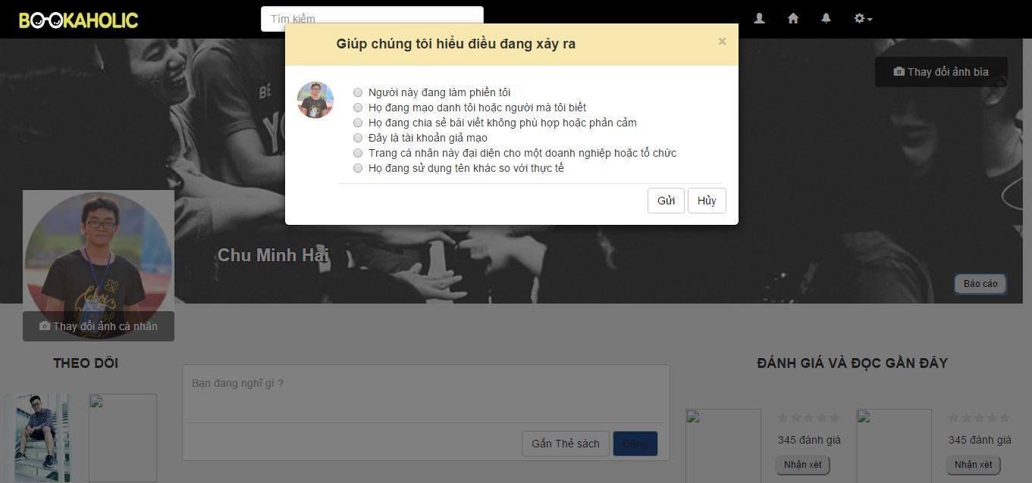

Figure 2.7: Report user

|  |  |  |  |  |  |  |  |
| --- | --- | --- | --- | --- | --- | --- | --- |
| No | Field name | Field name in Vietnamese | Type | Require | Mandatory | Max-Length | Description |
|  | Avatar | Ảnh đại diện | Image |  | Y |  | Avatar of reported user |
|  | Radio buttons | Người này đang làm phiền tôi | Label | Click | Y |  | List of reasons, click to choose a reason |
|  | Send | Gửi | Button | Click | Y |  | Click to send report to admin |
|  | Cancel | Hủy | Button | Click | Y |  | Cancel reporting, close popup |

Table 2.7: Report user

##### Request to add books

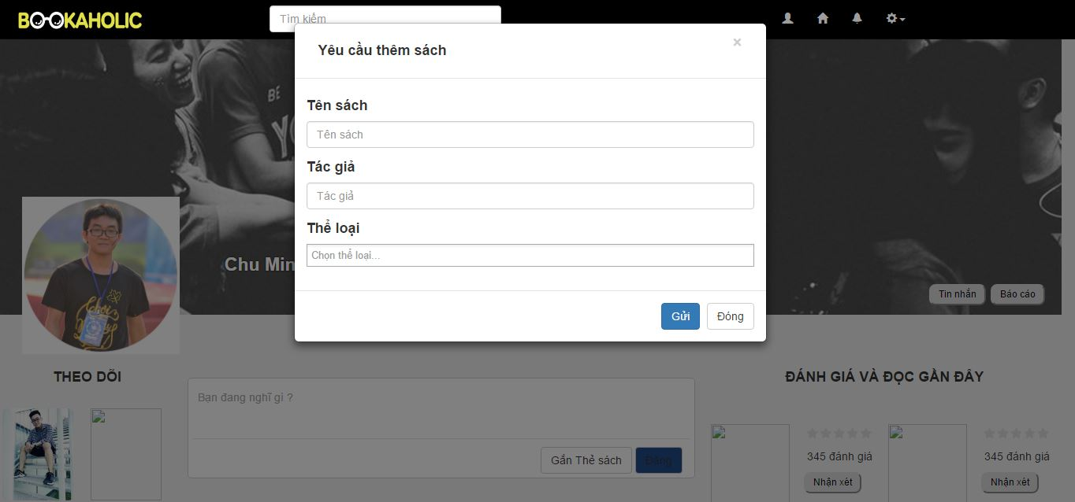

Figure 2.8: Request to add books

|  |  |  |  |  |  |  |  |
| --- | --- | --- | --- | --- | --- | --- | --- |
| No | Field name | Field name in Vietnamese | Type | Require | Mandatory | Max-Length | Description |
| 1 | Book’s name | Tên sách | Text field |  | Y |  | Request book’s name |
| 2 | Author | Tác giả | Text field |  | Y |  | Request book’s author |
| 3 | Category | Thể loại | Text field |  | Y |  | Request book’s category |
| 4 | Send | Gửi | Button |  | Y |  | When click, send request to admin |
| 5 | Close | Đóng | Button |  | Y |  | When click, close popup |

Table 2.8: Request to add books

##### Create a group

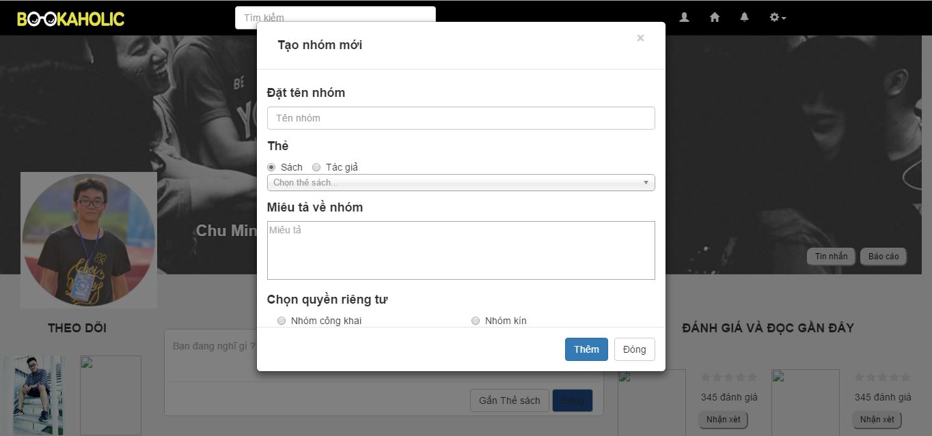

Figure 2.9: Create a group

|  |  |  |  |  |  |  |  |
| --- | --- | --- | --- | --- | --- | --- | --- |
| No | Field name | Field name in Vietnamese | Type | Require | Mandatory | Max-Length | Description |
| 1 | Name of group | Tên nhóm | Text field |  | Y |  |  |
| 2 | Book | Sách | Button | Click | Y |  |  |
| 3 | Author | Tác giả | Button | Click | Y |  |  |
| 4 | Category | Thể loại | Combo box | Click | Y |  |  |
| 5 | Description | Miêu tả | Text area |  | Y |  |  |
| 6 | Public group | Nhóm công khai | Radio button | Click | Y |  |  |
| 7 | Closed group | Nhóm kín | Radio button | Click | Y |  |  |
|  |  |  |  |  |  |  |  |

Table 2.9: Create a group

##### Group page

###### Group page-Conversation

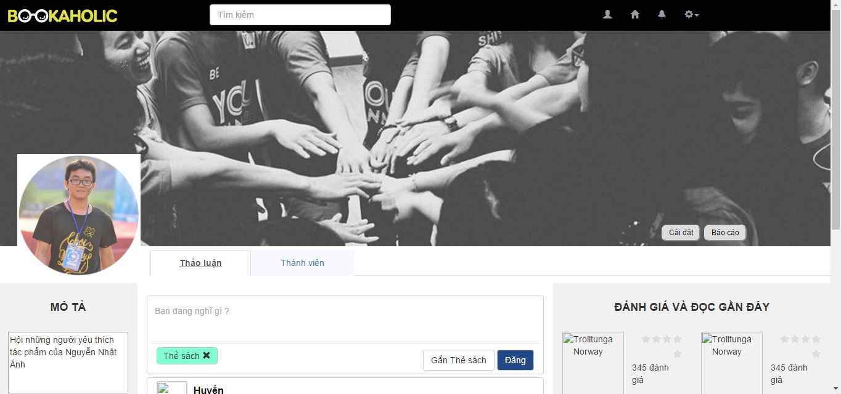

Figure 2.10.1: Group Page-Conversation

|  |  |  |  |  |  |  |  |
| --- | --- | --- | --- | --- | --- | --- | --- |
| No | Field name | Field name in Vietnamese | Type | Require | Mandatory | Max-Length | Description |
|  | Logo | Bookaholic | Image | Click | Y |  | Display homepage |
|  | Search box | Ô tìm kiếm | Textbox |  | Y |  | Search author, book. |
|  | Icon User | Trang cá nhân | Icon | Click | Y |  | Display user page |
|  | Icon Home | Trang chủ | Icon | Click | Y |  | Reload homepage |
|  | Icon comment | Tin nhắn | Icon | Click | Y |  | Displays list of messages |
|  | Icon bell | Thông báo | Icon | Click | Y |  | Displays list of notifications |
|  | Icon setting | Cài đặt | Icon | Click | Y |  | Display   * Create group * Setting * Logout |
|  | Create group | Tạo nhóm | Hyperlink | Click | Y |  | Display create group popup |
|  | Setting | Cài đặt | Hyperlink | Click | Y |  | Display edit information page |
|  | Logout | Đăng xuất | Hyperlink | Click | Y |  | Redirect to login page |
|  | Recommendation | Khung nhận xét | Text field |  | Y |  | Use to enter a recommendation |
|  | Description | Mô tả nhóm | Label |  | Y |  |  |
|  | Description’s content | Nội dung mô tả | Text area | Click | Y |  | Description about group |
|  | Group setting | Cài đặt | Button | Click | Y |  | When click, redirect to group setting page |
|  | Report group | Ảnh đại diện | Image |  | Y |  | Avatar of reported group |
| Người này đang làm phiền tôi | Label | Click | Y |  | List of reasons, click to choose a reason |
| Gửi | Button | Click | Y |  | Click to send report to admin |
| Hủy | Button | Click | Y |  | Cancel reporting, close popup |
|  | Post | Đăng | Button | Click | Y |  | Click to post a recommendation |
|  | Avatar | Ảnh đại diện | Image |  | Y |  | Avatar of group |
|  | Change avatar | Thay đổi ảnh đại diện | Hyperlink | Click | Y |  | Click to change avatar |
|  | Cover | Ảnh bìa | Image |  | Y |  | Cover of group |
|  | Change cover | Thay đổi ảnh bìa | Hyperlink | Click | Y |  | Click to change cover |
|  | Username | Tên người dùng | Hyperlink | Click | Y |  | Redirect to user page |
|  | Book’s image | Ảnh bìa sách | Image |  | Y |  |  |
|  | Book name | Tên sách | Hyperlink | Click | Y |  | Redirect to book page |

Table 2.10.1: Group Page-Conversation

###### Group page-Members

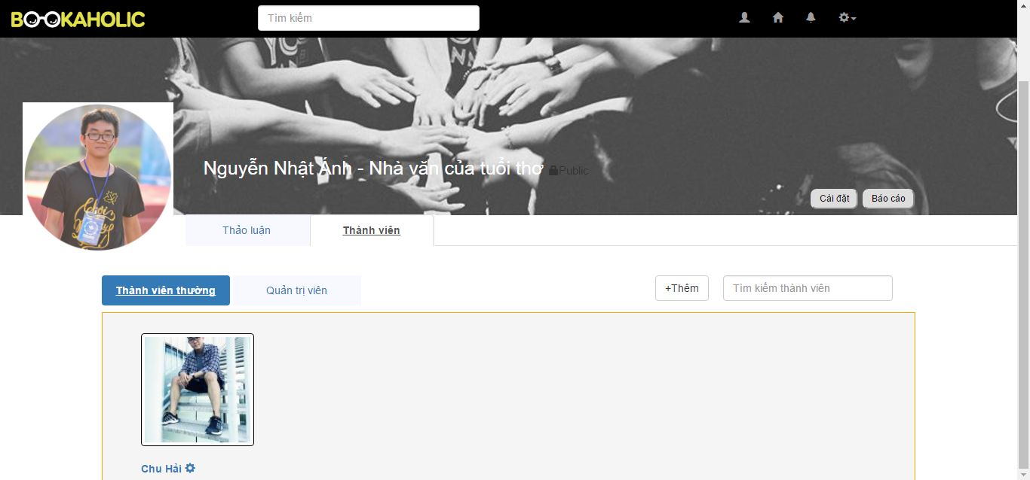

Figure 2.10.2.1: Group Page-Members

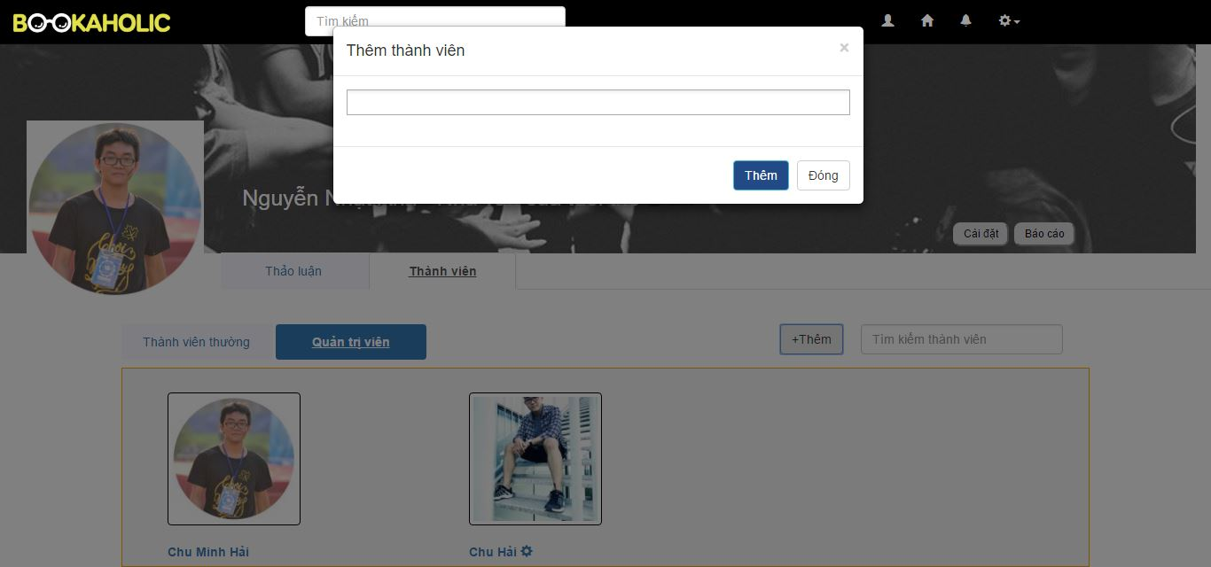

Figure 2.10.2.2: Add new member

|  |  |  |  |  |  |  |  |
| --- | --- | --- | --- | --- | --- | --- | --- |
| No | Field name | Field name in Vietnamese | Type | Require | Mandatory | Max-Length | Description |
|  | Search | Ô tìm kiếm | Search box | Click | Y |  | Search members |
|  | Add new member | Thêm thành viên mới | Button | Click | Y |  | Display popup with:  - Enter username text field  - Add button  - Close button |
| Nhập tên người dùng | Text field |  | Y |  | Enter a username to add to group |
| Nút thêm | Button |  | Y |  | When click, add selected user to group |
| Nút đóng | Button |  | Y |  | When click, cancel adding new member and close popup |
|  | Normal member | Ảnh đại diện của thành viên | Image |  | Y |  | Member’s avatar |
| Tên thành viên | Hyperlink | Click | Y |  | When click, redirect to member page |
| Biểu tượng cài đặt | Icon | Click | Y |  | When click, show modify popup:  - Set as an admin  - Remove from group |
|  | Modify popup | Thêm với tư cách quản lý | Hyperlink | Click | Y |  | Set member as an admin |
| Xóa khỏi nhóm | Hyperlink | Click | Y |  | Remove user from group. User no longer be as a member of group |
|  | Admin | Ảnh đại diện của quản trị viên | Image |  | Y |  | Admin’s avatar |
| Tên quản trị viên | Hyperlink | Click | Y |  | When click, redirect to user page |
| Biểu tượng cài đặt | Icon | Click | Y |  | When click, show modify admin popup:  - Remove as an admin  - Remove from group |
|  | Modify admin popup | Xóa với tư cách quản lý | Hyperlink | Click | Y |  | Remove admin right and become a member |
| Xóa khỏi nhóm | Hyperlink | Click | Y |  | Remove user from group. User no longer be as a member of group |

Table 2.10.2: Group Page-Members

##### Setting group

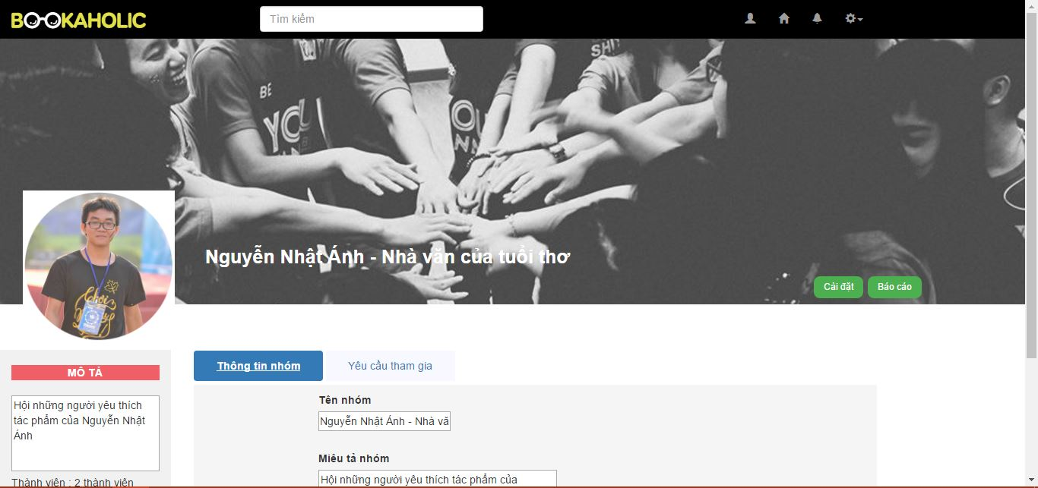

Figure 2.11.1: Edit group

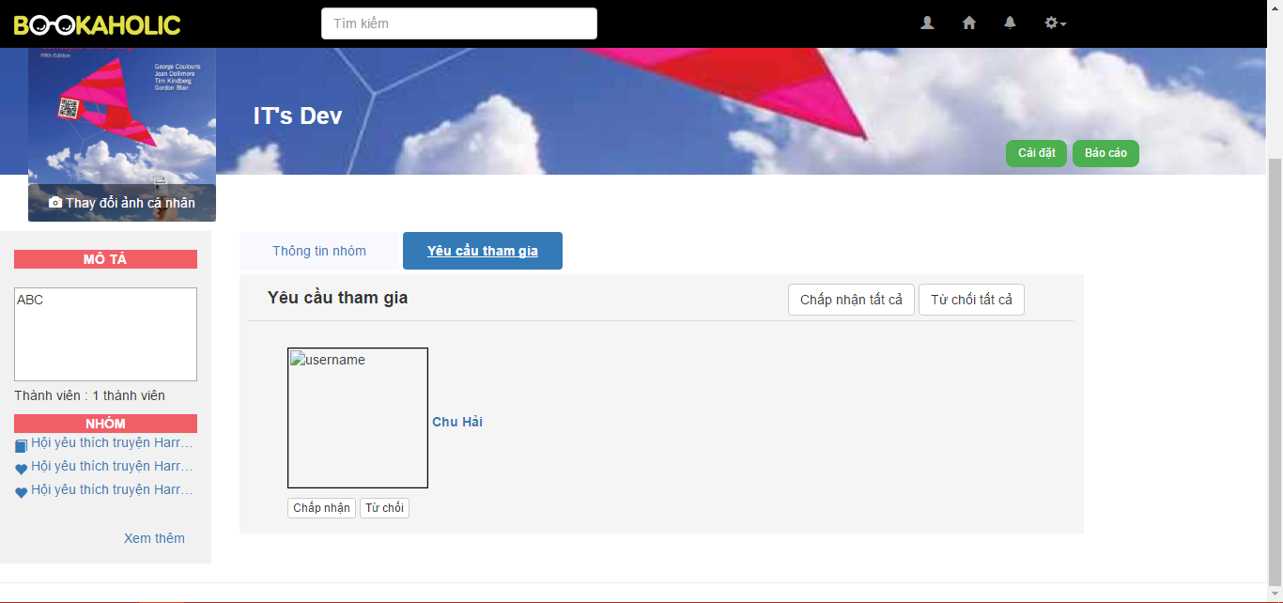

Figure 2.11.2: Accept to join

|  |  |  |  |  |  |  |  |
| --- | --- | --- | --- | --- | --- | --- | --- |
| No | Field name | Field name in Vietnamese | Type | Require | Mandatory | Max-Length | Description |
|  | Edit group tab | Tên nhóm | Hyperlink | Click | Y |  | Click to redirect to group page |
| Mô tả nhóm | Label |  | Y |  |  |
| Nội dung mô tả | Textarea | Click | Y |  | Description about group |
| Thông tin nhóm | Hyperlink | Click | Y |  | Group’s information tab |
| Yêu cầu tham gia | Hyperlink | Click | Y |  | Join-group request tab |
| Nhãn Tên nhóm | Label |  | Y |  |  |
| Tên nhóm | Text area |  | Y |  | Group name’s text area. Admin can edit to change |
| Nút radio | Button | Click | Y |  | Click to choose Public or Private Group’s type |
| Mô tả nhóm | Text area |  | Y |  | Group description’s text area. Admin can edit to change |
| Nút lưu | Button | Click | Y |  | When click, save and update all group’s info |
|  | Accept to join | Chấp nhận tất cả | Button | Click | Y |  | Accept all join-group requests |
| Từ chốt tất cả | Button | Click | Y |  | Denied all join-group requests |
| Tên người dùng | Hyperlink | Click | Y |  | When click, redirect to user page |
| Chấp nhận | Button | Click | Y |  | Accept chosen request |
| Từ chối | Button | Click | Y |  | Denied chosen request |

Table 2.11: Setting group

#### Admin

##### Login



Figure 3.1: Login

|  |  |  |  |  |  |  |  |
| --- | --- | --- | --- | --- | --- | --- | --- |
| No | Field name | Field name in Vietnamese | Type | Require | Mandatory | Max-Length | Description |
|  | Register | Đăng ký | Label |  | Y |  | Display register form |
|  | Username | Tên tài khoản | Text box | Type | Y | 20 | Username of Admin |
|  | Email | Email | Textbox | Type | Y |  | Email of Admin |
|  | Password | Mật khẩu | Text box | Type | Y | 50 | Password of Admin |

Table 3.1: Login

##### User management

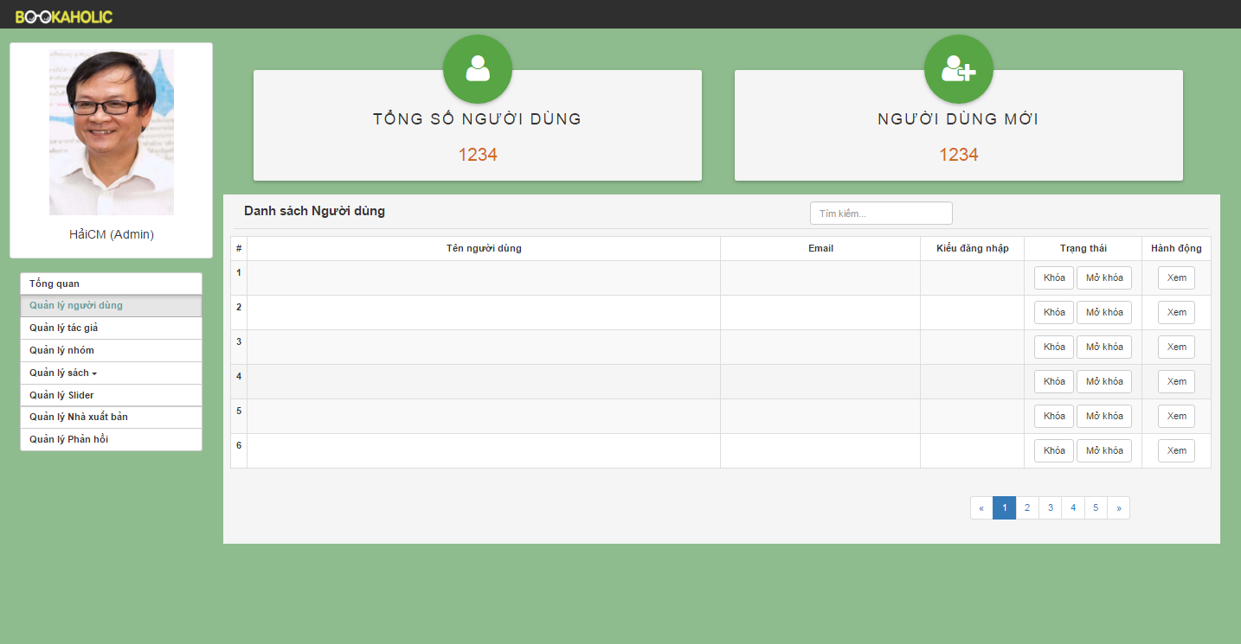

Figure 3.2: User management

|  |  |  |  |  |  |  |  |
| --- | --- | --- | --- | --- | --- | --- | --- |
| No | Field name | Field name in Vietnamese | Type | Require | Mandatory | Max-Length | Description |
| 1 | Total users | Tổng số người dùng | Label |  | Y |  | Total users registed |
| 2 | Total new users | Người dùng mới | Label |  | Y |  | Total new users |
| 3 | List user | Danh sách người dùng | Table |  | Y |  | List users  (User name, email, kind of login, status, action) |
| 4 | View button | Xem | Button | Click | Y |  | When click the view button then display user page. |

Table 3.2: User management

##### Author management

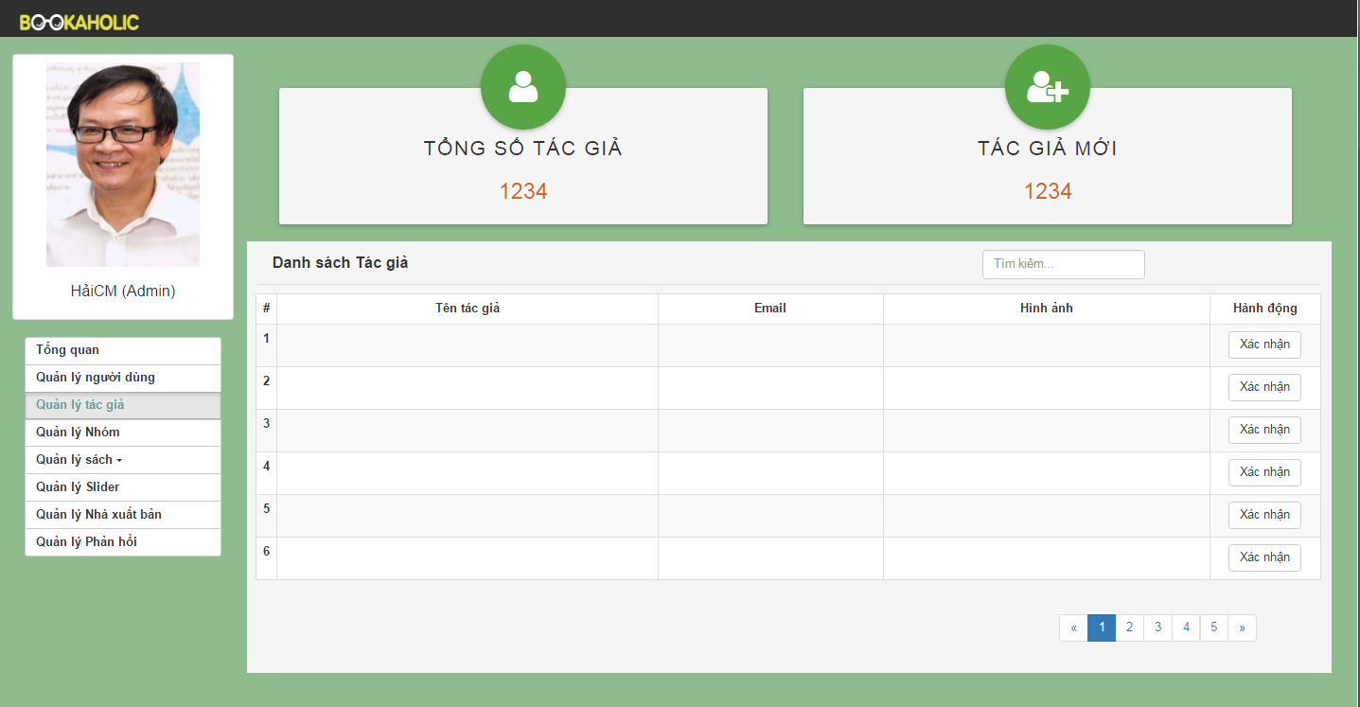

Figure 3.3: Author Management

|  |  |  |  |  |  |  |  |
| --- | --- | --- | --- | --- | --- | --- | --- |
| No | Field name | Field name in Vietnamese | Type | Require | Mandatory | Max-Length | Description |
| 1 | Total authors | Tổng số tác giả | Label |  | Y |  | Total authors registed |
| 2 | Total new authors | Tác giả mới | Label |  | Y |  | Total new authors |
| 3 | List author | Danh sách tác giả | Table |  | Y |  | List authors  (Author name, email, image, status, action) |
| 4 | Verify  button | Nút xác nhận | Butoon | Click | Y |  | Admin will confirm when author registed |

Table 3.3: Author management

##### Group management

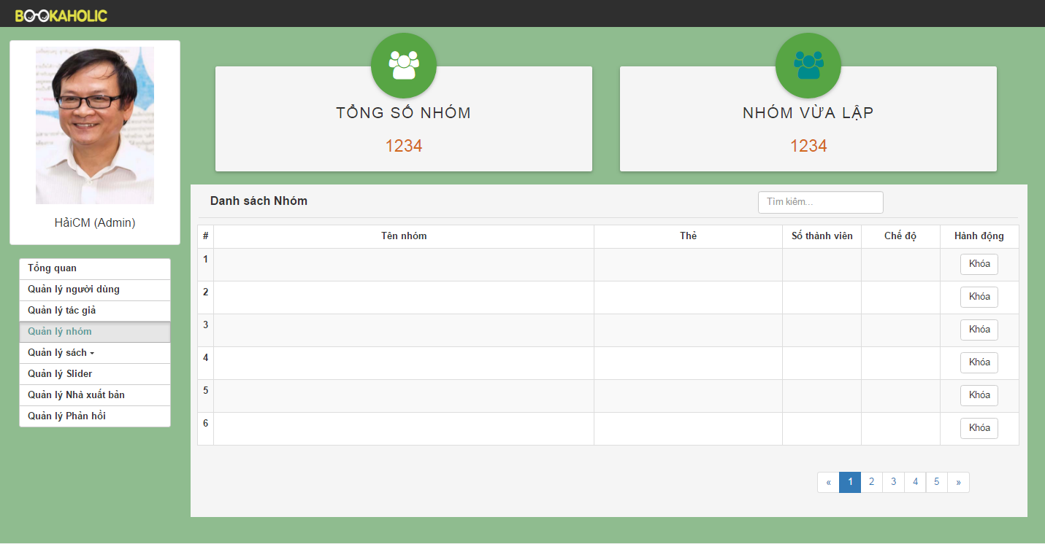

Figure 3.4: Group Management

|  |  |  |  |  |  |  |  |
| --- | --- | --- | --- | --- | --- | --- | --- |
| No | Field name | Field name in Vietnamese | Type | Require | Mandatory | Max-Length | Description |
| 1 | Total groups | Tổng số nhóm | Label |  | Y |  | Total groups |
| 2 | Total new groups | Tác giả mới | Label |  | Y |  | Total new groups |
| 3 | List group | Danh sách group | Table |  | Y |  | List groups  (Group name, tag book or tag author, number of member, public or private, action) |
| 4 | Lock button | Nút khóa | Button | Click | Y |  | Lock group |
|  |  |  |  |  |  |  |  |

Table 3.4: Group Management

##### Book management

###### Statistics books

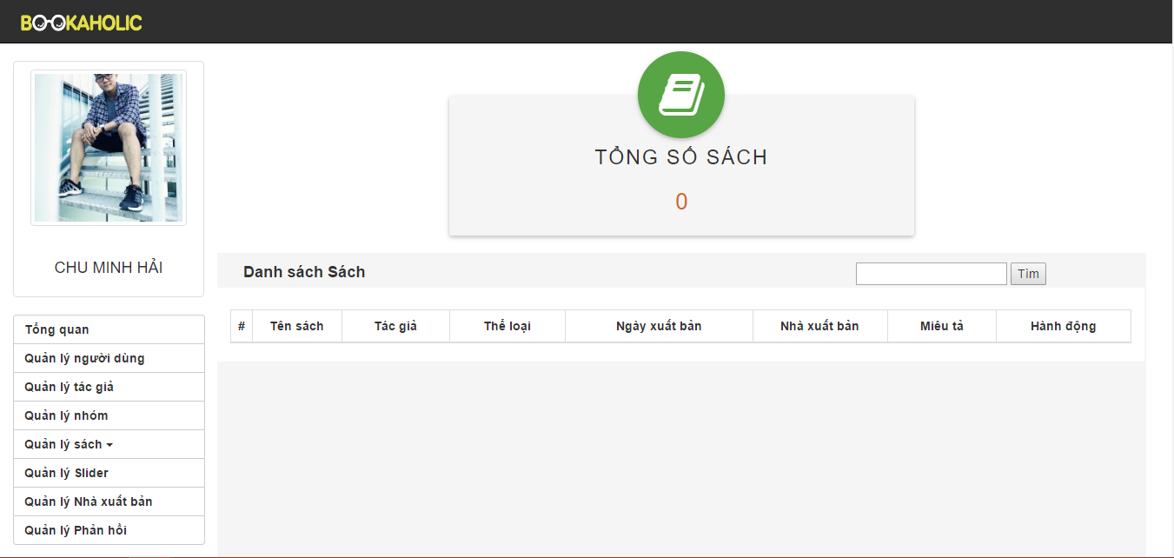

Figure 3.5.1: Statistics books

|  |  |  |  |  |  |  |  |
| --- | --- | --- | --- | --- | --- | --- | --- |
| No | Field name | Field name in Vietnamese | Type | Require | Mandatory | Max-Length | Description |
| 1 | Total books | Tổng số sách | Label |  | Y |  | Total books |
| 2 | Button Add book | Thêm sách mới | Button | Click | Y |  | When click the button add book then link to add book page.. |
| 3 | Search | Tìm kiếm | Textbox | Click | Y |  | Search about book |
| 4 | List book | Danh sách sách | Table |  | Y |  | List books (book’name, author, category, publishing date, action) |
| 5 | Edit button | Nút sửa | Button | Click | Y |  | When click button edit then appear popup edit book. |
| 6 | Delete button | Nút xóa | Button | Click | Y |  | When click button delete will this book deleted. |

Table 3.5.1: Statistics books

###### Request add book

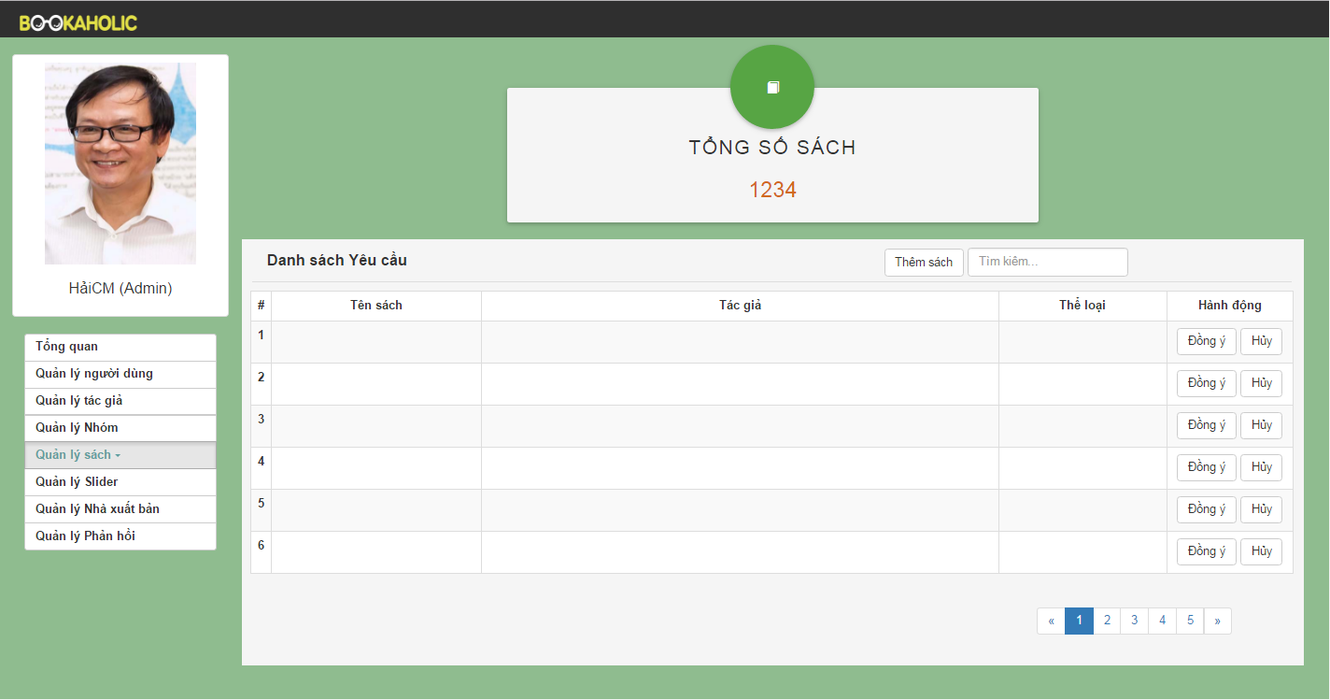

Figure 3.5.2: Request add book

|  |  |  |  |  |  |  |  |
| --- | --- | --- | --- | --- | --- | --- | --- |
| No | Field name | Field name in Vietnamese | Type | Require | Mandatory | Max-Length | Description |
| 1 | Total books | Tổng số sách | Label |  | Y |  | Total books |
| 2 | Button Add book | Thêm sách mới | Button | Click | Y |  | When click the button add book then link to add book page… |
| 3 | Search | Tìm kiếm | Textbox | Click | Y |  | Search about book |
| 4 | List book | Danh sách sách | Table |  | Y |  | List books (book’s name, author, category, publishing date, action). |
| 5 | Agree button | Nút đồng ý | Button | Click | Y |  | When click agree button, the new book will be added. |
| 6 | Button Cancel | Nút hủy | Button | Click | Y |  | When click cancel button , the book will be cancel. |

Table 3.5.2: Request add book

###### Add a book

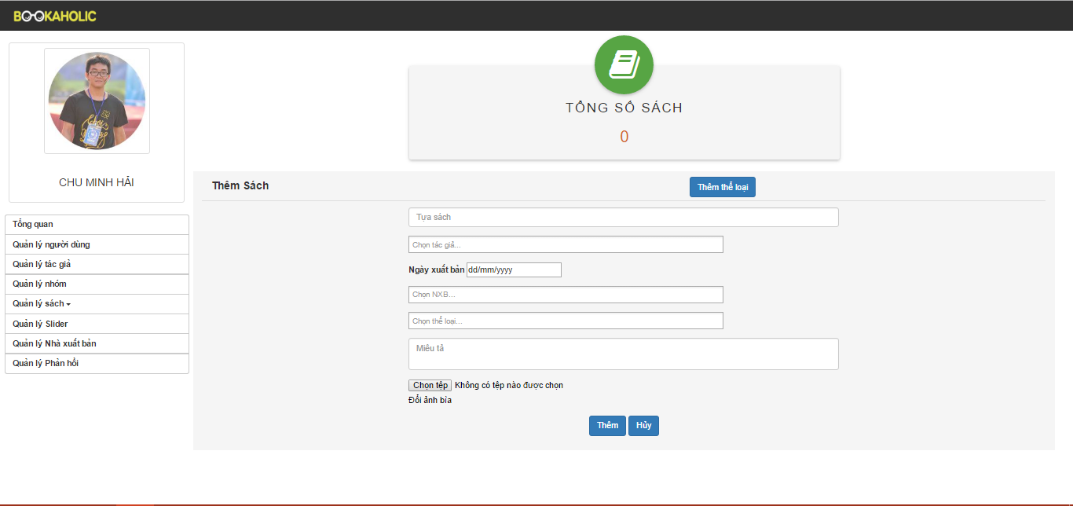

Figure 3.5.3: Add a book

|  |  |  |  |  |  |  |  |
| --- | --- | --- | --- | --- | --- | --- | --- |
| No | Field name | Field name in Vietnamese | Type | Require | Mandatory | Max-Length | Description |
| 1 | Total books | Tổng số sách | Label |  | Y |  | Total books |
| 2 | Button Add new category | Thêm thể loại | Text | Click | Y |  | When click the add new category button will show add new category popup |
| 3 | Add new category popup | Thêm thể loại | Textbox |  | Y |  | Header of popup |
| Ô nhập tên thể loại | Button |  | T |  | Enter new category |
| Nút Thêm | Button | Click | Y |  | When click add button, new category will be added |
| Nút Hủy |  | Click | Y |  | When click cancel button, close popup |
| 4 | Add a book form | Tên sách | Text |  | Y |  | Enter new book name |
| Chọn tác giả | Search box |  | Y |  | Search the author of the book |
| Ngày xuất bản | Choose date | Click | Y |  | Choose exactly publishing date |
| Chọn NXB | Combo box | Click | Y |  | Choose publisher |
| Chọn thể loại | Combo box | Click | Y |  | Choose category of the book |
| Miêu tả | Text field |  | Y |  | Description about the book |
| Chọn ảnh bìa | Button | Click | Y |  | Upload book image |
| Nút Thêm | Button | Click | Y |  | When click add button, new book has added |
| Nút Hủy | Button | Click | Y |  | When click cancel button, cancel adding new book |

Table 3.5.3: Add a book

##### Slider management

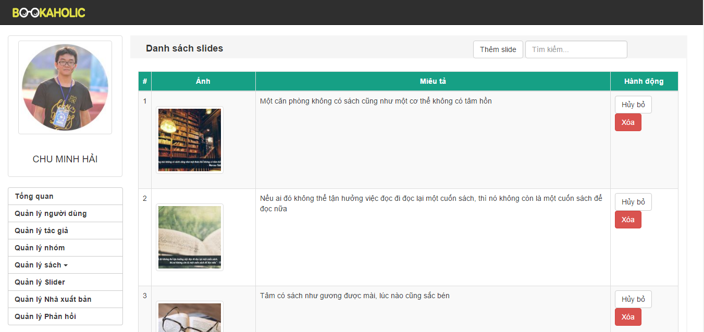

Figure 3.6.1: Slider Management

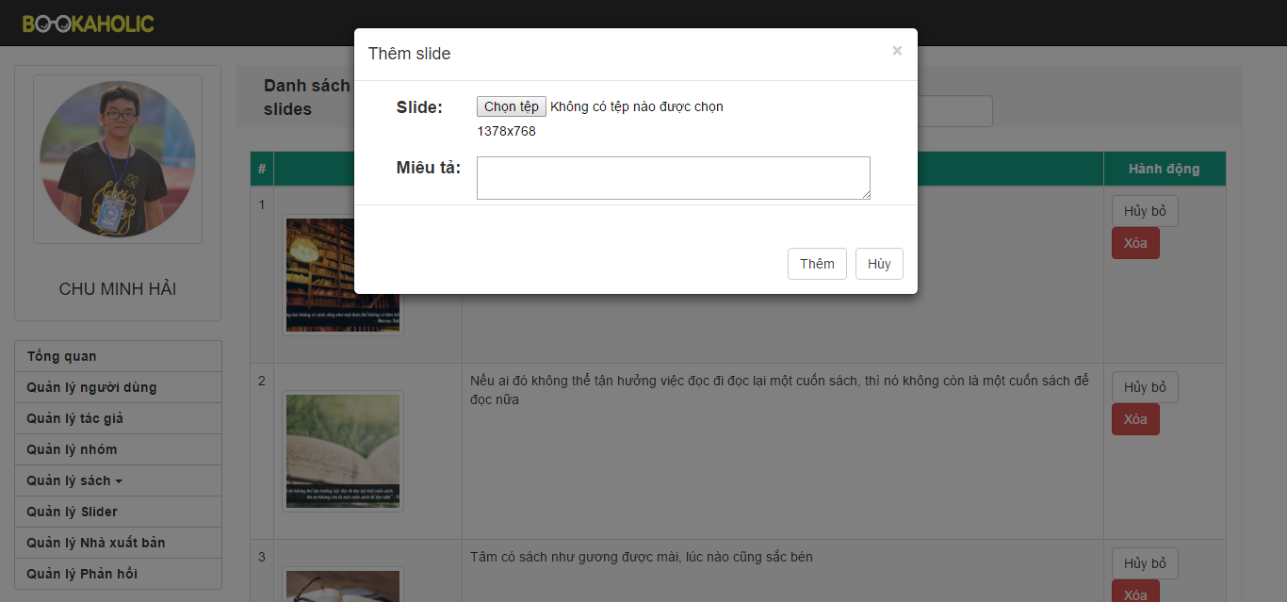

Figure 3.6.2: Popup add slider

|  |  |  |  |  |  |  |  |
| --- | --- | --- | --- | --- | --- | --- | --- |
| No | Field name | Field name in Vietnamese | Type | Require | Mandatory | Max-Length | Description |
| 1 | Add slide button | Thêm slide mới | Button |  | Y |  | When click the add slide button the popup will appear . |
| 2 | Search | Tìm kiếm | Textbox | Click | Y |  | Search slide |
| 3 | Popup Add Slide | Khung thêm slide | Model popup |  | Y |  | Popup appear and allow add new slide |
| Chọn file |  |  | Y |  | Allow choose file |
| Miêu tả | Text input |  | Y |  | Enter the description about the slide |
| Nút thêm | Button | Click | Y |  | When choose file and enter description, then click the add button, the slide will be added. |
| Cancel button | Button | Click | Y |  | When click cancel button, add new slide will be canceled. |
| 4 | List slides | Danh sách slide | Table |  | Y |  | List slides (image, description, on button, off button, action). |
| 5 | On button | Nút bật | Button | Click | Y |  | When click on the on button, the slide will be show in the login page. |
| 6 | Off button | Nút tắt | Button | Click | Y |  | When click on the off button, the slide will be don’t show in the login page. |
| 7 | Delete button | Nút xóa | Button | Click | Y |  | When click on the delete button, the slide will be deleted. |

Table 3.6: Slider Management

##### Publisher management

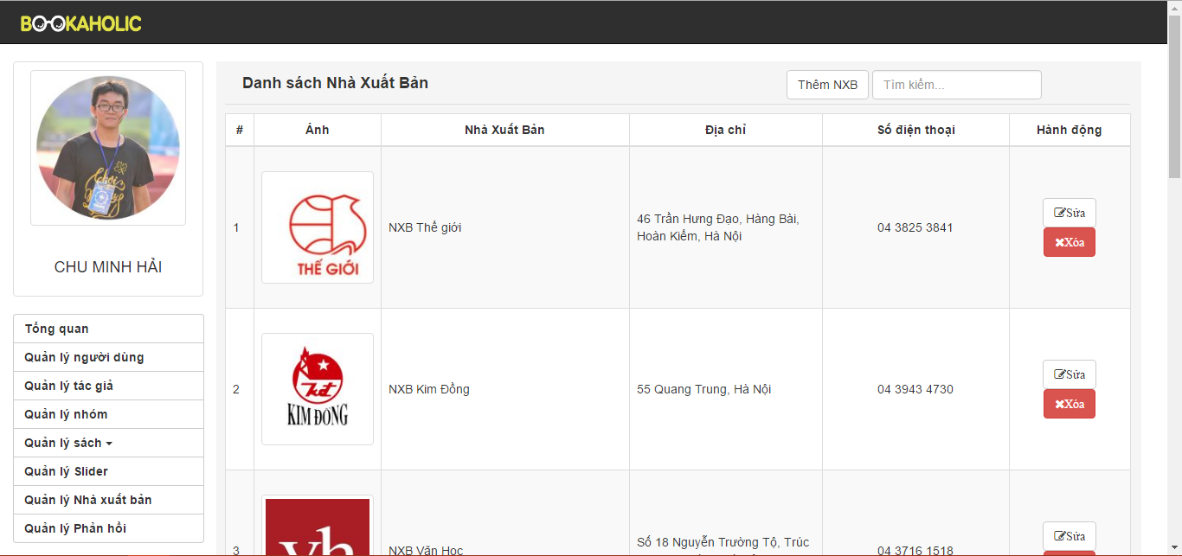

Figure 3.7.1: Publisher Management

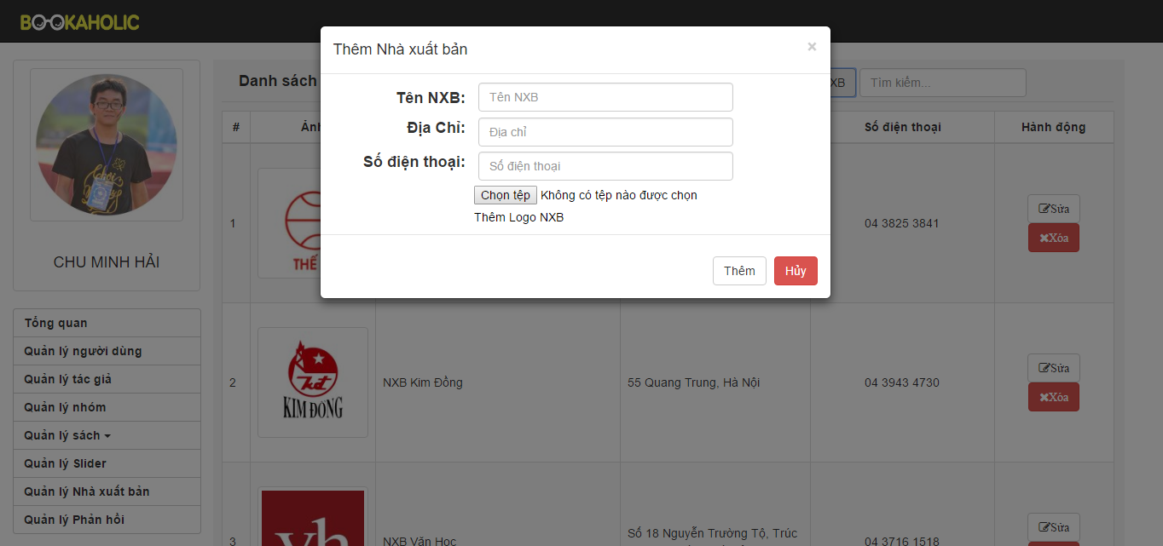

Figure 3.7.2: Add new publisher

|  |  |  |  |  |  |  |  |
| --- | --- | --- | --- | --- | --- | --- | --- |
| No | Field name | Field name in Vietnamese | Type | Require | Mandatory | Max-Length | Description |
| 1 | Add publisher button | Thêm nhà xuất bản mới | Button |  | Y |  | When click the add spublisher button the popup will appear . |
| 2 | Popup Add publisher | Khung thêm nhà xuất bản | Model popup |  | Y |  | Popup appear and allow add new publisher . |
| Chọn file |  |  | Y |  | Allow choose file |
| Tên nhà xuất bản | Text input |  | Y |  | Enter the name of publisher |
| Địa chỉ | Text input | Click | Y |  | Enter the address of publisher |
| Nút thêm | Button | Click | Y |  | When choose file and enter name, enter address then click the add button, the publisher will be added. |
| Cancel button | Button | Click | Y |  | When click cancel button, add new publisher will be canceled. |
| 3 | List publishers | Danh sách nhà xuất bản | Table |  | Y |  | List publisher (image, name of publisher, address). |
| Nút sửa | Button | Click | Y |  | Edit publisher’s info |
| Nút xóa | Button | Click | Y |  | Delete publisher |
| 4 | Search | Tìm kiếm | Textbox | Click | Y |  | Search publisher |

Table 3.7: Publisher Management

##### Report management

###### Report user management

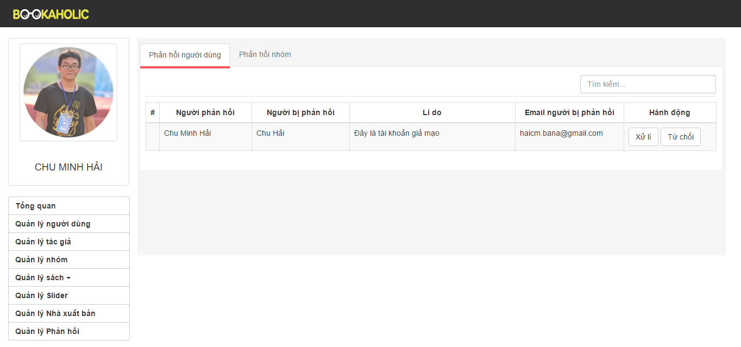

Figure 3.8.1: Report user

|  |  |  |  |  |  |  |  |
| --- | --- | --- | --- | --- | --- | --- | --- |
| No | Field name | Field name in Vietnamese | Type | Require | Mandatory | Max-Length | Description |
| 1 | Search | Tìm kiếm | Textbox | Click | Y |  | Search user |
| 2 | List reports | Danh sách phản hồi | Table |  | Y |  | List reports (reporter, reported, email of reported, action ). |
| 3 | Handling button | Nút xử lý | Button | Click | Y |  | When click handling button, reported user has been banned |
| 4 | Denied button | Nút từ chối | Button | Click | Y |  | When click denied button, report has denied |

Table 3.8.1: Report user

###### Report group management

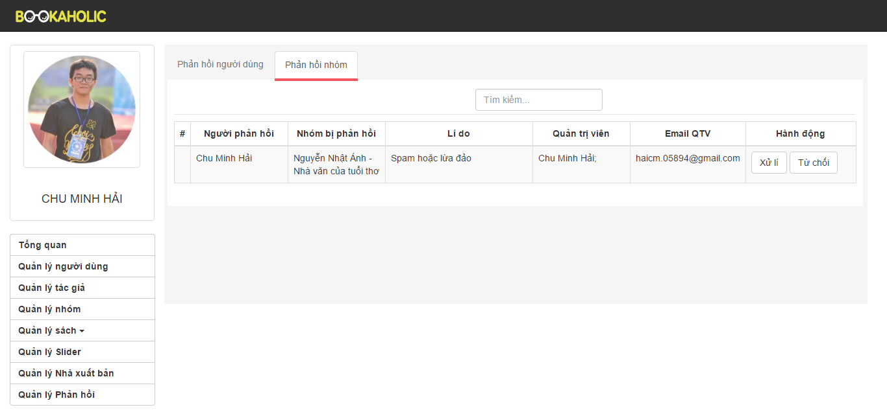

Figure 3.8.2: Report group

|  |  |  |  |  |  |  |  |
| --- | --- | --- | --- | --- | --- | --- | --- |
| No | Field name | Field name in Vietnamese | Type | Require | Mandatory | Max-Length | Description |
| 1 | Search | Tìm kiếm | Textbox | Click | Y |  | Search user |
| 2 | List groups | Danh sách nhóm | Table |  | Y |  | List groups (reporter, group was reported, reason,administrators, email of adminstrators action ). |
| 3 | Handling button | Nút xử lý | Button | Click | Y |  | When click handling button, reported group has been banned |
| 4 | Execute button | Nút thực hiện | Button | Click | Y |  | When click denied button, report has denied |

Table 3.8.2: Report group

# SOFTWARE TESTING

## Introduction

### Purpose

This is the comprehensive test plan of the BSN project. The purpose of the document describes scopes of test and activities which need to be taken during test process of project. It addresses the following items: Scopes of Testing, Requirements for Testing, Test Strategy, Test Resources, Test Environment, Test Milestones and Deliverables.

### Definitions and Acronyms

This section describes the definitions, terms, and acronyms that are used in software requirements specification.

|  |  |  |
| --- | --- | --- |
| **Acronym** | **Definition** | **Note** |
| BSN | Bookaholic Social Network |  |
| GUI | Graphic User Interface |  |
| IT | Integration Test |  |
| KLOC | 1000 line of code |  |
| PM | Project Manager |  |
| QA | Quality Assurance |  |
| SRS | Software Requirement Specification |  |
| ST | System Test |  |
| TC | Test Case |  |
| TL | Test Leader |  |
| TP | Test Plan |  |
| TR | Test Report |  |
| UT | Unit Test |  |

1. Definitions and Acronyms

### Scope of testing

BSN will be tested by 4 phases:

**Phase 1: Unit testing**

* Unit testing will be done by developers
* Developers user White Box Testing technique to do
* When executing unit testing, if any bugs are found, developers have to log bug on “Defect Log Management” file and fix it until it is correct.

*Rule for filling test result:*

|  |  |
| --- | --- |
| Test result pass | Pass |
| Test result fail | Fail |
| Do not test | Untested |
| Cannot test | N/A (Not available) |

**Phase 2: Integration testing**

* After finishing component testing, integration testing will be performed by testers.
* Material are integration test cases, high- level design and test tools.
* Integration test focuses on specific areas of use cases when all requirements are completed.
* Integration test should be performed to ensure all components incorporate well.
* When executing integration testing, if any bugs are found, testers have to log on “Defect Log Management” file and assign to developer fix it and redo this process until it is correct.

*Rule for filling test result:*

|  |  |
| --- | --- |
| Test result pass | Pass |
| Test result fail | Fail |
| Do not test | Untested |
| Cannot test | N/A (Not available) |

**Phase 3: System testing**

* After finishing integration testing and developers collect all functions and items, testers will be performed system testing, it means doing test whole system.
* Material area system test case, SRS
* If any bugs are found, developers have to fix and testers will verify them. System test is ended only when test cases are passed and no bug is found.

*Rule for filling test result:*

|  |  |
| --- | --- |
| Test result pass | Pass |
| Test result fail | Fail |
| Do not test | Untested |
| Cannot test | N/A (Not available) |

### Constraints

* There are only 2 testers and do not have much experience in test plan, test phase and testing.
* Deadline for testing only can be met if development progress is on time.
* Time of testing is short.
* Test execution can be performed when system passes Unit Test Inspection.
* At least one round of testing must be performed for requirements.
* Have more environments should be tested: Window 8… and more browsers: Google Chrome 50.0 or above.

## Test plan

### Test type

#### Function Testing

* Functional testing is a type of software testing whereby the system is tested against the functional requirements/specifications.
* Functions are tested by feeding them input and examining the output. Functional testing ensure that the requirements are properly satisfied by the website. This type of testing is not concerned with how processing occurs, but rather, with the results of processing.
* During functional testing, [Black Box Testing](http://softwaretestingfundamentals.com/black-box-testing/) technique is used in which the internal logic of the system being tested is not known to the tester.

|  |  |
| --- | --- |
| **Test Objective:** | The type of this test is to ensure proper target-of-test functionality, including user interaction, all function defined in specification document implemented correctly. |
| **Technique:** | Executing each use case, use-case flow, or function, using valid and invalid data, to verify the following:  - The expected results occur when valid data is used.  - The appropriate error or warning messages are displayed when invalid data is used.  - Each business rule is properly applied. |
| **Completion Criteria:** | - All planned tests have been executed.  - All identified defects have been addressed and closed. |
| **Special Considerations:** | Testing may be stopped when  Time runs out  A certain number of defects found  Test coverage > 97%  Stop when testing becomes unproductive |

1. Function Testing

#### User Interface Testing

GUI testing is the process of ensuring proper functionality of the GUI for a given web and making sure it conforms to its written specifications.

GUI testing evaluates design elements such as layout, colors, fonts, font sizes, labels, text boxes, text formatting, captions, buttons, lists, icons, links, content and more.

|  |  |
| --- | --- |
| **Test Objective:** | Verify the following:  - Navigation through the target-of-test properly reflects business functions and requirements, including window-to-window, field-to-field, and use of access methods (tab keys, mouse movements, accelerator keys)  - Window objects and characteristics, such as menus, size, position, state, and focus conform to standards. |
| **Technique:** | Create or modify tests for each window to verify proper navigation and object states for each application window and objects. |
| **Completion Criteria:** | Each window successfully verified to remain consistent with benchmark version or within acceptable standard |
| **Special Considerations:** | Not all properties for custom and third party objects can be accessed. |

1. GUI Testing

##### Data and Database Integrity Testing

The databases and the database processes should be tested as a subsystem within the Project. These subsystems should be tested without the target-of-test’s User Interface as the interface to the data.  Additional research into the Database Management System (DBMS) needs to be performed to identify the tools and techniques that may exist to support the testing identified below.

|  |  |
| --- | --- |
| **Test Objective:** | Ensure database access methods and processes function properly and without data corruption. |
| **Technique:** | - Invoke each database access method and process, seeding each with valid and invalid data or requests for data.  - Inspect the database to ensure the data has been populated as intended, all database events occurred properly, or review the returned data to ensure that the correct data was retrieved for the correct reasons. |
| **Completion Criteria:** | All database access methods and processes function as designed and without any data corruption. |
| **Special Considerations:** | - Testing may require a DBMS development environment or drivers to enter or modify data directly in the databases.  - Processes should be invoked manually.  - Small or minimally sized databases (limited number of records) should be used to increase the visibility of any non-acceptable events. |

1. Data and Data Integrity Testing

### Test stages

Clearly state the stage in which the test will be executed. Identified below are the stages in which common test are executed

| **Type of Tests** | **Stage of Test** | | | |
| --- | --- | --- | --- | --- |
| **Unit** | **Integration** | **System** | **Acceptance** |
| Function Testing | X | X | X | X |
| User Interface Testing | X |  | X | X |

1. Test stages

### Test model

DDL follows V-Model process:



1. V-model process

Testing progress is divided to 5 phases include: Unit test, Component test, Integration test, System test and Acceptance test

* Unit test:
  + Unit testing is used to verify a single minimal unit of source code. The purpose of unit testing is to isolate the smallest testable parts of DDL and verify that they function properly in isolation.
  + Unit testing is the first level of testing and is perform prior to component testing
  + Unit testing will be done by developer.
* Integration test:
  + Integration testing is a level of the software testing process where individual units or component are combined and tested as a group.
  + The purpose is to expose faults in the interaction between integrated units.
  + Integration testing is performed after component testing
  + Integration testing will be done by tester

|  |  |
| --- | --- |
| **No** | **Integration Testing Method** |
| 1 | Bottom-up integration  This testing begins with unit testing, followed by tests of progressively higher-level combinations of units called modules. |
| 2 | Top- Down integration  This testing, the highest-level modules are tested first and progressively lower-level modules are tested after that |

* + There are two methods of doing integration testing: Bottom-up Integration testing and Top Down Integration testing:

Integration test

* System test:
  + System Testing is a level of the software testing process where a complete, integrated system is tested
  + The purpose is to evaluate the system’s compliance with the specified requirements
  + System testing is performed after integration testing
  + System testing will be done by tester
* Acceptance test:
  + Acceptance testing is performed after system testing
  + Acceptance testing will be performed by the test leader and team leader.
  + The acceptance test will be done for a period of 1 weeks after completion of the system test process

### Acceptance test criteria.

* Criteria for Unit test of Development team, for Test team accepts to start testing:
  + Number of TC/KLOC: 40TC/KLOC
  + Number defects/KLOC: 3-4 defects/KLOC
  + Statement coverage: 100%
  + Branch coverage: 100%
  + Path coverage: 100%
* Criteria for Integration test:
  + Number of TC/KLOC: 30 TC/KLOC
  + Number defects/KLOC: 2-3 defects/KLOC
* Criteria for System test:
  + Number of TC/KLOC: 20 TC/KLOC
  + Number defects/KLOC: 4-6 defects/KLOC
* Criteria for Acceptance test:
  + Number defects/KLOC: 1-2 defects/KLOC

### Futures to be tested

Refer 3.3.1.2 Product features for more detail.

### Feature not to be tested

* The stable of website when do not connect internet.
* Over than 5000 users connect to system at the same time.

### Resources

#### Human resource

|  |  |  |
| --- | --- | --- |
| **Worker/Doer** | **Role** | **Specific Responsibilities/Comments** |
| MaiCTP | Test Leader | Manage Test Resource and assign test tasks.  Create and review Test Plan.  Create and review Test Case.  Execute test.  Create and review Test Report |
| ChinhVC | Tester | Create and review Test Case.  Execute test.  Create Test view points  Create and review Test Report |

1. Human resource

#### Test Environment

##### Hardware

|  |  |  |
| --- | --- | --- |
| **Name** | **Purpose** | **Detail** |
| Laptop HP | Device for create and execute test | Window 8.1 Pro Core i3 |
| Laptop Asus | Device for create and execute test | Window 8.1 Pro Core i5 |

1. Hardware

##### Software

|  |  |  |
| --- | --- | --- |
| **Name** | **Purpose** | **Detail** |
| Test Plan | Managing test | Microsoft Word 2010, 2013 |
| Test case | Executing test | Microsoft Excel 2010, 2013 |
| Test report, Test checklist | Tracking test | Microsoft Excel 2010, 2013 |
| Chrome | Executing test | Chrome 40.0 |
| Firefox | Executing test | Firefox |

1. Software

##### Infrastructure

|  |  |  |  |  |
| --- | --- | --- | --- | --- |
| **Name** | **Purpose** | **Detail** | **Vendor/In-house** | **Version** |
| DDL_Defect Log Management_v1.0_EN | Tracking bug during testing time | Microsoft Excel 2013, 2010 | FPT-University | v1.0 |
| Test Effort | Effort execute test | Microsoft Excel 2013, 2010 | FPT-University | v1.0 |

1. Infrastructure

### Test milestones

|  |  |  |  |
| --- | --- | --- | --- |
| **Milestone Task** | **Effort (pd)** | **Start Date** | **End Date** |
| Create Test Plan | 6 | 21/10/2015 | 23/10/2015 |
| Review & Update Test Plan | 2 | 26/12/2015 | 27/12/2015 |
| Create Integration Test case | 2 | 06/11/2015 | 10/11/2015 |
| Review & Update Integration Test Case | 2 | 11/11/2015 | 12/11/2015 |
| Create System Test case | 6 | 30/10/2015 | 05/11/2015 |
| Review & Update System Test Case | 2 | 04/11/2015 | 05/11/2015 |
| Execute Integration test phase 1 | 2 | 13/11/2015 | 17/11/2015 |
| Execute Integration test phase 2 | 2 | 24/11/2015 | 26/11/2015 |
| Execute Integration test phase 3 | 2 | 03/12/2015 | 05/12/2015 |
| Execute System test phase 1 | 4 | 18/11/2015 | 20/11/2015 |
| Execute System test phase 2 | 4 | 27/11/2015 | 01/12/2015 |
| Execute System test phase 3 | 4 | 06/12/2015 | 09/12/2015 |
| Create Test Plan | 6 | 21/10/2015 | 23/10/2015 |
| Review & Update Test Plan | 2 | 26/12/2015 | 27/12/2015 |

1. Test milestones

### Deliverables

| **No** | **Deliverables** | **Responsibilities** | **Delivered Date** |
| --- | --- | --- | --- |
| 1 | Test Plan | Tester |  |
| 2 | Integration Test case | Tester |  |
| 3 | System Test case | Tester |  |
| 4 | Defect Log Management | All members |  |
| 5 | Test report | Test Leader |  |

1. Deliverables

## Test case

Refer to:

* + DDL_Integration Test Case_v1.0_EN.xlsx
  + DDL_System Test Case_v1.0_EN.xlsx
  + DDL_Common Test Case_v1.0_EN.xlsx
  + DDL_UnitTestCase_CategoryRepository_v1.0.xlsx
  + DDL_UnitTestCase_MessageRepository_v1.0.xlsx
  + DDL_UnitTestCase_ProjectRepository_v1.0.xlsx
  + DDL_UnitTestCase_SlideRepository_v1.0.xlsx
  + DDL_UnitTestCase_UserResponsitory_v1.0.xls

## Test Report

### System test report

|  |  |  |  |  |  |
| --- | --- | --- | --- | --- | --- |
| **No** | **Module Code** | **Pass** | **Fail** | **N/A** | **Number of Test Case** |
| 1 | Common Module | 20 | 0 | 0 | 20 |
| 2 | Display Personal Page | 30 | 0 | 0 | 30 |
| 3 | Account management module | 122 | 0 | 0 | 122 |
| 4 | Create Edit Project | 228 | 0 | 0 | 228 |
| 5 | Project detail | 88 | 0 | 0 | 88 |
| 6 | Back Project | 46 | 0 | 0 | 46 |
| 7 | Project management | 62 | 0 | 0 | 62 |
| 8 | Discover | 18 | 0 | 0 | 18 |
| 9 | Statistic | 24 | 0 | 0 | 24 |
| 10 | Message | 52 | 0 | 0 | 52 |
| 11 | Admin Module | 108 | 0 | 0 | 108 |
| 12 | Common + UI + Security | 56 | 0 | 0 | 56 |
|  | **Total** | 868 | 0 | 0 | 868 |

1. System test report

### Integration test report

|  |  |  |  |  |  |
| --- | --- | --- | --- | --- | --- |
| **No** | **Module Code** | **Pass** | **Fail** | **N/A** | **Number of Test Case** |
| 1 | Registered_User_function | 188 | 0 | 0 | 118 |
| 2 | Admin_Function | 110 | 2 | 0 | 112 |
|  | **Total** | 298 | 2 | 0 | 300 |

1. Integration test report

### Test report

|  |  |  |  |  |  |  |  |  |
| --- | --- | --- | --- | --- | --- | --- | --- | --- |
| **No** | **Module Code** | **Round 1** | | **Round 2** | | **Round 3** | | **Final** |
| Pass | Fail | Pass | Fail | Pass | Fail |
| 1 | Unit Test | 356 | 0 | 356 | 0 | 356 | 0 | 356 |
| 2 | Integration Test | 298 | 2 | 300 | 0 | 300 | 0 | 300 |
| 3 | System Test | 748 | 110 | 770 | 98 | 868 | 0 | 868 |
|  | **Total** | 1402 | 112 | 1426 | 98 | 1524 | 0 | 1524 |

1. Test Report

### Defect report

|  |  |  |  |  |
| --- | --- | --- | --- | --- |
| **Defects** | **Logged** | **%Closed** | **%Invalid** | **%Open** |
| **Critical** | 0 | 0% | 0% | 0% |
| **High** | 4 | 0% | 0% | 0% |
| **Medium** | 24 | 100% | 0% | 0% |
| **Low** | 38 | 100% | 0% | 0% |
| **Total** | 66 | 100% | 0% | 0% |

# USER MANUAL

## Introduction

### Purpose

This document contains guide-lines step by step to deploy DDL App to Azure website and This user's manual has been developed to help users better understand the requirements that may apply to use this website by providing them simple step by step tutorials. This manual is intended to help make website's functions more accessible and their associated requirements more understandable to users.

### Environment

Following are the software required to start the DDL system:

* Operating System: Windows 7, Windows 8, Window 10
* Browsers: Firefox 40, Chrome 44 or higher.
* Database: SQL 2010 or higher
* .NET Framework 4.5

## Installation Guideline

### Connecting an ASP.NET MVC Web App with SQL Azure

#### Creating the SQL Azure Database

The first thing to do is creat your sql database on azure:

* Step 1: Go to your azure portal, and click the new button in the bottom left corner



1. New button

* Step 2: Then choose Data Services >> SQL Database >> Quick Create and fill in the form. My settings were:
  + Database Name: **DDL_CapstoneProject**
  + Server: **New SQL database server**
  + Region: **South East Asia**
  + **Make sure you remember the username and password you choose**
* Step 3: Press [Create SQL Database] button

1. Create SQL Database

After waiting a few seconds your database should be created.

* Step 4: Click SQL Databases on the left column, then select your database in the main pane



1. List SQL Database

* Step 5: Go to the database dashboard



1. Menu

Once on the dashboard you need to ensure that other azure services are allowed to communicate with you database (this should be set by default). If this option is not selected the firewall on the sql azure database will disallow connections from your website:

* Step 6: Select ‘Manage allowed IP addresses’



1. Dashboard

* Step 7: Ensure that ‘Windows Azure Services’ under ‘allowed services’ is set to Yes



1. Managed allowed IP address

Finally you need to get the connection string for the database:

* Step 8: From the database dashboard (see Figure 6-4), select “Show connection strings”



1. Dashboard

* Step 9: On the window that pops up copy the connection string labelled ‘ADO.NET’ for later use:



1. Connection Strings

Your database is now set-up and ready for you to configure in your web app.

#### Updating Connection Details in Your Web App

The next step is to update you mvc appication to point at the newly created sql azure database.

* Step 1: Within your visual studio project, find the file called Web.config and open it



1. Project Solution Explorer

* Step 2: Add the following code into the file directly.

<connectionStrings>

<add name="DDLDataContext"

connectionString=”*enter your connection string here*”

providerName="System.Data.SqlClient" />

</connectionStrings>

* Step 3: Ensure that you replace ‘enter your connection string here’ with the one copied from sql azure earlier
* Step 4: There should also be a placeholer inside the connection string that read ‘{your_password_here}’ – this should be replaced with the password you set earlier.
* Step 5: Save the file

### Create & Deploying the Azure Website

#### Create Azure Website

In order to deploy your website to windows azure you’re going to need to set-up an account. At [Windows Azure website](http://www.codenutz.com/azure) you can create an account for free and have a free trial. Furthermore, at this point in time you can set-up up to 10 azure websites for free – you cannot use custom domain names, ssl or several other features, but they are perfect for experimentation.

Once you have created you account head to [http://manage.windowsazure.com](http://manage.windowsazure.com/) where you can set-up your first website:

* Step 1: From the main screen click the new button in the bottom left corner



1. New Button

* Step 2: Select **Compute** **🡪 Web Site 🡪 Quick Create.**
* **Step 3:** Enter the name for your website, I used “dandeliondemo” (note that you have to choose a name that’s available).
* Step 4: Select a region where you want your site to be hosted, I suggest choose South East Asia
* Step 5: Press create website



1. Create Web Site

You’ll have to wait a few seconds for azure to spin up the website, but you will be able to see in the interface a green tick denoting that it is ready to use:



1. List Website

* Step 6: Once it is ready click on it, and select ‘Download publish profile’ – this should download a file to your computer called something like Dandeliondemo.azurewebsites.net.PublishSetting

Now you’ve got an azure website ready, we can get to publishing your mvc site to the azure service.

#### Deploying to the Azure Website

* Step 1: From visual studio, right click the website project and choose the ‘Publish…’ option. You should be presented with a publish dialog like this:



1. Publish Web dialog

* Step 2: Choose ‘Import…’ – on this screen you can choose to import the profile directly from azure, or from a profile file. Either is very simple, but as we downloaded this file we’ll choose ‘Import from a publish profile file’. Click the browse button, select the file you just downloaded and click Ok. ***This will prepopulate a number of fields in the publish dialog which for now we dont need to worry about.***
* Step 3: Finally just click the ‘Publish’ button, and you website will be deployed to windows azure. You should see the progress reported from within the visual studio output window with various bits of information like ‘Adding file…’ and ‘Adding ACLs’ etc. The first time you deploy tends to be the longest as all of the files have to be uploaded – subsequent deployments are much quicker as only the changed files are transferred.

Once your website has finished deploying, visual studio should automatically open it in your browser for you, which should look something like this:

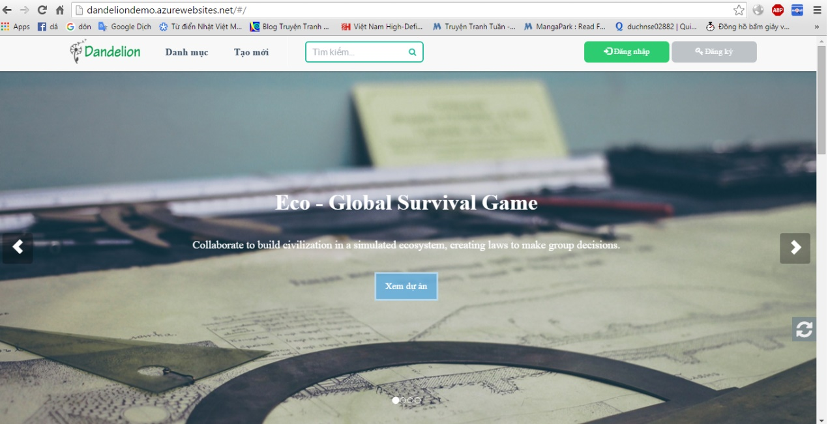

1. DDL screen after deploy successfully

### Connecting SQL Management Studio to SQL Azure

#### Allowing access to SQL Azur**e**

Here we’re going to set the SQL Azure fierwall to allow connections from our local IP.

* Step 1: Navigate to your SQL Azure database dashboard (more detail instructions can be found in Creating the SQL Azure Database.
* Step 2: Next go to ‘Manage allowed IP addresses’



1. Dashboard

* Step 3: You should see on this screen that your IP address is listed as ‘Current client IP Address’. Here Azure has recognised your ip address and listed it for you so that you can easily add it to the firewall rules:



1. Manage allowed IP address

* Step 4: To add the firewall rule simple click right arrow and you should see the IP address move into the list of rules:



1. Manage allowed IP address

* Step 5: Finally click the Save button at the bottom of the page



1. Save button

#### Connecting with SQL Server Management Studio

To connect to your database you need the full name of the server (servername*.database.windows.net*) that contains the database you want to connect to:

* Step 1: Go to the [Azure Portal](https://portal.azure.com/)
* Step 2: Browse to the database you want to connect to.
* Step 3: Locate the full server name:



1. SQL database server name

Use the fully qualified server name in step 3 below to connect to SQL database.

* Step 1: Open SSMS.
* Step 2: Click Connect > Database Engine...



1. SQL Server Management Studio

* Step 3: In the Connect to Server dialog box, in the Server name box, type the server name in the format *<servername>*.database.windows.net.
* Step 4: In the Authentication list, select SQL Server Authentication
* Step 5: Enter the Login and Password you specified when you created your SQL Database server, and click Connect.



1. Connect dialog

If the connection fails: Make sure that the firewall of the logical server you have created allows connections from your local computer. For more information, see [How to: Configure Firewall Settings on SQL Database](https://azure.microsoft.com/en-us/documentation/articles/sql-database-configure-firewall-settings/).

## User Guideline

### User Client

#### Register

This is the first page which user will see. From this page the user can go to every page they want.

To register account on website, the users do the steps below:

* Step 1: Open browser and enter to the address bar: <http://dandelionvn.com/>. Homepage is displayed.
* Step 2: Click on [Đăng ký] button in header. Users will be gone to register page.
* Step 3: Enter information and click on [Đăng ký] button or User can register by choose Login with Facebook.



1. Register screen

#### Login

To login account on website, User do the steps below:

* Step 1: Open browser and enter to the address bar: <http://dandelionvn.com/>. Homepage is displayed.
* Step 2: Click on [Đăng nhập] button in header. User will go to Login page.
* Step 3: User can choose Login with Facebook.
* Step 3: User can choose Login with DDL’s account:
  + Step 3.1: User enter username and password
  + Step 3.2: Click on Login button

**

1. Login page

#### Search project

To use search function on website, the users do the steps below:

* Step 1: In Home page, enter project to search in header.
* Step 2: Click on search icon or press enter.



1. Search project

* Step3: Search result page is displayed.



1. Search project result

#### Discover

In this page, user can view projects, view status of project and filter project by level, status… Go to Discover page, the user do the steps below:

* Step 1: Go to Homepage.
* Step 2: Click on [Danh Mục] hyperlink in header
* Step 3: Discover page is displayed and allow user can view and filter project.



1. Discover

#### Create project

In this page, user view projects, view status of project and filter project by level, status… Go to Discover page, the user do the steps below:

* Step 1: Go to Homepage.
* Step 2: Click on [Tạo mới] hyperlinl in header. System will go to [Create Project] page.
* Step 3: User enter information
* Step 4: Click on [Bắt đầu] button.



1. Create project screen

* Step 5: Confirm form is display some of information of your project. Click [Có] button to create project, click [Không] to cancel.



1. Popup create project screen

#### Edit project

When project is created user can edit project by the way go to edit project page.

* Step 1: Go to edit project page.
* Step 2: In this page, have tabs to user enter information
* Step 3: Click [Gửi dự án] button project to admin review and accept project.

##### Basic tab

User choose image, enter name, short description, category, position, goal, time. Them save information.



1. Basic tab screen

##### Reward tab

User create reward to give people donate project. At a reward user can edit, hide reward.



1. Reward tab screen

To create reward user do the step below:

* Step 1: Click on Add new reward.
* Step 2: Enter information reward
* Step 3: Click on Create button



1. Reward tab screen

##### Story tab

In this tab, user fills information details about project.

1. Story tab screen

##### Update tab

User create update version to people can follow status project.



1. Update tab screen

To create update user do the step below:

* Step 1: Click on Add new update.
* Step 2: Enter information update
* Step 3: Click on Create button



1. Create new update

##### Question and Answer tab

User create Q&A to answer the question about project.



1. Q&A tab screen

To create update user do the step below:

* Step 1: Click on Add new Q&A.
* Step 2: Enter question and answer.
* Step 3: Click on Create button



1. Create new Q&A

#### Project detail

In this page user can view details project. And user also can use share, follow, back, comment, report, send question to creator.



1. Project detail screen

##### Share project



1. Share project

##### Remind, follow project



1. Follow/remind project

##### Send question about project

To send question about project user do the step below:

* Step 1: Go to project detail of a project
* Step 2: Go to Thông tin tab and click on Gửi câu hỏi button
* Step 3: Enter question and click on Gửi câu hỏi.



1. Send question

##### Report project

To send report about project user do the step below:

* Step 1: Go to project detail of a project
* Step 2: Go to Thông tin tab and click on Báo cáo sai phạm button
* Step 3: Enter content and click on Gửi báo cáo.



1. Sent report

##### Comment tab

User can comment all of things relate about project



1. Comment tab screen

#### Back project

This is the most importance feature. To use this fearture user do the steps below:

* Step 1: From project details page, click back this project button (“Ủng hộ dự án”). System go to back project page.
* Step 2: Choose a reward, then fill pledge and click continue button. System go to payment project.



1. Back project screen

* Step 3: Enter information and click on Ủng hộ button. System go to the Bao Kim and backer complete some of step in Baokim to back success project.



1. Payment project screen

#### Message

In this page user can view messages to create new message, delete message, view message conversation.



1. Message screen

##### Send message

To sent message user do the steps below:

* Step 1: Click on avatar in header, then click on [Tin nhắn] hyperlink. System will go to message page.
* Step 2: Click on [Soạn tin nhắn] button.
* Step 3: Enter information and click [Gửi] button.



1. Send message

##### Delete message

To delete message user do the steps below:

Step 1: Click on avatar in header, then click on [Tin nhắn] hyperlink. System go to message page.

Step 2: Select message want to delete.

Step 3: Click [Xóa tin nhắn] button, confirm delete

Step 4: Click [Có, tôi chắc chắn] to delete messages, [Không] to cancel.



1. Delete message screen

##### Message view

In this page, user can sent and receive message create a conversation. To view conversation user do the steps below:

* Step 1: Click on avatar in header, then click on Message “Tin nhắn” button. System go to message page.
* Step 2: Click on a message to view conversation.



1. Message view screen

#### Project management

In this page help user manage project created, backed, reminded.

##### View created project

To view project created user do the steps below:

* Step 1: Click on avatar in header, then click on [Dự án đã tạo] hyperlink. System will go to created project page.
* Step 2: User can delete draft project.
* Step 2.1: Or User can edit draft project, running project.
* Step 2.2: Or User can view list backer of running project.



1. Created project screen

##### View list backing

To view list backing do the steps below:

* Step 1: Click on avatar in header, then click on [Dự án đã tạo] button. System will go to created project page.
* Step 2: Click on [Danh sách ủng hộ] button of project. System will go to list backer page
* Step 3: Choose a backer and click view backing details.



1. List backer screen

##### View backed project list

In this page help user manage project backed. To view project backed user do the steps below:



1. Backed project screen

* Step 1: Click on avatar in header, then click on [Dự án ủng hộ] hyperlink. System will go to backed project page.
* Step 2: Click on [Lịch sử ủng hộ] hyperlink
* Step 3: Choose a project and click view details.



1. Backed project history screen

##### View reminded project

To view project reminded user do the steps below:

* Step 1: Click on avatar in header, then click on [Dự án theo dõi] hyperlink. System will go to backed project page.
* Step 2: Click on “X” icon to cancel remind a project



1. Starred project screen

#### Account management

##### Change password

To change password user do the steps below:

* Step 1: Click on avatar in header, then click on “Tài khoản” button. System will go to account project page.
* Step 2: Click on “Thay đổi mật khẩu” button
* Step 3: Enter current pass, new pass, confirm pass.
* Step 4: Click “Lưu thiết lập” button.



1. Account screen

##### Edit profile

To change password user do the steps below:

* Step 1: Click on avatar in header, then click on “Tài khoản” button. System will go to account project page.
* Step 2: Click on “Sửa thông tin cá nhân” button
* Step 3: Enter information.
* Step 4: Click “Lưu thiết lập” button.



1. Edit profile screen

##### Public profile

User can view public profile.

1. Public profile screen

### Admin

#### Login



1. Login screen

To login admin account, the users do the steps below:

* Step 1: Open browser and enter to the address bar: <http://dandelionvn.com/admin/>.
* Step 2: User enter username and password
* Step 3: Click on Login button

#### Dashboard

At this page, Admin can view overview about project, user, backing, category.



1. Dashboard 1



1. Dash board 2



1. Dashboard 3

#### Manage User

To lock/unlock an account. Admin do the step below:

* Step 1: Go to Admin page, Click on [Danh sách thành viên]. System return list account.
* Step 2: Choose account and click on lock/unlock button to lock/unlock account.



1. Users list screen

#### Manage Project

To accept/reject project. Admin do the step below:

* Step 1: Go to Admin page, Click on [Danh sách dự án]. System returns list project.
* Step 2: Choose account and click view button. System go to project detail page.
* Step 3: Click [Chấp nhận/Từ chối] button to accept/reject project.



1. Projects list screen

#### View Backing

Admin can manage list banker.



1. Backing list screen

#### Manage Category

Admin can manage categories. (Create new, edit, lock, unlock category)



1. Category management screen

#### Manage Slide

Admin can manage sliders. (Create new, edit, Activate/deactivate slide)



1. Slide management screen

#### Message (same as message of user)

Admin can manage message. (Create sent, receive, delete message)



1. Message screen

#### Manage Report

##### Manage User Report

* Step 1: Click on [Báo cáo người dùng] hyperlink
* Step 2: Choose user to report
* Step 3: Click on [Đồng ý]/[Hủy]



1. User Report management screen

##### Manage Project Report

* Step 1: Click on [Báo cáo dự án] hyperlink
* Step 2: Choose project to report
* Step 3: Click on [Đồng ý]/[Hủy]



1. Project Report management screen

# PROJECT RESULT REPORT

## Product Judging

### Advantage of Dandelion system

The idea of Dandelion project is to develop a website where anyone can launch their project with the creative ideas to get funding from community and they can make their ideasand products become a reality. We want to create a website that support for Vietnamese people by using the payment method that is widely used by Vietnamese people and support them to create or back projects easily.

As the goals that we have set before started project, the Dandelion system has been developed in right direction. And what it provides to users is listed below:

* Guest: guest can search, view projects which is fundraising on Dandelion website with friendly interface.
* Member: member can create, launch and back the project to get the rewards, deals from creater. They can manage their backed, created and reminded project easily.
* Admin: Admin can manage users, projects in system. Admin can view statistics about projects, backed money and profit.

### Current Limitations

* Some screen can’t display well on Mobile or screen which has resolution lower than 1024x768.
* Website not support for English language.
* Not support payment methods for people in other contries.
* Not support payment by mobile cards.

### Expectation in Future

* Support multi-language and other payment method such as visa and master card to get funding from people in other countries.
* Support payment by mobile cards such as Viettel, Mobi, Vina, …
* App for Android and IOS which supports members manage their projects and admin can manage system anywhere by smart phone.
* Expand server to inscrease number of users.

## Project Summary

|  |  |  |  |  |
| --- | --- | --- | --- | --- |
| **Project Title** | | **Dandelion** | | |
| **Project Supervisor** | | Nguyễn Văn Sang | | |
| **Committers (6)** | | | | |
| **1** | **Project Manager** | Lưu Ngọc Mạnh | [manhlnse02619@fpt.edu.vn](mailto:manhlnse02619@fpt.edu.vn) | |
| **2** | **Team member** | Vũ Công Chính | [chinhvcse02585@fpt.edu.vn](mailto:chinhvcse02585@fpt.edu.vn) | |
| **3** | **Team member** | Nguyễn Minh Huy | [huynmse02723@fpt.edu.vn](mailto:huynmse02723@fpt.edu.vn) | |
| **4** | **Team member** | Vũ Ngọc Trung | [trungvnse02967@fpt.edu.vn](mailto:trungvnse02967@fpt.edu.vn) | |
| **5** | **Team member** | Dương Đức Anh | [anhddse02700@fpt.edu.vn](mailto:anhddse02700@fpt.edu.vn) | |
| **6** | **Team member** | Cao Thị Phương Mai | [maictpse02908@fpt.edu.vn](mailto:maictpse02908@fpt.edu.vn) | |
| **Main objective** | | Develop a system which will provide to users functionality to collect funding for their project and back to get the amazing products from creative projects. | | |
| **Purpose** | | Provide a Dandelion online on website. | | |
| **Source Repository** | | <https://github.com/sangnvus/2015FALLJS01.git> | | |
|  | | **Plan** | | **Actual** |
| **Start Date** | | 07/09/2015 | | 07/09/2015 |
| **End Date** | | 25/12/2014 | | 23/12/2015 |
| **Releases version** | | 1.0 | | 1.0 |
| **Duration** | | 80 | | 78 |
| **Effort (person-day)** | | 480 | | 468 |
| **Test cases** | | 1800 | | 1524 |
| **Defects** | | 200-300 | | 66 |
| **Document pages** | | ~ 3000 pages | | ~ 3500 pages |
| **Lines of code (C#)** | | ~ 10000 | | ~ 15000 |
| **Lines of code (HTML)** | | ~ 5000 | | ~ 10000 |
| **Lines of code (AngularJS)** | | ~ 10000 | | ~ 13000 |
| **LOC (Total)** | | ~ 25000 | | ~ 38000 |

1. Project summary

Knowledge:

* Work process of FPT Software to develop a project.
* Putting the learned knowledge into practice.
* Improve skils: teamwork, leader-ship, research and self-study, plan and manage time.
* Technical: AngularJS (Single Page Appliction), Azure Web App, WebApi 2.0, ASP.Net MVC5.
* Tools: Visual Studio, TortoiseGit, Enterprise Architect, Office tools.

## Lesson Learnt

* Together with leadership skills, the project manager needs to be aware of the strengths and weaknesses of his/her staff, so that the talents are harnessed and the shortfalls downplayed for the benefit of the project.
* The success of a project is largely dependent on the skills and strengths of the people involved. Therefore, a project needs to have a dedicated, talented set of individuals working towards a common goal.
* If you have the knowledge and experience to make a decision, then you should go ahead and so, without expecting leader to assign you task at every turn.
* Procrastination does not work. After assimilating the relevant information, decisions need to be made. Wrong decisions can be salvaged, if discovered early; but right decisions cannot be postponed.
* Be open to change. Sometimes, you may find that the things you knew along may not be correct at this given time, under these specific conditions.
* Good communication is that which will stop mistakes from becoming failures.
* Please think carefully before making a decision because if the wrong decisions you'll have to redo it from scratch.

# REFERENCES

1. Kickstarter

<https://www.kickstarter.com/>

1. Comicola

<https://www.comicola.com/>

1. Indiegogo

<https://www.indiegogo.com/>

1. Wikipedia, 2012, IBM Rational Unified Process, viewed 30 September 2013

<http://en.wikipedia.org/wiki/IBM_Rational_Unified_Process>

1. AngularJS Overview

<http://www.tutorialspoint.com/angularjs/angularjs_overview.html>

1. Capstone Project Report Teamplate – FPT University, Ha Noi, Viet Nam.
2. Report document guidelines (2013) – FPT University, Ha Noi, Viet Nam.
3. Template_Project_Plan, (2010), FPT University, Hanoi, Vietnam
4. Template Software_Requirements_Specification, (2010), FPT Software, Hanoi, Vietnam
5. Template Software_Design_Template, (2010), FPT Software, Hanoi, Vietnam
6. Templates for Test case & Defect log, FPT Software, Hanoi, Vietnam
7. The Unified Modeling Language diagram

<http://www.uml-diagrams.org/>